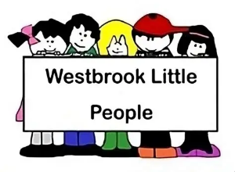
06.9a Internet Safety Audit (add name of setting)………………………………………
Technology used in our setting  (Add the types and numbers of devices) | ICT Equipment  Computers (office)  Computers (children)  iPad (staff/children)  Cameras/videos  Electronic learning journals  Nursery Management Software  Other. | Quantity | Wi-fi enabled  Yes or No? | Security settings i.e. passwords, firewalls, screen locks etc.. |  | Who has access?
Policies and Procedures -name of policy, or policy in which it is incorporated. | Subject  - Acceptable use: Yes/No  - Staff use of social media Yes/No  - GDPR/Data Protection Yes/No  - Personal mobile phones / wearable technology |  | Policy/Procedure |  | Further action required
Approved Apps/websites/online tools. | List the apps/websites/online tools that you use in your setting with the children  i.e YouTube Kids, CBeebies, Hungry Little Minds.
How are children supervised when using devices? | Please give details here…
How is the physical safety of users managed, i.e. posture, time spent on devices | Please give details, including, posture, time spent on devices etc.
How are devices stored securely when not in use? | Please give details….
How do staff model safe practice when using technology with children? | Please give details…
How is internet safety and use of technology incorporated into the early Years curriculum? | Please give details…
How is the home learning environment supported? | Add details of information shared with parents to support safe internet use at home.
Resources to support Internet safety in early years provision. | - http://internetmatters.org/  - Online safety guide 0-5 year olds - Internet Matters

