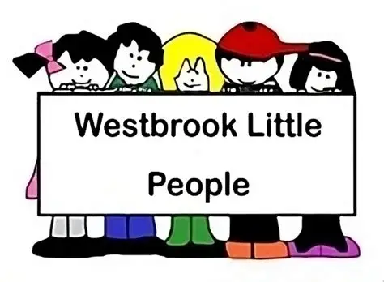
06 Safeguarding children, young people and vulnerable adults' procedures
06.8 Looked after children
Identification.
A 'Looked after Child' is a child in public care, who is placed with foster carers, in a residential home or with parents/carers or other relatives.
Services provided to Looked After Children
Under two-year-olds
- Places will not normally be provided for babies and under two-year-olds who are in public care.
- We can offer services that enable a child to play/engage with other children while the carer stays.
- Where the child is already in attendance and has a secure attachment with an existing key person a continuation of the existing place will be offered.
Two-year-olds
- Places will be offered to two-year-old children who are looked after; where the placement in the setting will normally last a minimum of three months.
- Where the child is already in attendance and has a secure attachment with an existing key person a continuation of the existing place will be offered.
Three- and four-year-olds
- Places will be offered for funded children who are looked after; where the placement in the setting will normally last a minimum of six weeks.
- If a child who attends a setting is taken into care and is cared for by a local carer the place will continue to be made available to the child.
Additional Support
- The designated safeguarding lead and key person at Westbrook Little People will liaise with agencies and professionals involved with the child, and their family, and ensure appropriate information is gained and shared.
- A meeting of professionals involved with the child is convened by the setting at the start of a placement. A Personal Education Plan (PEP) for children over 3 years old is put in place within 10 days of the child becoming looked after.
- Following this meeting, 6.8a Care plan for looked after children form is completed. The care plan is reviewed after two weeks, six weeks, three months, and thereafter at three to six monthly intervals.
- Westbrook Little People will have regular contact with the social worker and this will be maintained through planned meetings, which will include contribution to the PEP which is reviewed annually.

