

Pepperridge of Wildwood

February 3, 2025

Dear Homeowner,

CONGRATULATIONS!

Because of everyone’s hard work and commitment to this community, we were able to pass Amendment 8 to the Declaration and Bylaws, which states:

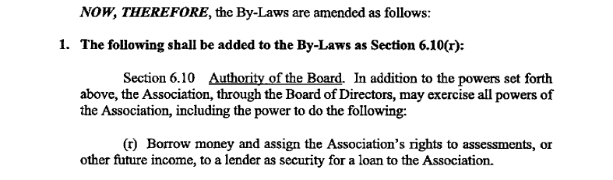
With this Amendment the Board was able to finalize and close on the loan and the funds were deposited to a special account in the Association’s name as of 1/28/25.

Work will begin shortly to replace the roofs. More to come on this project!

MORE GOOD NEWS!

Because the roof work is now funded and the work is starting shortly, the Board was able to source a better and more cost-effective insurance policy!

The renewed annual pricing for the current policy would have been $296,860.10. However, due to the swift and dedicated efforts of your Board, they have been able secure a policy through an excellent carrier for only $69,896.00 per year.

For an annual savings of: $226,964.10!

In addition, this includes 100% coverage vs. the only 80% coverage on the current policy. So there should be no issues with selling or buying a home!

A BIG THANK YOU to the Board for making such a monumental change possible for this community and well ahead of schedule!!

POLICY CHANGE TO QUALIFY FOR NEW INSURANCE

However, please read this carefully!

There are some terms that the new carrier/policy will require, and it is incumbent on each and every Homeowner, Tenant, and Guest to ensure that compliance is 100%.

This is directly from the carrier:

Dear Residents,

In accordance with the regulations established by our insurance provider, Pepperridge of Wildwood has now implemented a revised policy concerning outdoor grilling. This policy is effective immediately and has been put in place to ensure the safety and well-being of all residents within the community.

Outdoor Grilling Policy:
- Prohibited Items: The use of charcoal grills is strictly prohibited within the community premises. This prohibition has been enacted in alignment with the safety guidelines set by our insurance provider and is aimed at minimizing potential risks.

- Acceptable Grills: While charcoal grills are not allowed, residents are welcome to use propane grills for outdoor cooking. However, propane grills must be 10 feet from any residential building when in use. This precautionary measure is crucial to prevent any accidental fires and to safeguard the surrounding properties.

We urge all residents to kindly comply with these guidelines to guarantee a secure and harmonious environment for everyone.

Thank you for your cooperation and understanding. Together, we can ensure the continued well-being of the Pepperridge of Wildwood community. If you have any questions, please don’t hesitate to contact me.

If you are found to be in violation of one of these requirements/regulations, there will be an automatic $250.00 fine added to your account immediately.

If you have any questions or comments regarding this matter, please contact the office at
513-843-0310.

Regards,

Beth Campbell
Property Manager

