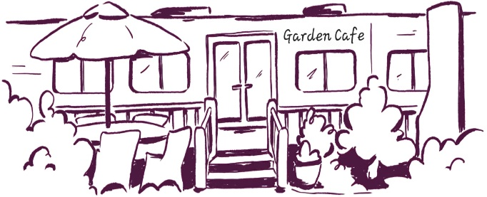
Garden cafe Lunch 12-3pm

Bowl of mixed olives £4.50 vg
Cheese potato wedges v with BBQ sauce £6.50 add bacon £2
On Sourdough - £12.50 rocket leaves & balsamic glaze, with or without chilli flakes add fried egg £1.50 bacon £2 olives £2 avo £2 feta £3 salmon £3.50 Smashed Avo with cherry vine tomatoes, savoury granola & sesame salt vg Smoked Mackerel Pate horseradish mayo, rocket & red onion, topped with roasted balsamic cherry vine tomatoes, radish, q, caperberry & lemon v
Feta salad bowl with homemade tzatziki & lemon & oregano dressing £14 v add toasted sourdough £1 salmon £3.50 chicken £3 avo £2 mixed leaves, tomatoes, q, red onion & olives
Fish fingers in a toasted bun with leaves, tartar sauce, pea shoots & lemon £14 v dressed salad & homemade potato salad
BBQ Chicken & Cheese Burger with salad & potato wedges £14 add bacon £2 in a toasted bap with BBQ sauce, rocket, coleslaw & red onion
Cous Cous & Butternut Squash Salad Bowl with lime & ginger dressing £14 vg add chicken £3 feta £3 squash, red onion, cherry tomatoes, spinach & chickpeas topped with lime & almonds
Sandwiches – white farmhouse, wholemeal or toasted open sourdough & salad garnish Avo, chilli jam, rocket, radish & vegan mayo sandwich cake £9 vg add feta or cheddar £1 Egg mayo, cress & avo £8.50 v add bacon £1 Cheese, Ham & Dijon mayo £9 add coleslaw £1 Bacon, Lettuce, Tomato, avo & mayo £9 King Prawns with mixed leaves, tomato & Marie Rose sauce £9
Toasties – white farmhouse, wholemeal or Sourdough & salad garnish Avo, chilli jam, rocket & radish £9 vg add feta or Cheddar £1 Cheddar, Ham & Dijon mayo £9 add side of coleslaw £1.50 Brie, Bacon & Chilli jam £9 Tuna mayo, cheese & red onion £9 BBQ Chicken, rocket, red onion, tomato & cheese £9 add side of coleslaw £1.50
Jacket potato - £10 with salad & our house dressing King Prawns in Marie Rose dressing & pea shoots v BBQ chicken, rocket, tomato, red onion & cheese Feta, rocket, tomato & red onion v OR choose two toppings; cheddar, baked beans, coleslaw, tuna mayo, sweetcorn, red onion, bacon, sausage, brie or chilli jam additional toppings £1.50 each

side of coleslaw or potato salad £1.50 salad £3

Gluten free bread, Dairy free spread & Vegan mayo is available Please ask a member of staff if you wish to see the allergen menu

