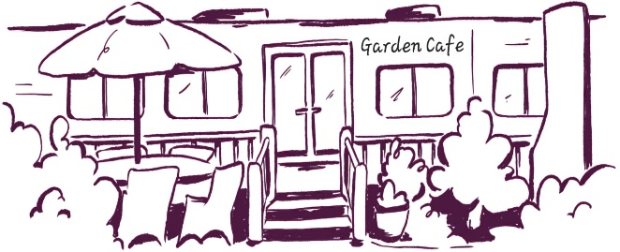

Garden cafe Breakfast menu
Monday – Friday Breakfast bap & cafetiere from 8am
Monday – Friday 9am – 11.45am
Saturday 9am – 11.45am Sunday 10am – 11.45am

Big breakfast £12.50 Revett’s sausages, bacon, fried eggs, mushrooms, tomato, Farmhouse toast & baked beans
Mini breakfast £10.50 Revett’s sausage, bacon, fried egg, mushrooms, tomato, Farmhouse toast & baked beans
Gluten free Big breakfast £12.50 or Mini Breakfast £10.50 Revett’s gluten free sausage, bacon, fried egg, mushrooms, tomato, gluten free toast & baked beans
Vegan breakfast £12.50 with sourdough toast & dairy free spread add hash brown £2 vg & df add egg £1.50 v Vegan sausage, avo, baked beans, herb cherry vine tomatoes, wilted spinach & mushrooms
Eggs on toast £8.50 v Scrambled or Fried add bacon £2 mushrooms £2 or salmon £3.50
On sourdough £10.50 add; fried egg £1.50 avo £2 bacon £2 add mushrooms £2 feta £3 salmon £3.50 Smashed Avo topped with cherry vine tomatoes, chilli flakes, sesame salt & pumpkin seeds vg Smoked salmon, spinach, fried egg, topped with cherry vine tomatoes & hollandaise sauce v Bacon, rocket, fried egg, cherry vine tomatoes & hollandaise sauce
Greek yogurt £6.50 with homemade granola & fresh berries v
Baps; add hash browns, mushrooms, bacon, sausage or black pudding £2 add an egg £1.50 Fully loaded bap; bacon, sausages & fried egg £9 Bacon or sausage £6 Bacon & sausage bap £8 Vegan Sausage £6 vg Fried Eggs £6 v
White or Wholemeal Farmhouse, Gluten free or Sourdough toast £3.50 slice of bread & butter £1.50 jam, marmalade, marmite, peanut butter, Nutella, honey or chilli jam 50p
Extras; baked beans vg fried egg £1.50 v rashes bacon, black pud, “Revett’s” sausage, gl free sausage £2 vegan sausage, avo, hash browns, mushrooms £2 vg Feta £3 v Smoked Salmon £3.50 v

Gluten free bread & sausages are available Dairy free spread available Please ask a member of staff if you wish to see the allergens menu

