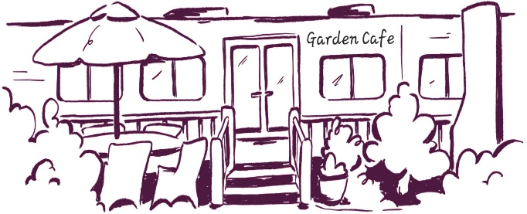
Garden cafe Lunch 12-3pm
Bowl of mixed olives £4.50 vg
Cheese potato wedges £6.50 v add bacon £2 with melting cheese, chilli flakes & sweet chilli mayo
Homemade Soup of the day £8 with sourdough croutons & buttered toast
On Sourdough - £12.50 rocket leaves & balsamic glaze, with or without chilli flakes add fried egg £1.50 bacon £2 avo £2 feta £3 salmon £3 Smashed Avo with cherry vine tomatoes, sesame salt & savoury granola vg Halloumi with chilli jam, rocket, red onion, sundried tomatoes & savoury granola v
Hummus Bowl with rocket & sweet chilli dressing vg £12.50 add pitta £2 feta £3 halloumi £3 roasted chickpeas, cherry vine tomatoes, q, red onion, olives & savoury granola
Fish fingers in a toasted bun with leaves, tartar sauce, pea shoots & lemon £12.50 v salad & potato wedges
Cajun Chicken burger in a toasted bun with coleslaw £14 add bacon £2 cheese £1 Sriracha mayo, rocket, red onion & tomato, with salad & potato wedges with chilli flakes
Sandwiches – white farmhouse, wholemeal or toasted open sourdough & salad garnish Avo, vegan pesto mayo, rocket & radish £9 vg add feta or cheddar £1 Egg mayo, cress & avo £8.50 v add bacon £1 Cheese, Ham & Dijon mayo £9 add coleslaw £1 Bacon, Lettuce, Tomato, avo & mayo £9 King Prawns with pea shoots & tomatoes in Marie Rose sauce £9
Toasties – white farmhouse, wholemeal or Sourdough & salad garnish Avo, vegan pesto mayo, rocket & radish £9 vg add feta or cheddar £1 Cheddar, Ham & Dijon mayo £9 add side of coleslaw £1.50 Brie, bacon & chilli jam £9 Tuna mayo, cheese & red onion £9 Cajun Chicken, Sriracha mayo, rocket, red onion, tomato & cheese £9 add side of coleslaw £1.50
Jacket potato - £9 with salad & our house dressing King Prawns in Marie Rose dressing & pea shoots Cajun chicken, melting cheddar, rocket, red onion, tomato & Sriracha mayo OR choose two toppings; cheddar, baked beans, coleslaw, tuna mayo, sweetcorn, red onion, bacon, sausage, brie or chilli jam additional toppings £1.50 each

side of coleslaw £1.50 salad £3
savoury chickpea, seeds & nut granola 75p
Gluten free bread, Dairy free spread & Vegan mayo is available Please ask a member of staff if you wish to see the allergen menu

