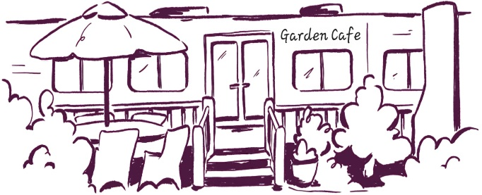
Garden cafe Lunch 12-3pm

Bowl of mixed olives £4.50 vg
Cheese potato wedges v with BBQ dip £6.50 add bacon £2
On Sourdough - £13 rocket leaves & balsamic glaze, with or without chilli flakes add fried egg £1.50 bacon £2 olives £2 avo £2 feta £3 salmon £3.50 Smashed Avo with cherry vine tomatoes, savoury granola & sesame salt vg Smoked Mackerel pate, rocket, red onion, cherry vine tomatoes, radish, q & caperberry v
Feta salad bowl with homemade tzatziki & lemon & oregano dressing £15 v mixed leaves, tomatoes, q, red onion & olives add sourdough £1 salmon £3.50
Coronation Chickpea salad with raisins & apricots £15 vg add chicken or feta £3 rocket, red onion, sundried tomatoes, peppers & topped with toasted flaked almonds
Chicken, Bacon & Avo Caesar salad bowl £17 salad leaves & Caesar dressing, cherry vine tomatoes, sourdough croutons & parmesan
BBQ Chicken & Cheese Burger with salad & potato wedges £15 add bacon £2 in a toasted bap with BBQ sauce, rocket, coleslaw & red onion
Coronation Chickpea in a bap with rocket, red onion, peppers, raisins & almonds £12.50 vg
Fish fingers in a bap, leaves, Stokes tartar or tomato sauce, pea shoots & lemon £12.50 v
Sandwiches – white farmhouse or wholemeal & salad garnish toasted open sourdough £1 Avo, chilli jam, rocket, radish & vegan mayo sandwich cake £9.50 vg Egg mayo, cress & avo £9 v add bacon £1 Cheese, Ham & Dijon mayo £9.50 add coleslaw £1 Bacon, Lettuce, Tomato, Avo & mayo £9.50 King Prawns with mixed leaves, tomato & Marie Rose sauce £9.50 v
Toasties – white farmhouse with a salad garnish sourdough toastie £1 Coronation Chickpea, rocket, red onion, peppers, raisins & almonds £9.50 vg feta or Cheddar £1 Cheddar, Ham & Dijon mayo £9.50 Brie, Bacon & Chilli jam £9.50 Tuna mayo, cheese & red onion £9.50 v BBQ Chicken, rocket, red onion, tomato & cheese £9.50
Jacket potato - £10 with salad & our house dressing King Prawns, Marie Rose dressing & pea shoots v BBQ Chicken, rocket, tomato, red onion & melting cheese Coronation chickpeas, rocket, red onion, peppers, raisins, apricots & flaked almonds vg Feta, rocket, tomato & red onion v OR choose two toppings; cheddar, feta, baked beans, coleslaw, tuna mayo, sweetcorn, red onion, bacon, sausage, chicken, brie or chilli jam additional toppings £1.50 each

side of homemade coleslaw or potato salad £1.50 salad £3
Gluten free bread, Dairy free spread & Vegan mayo is available menu Coronation chickpea can be served without the almonds Please ask a member of staff if you wish to see the allergen

