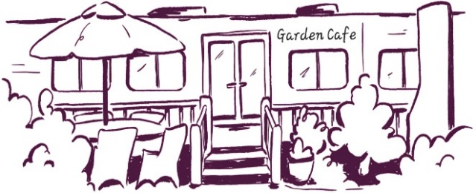
Garden cafe Drinks menu
Cafetiere £2.50
Espresso £2.80 Syrup 50p Extra shot 50p
Americano Flat white Long black Double espresso £3.30
Cappuccino Latte Chai latte Mocha £3.70
Vanilla latte Vanilla iced latte £4.20
Hot chocolate £3.20 add cream 50p or marshmallows 50p
Tea £2.40
Still or sparkling water £1.80 Selection of cans £2.30
Fruit burst Elderflower £3.30
Freshly made milkshake £4 with cream 50p chocolate, strawberry, vanilla, banana, cookie & cream, Biscoff or mocha
Cakes & Bakes
Sausage roll with Stokes chilli jam £3.50
Vegan sausage roll with Stokes chilli jam £3.50 vg
Cheese scone with Stokes red onion marmalade & butter £3.50
Fruit scone with butter & jam £3.50 Rhodda Cornish clotted cream £1.50
Toasted tea cake with butter £3 v/vg
Salted Chocolate Millionaire Rocky Road Shortbread £3.50
Carrot cake Tart £3.70
Vegan flapjack No bake Brownie £3.70 vg/nuts
Chocolate brownie gluten, dairy free & vegan £3.50 gl & d free vg Orange & almond French apple cake gluten & dairy free £3.50 gl & d free served warm with ice cream or custard £2 dairy free ice cream is available
Yorvale ice cream 120ml tub £2.80 caramel honeycomb, choc, strawberry or vanilla Mango & coconut - dairy free
Pipers crisps 40g £1.50 sea salt, sweet chilli, cheddar & onion & cider vinegar & sea salt
Doggy sausage £2

