
Riley Parks
Email: rooriley2009@gmail.com
Website: RileyParksTheatre.com

Height: 5’1” Hair: Auburn/Blonde Eyes: Hazel
Voice: Mezzo Soprano

Professional Regional Theatre
Sound of Music Gretl Mill Mountain Theatre
Fun Home Young Allison Mill Mountain Theatre
Waitress Ensemble Mill Mountain Theatre
Annie Pepper/Maid Mill Mountain Theatre
James and the Giant Peach* James Virginia Children’s Theatre

Musical Theatre
Big Fish Sandra Patrick Henry High School
Little Shop of Horrors Audrey II Patrick Henry High School
Shrek Blind Mice/Little Pig Mill Mountain Theatre
Little Mermaid Scuttle Roanoke City Schools
Footloose Wendy Jo Attic Productions
Wizard of Oz Dorothy Attic Productions
Shrek Jr Fiona Roanoke City Schools
Nemo Jr Dance Captain/Swing Mill Mountain Theatre
Newsies Jr Race/Dance Captain James Madison Middle School
Matilda Dance Ensemble Mill Mountain Theatre
Into The Woods Witch/Little Red Roanoke Catholic School

Theatre
The Miracle Worker Helen Keller Attic Productions
Peter and Wendy Wendy Darling Mill Mountain Theatre
As You Like It Corin/Dennis/Amiens Mill Mountain Theatre

Training
Acting: Mill Mountain Theatre Conservatory and KJPAS Studio
Voice: Kevin Jones Performing Arts
Dance: Divine Dance Studio-Jazz, Contemporary, Hip Hop, Ballet, Tap
Piano: Bethany Costello
Stage Combat: Belmont University Theatre Intensive
Music Theatre: Broadway Evolved Summer Intensive

Special Skills
Singer/Songwriter, Roller Skating, Stage Combat (hand to hand, Broadsword), Puppeteering, Piano, Guitar, Omnichord, Scooter Riding, Hula-Hooping, Jump Rope, British Accent, Southern Accent, Australian Accent, Russian Accent

*Touring Production

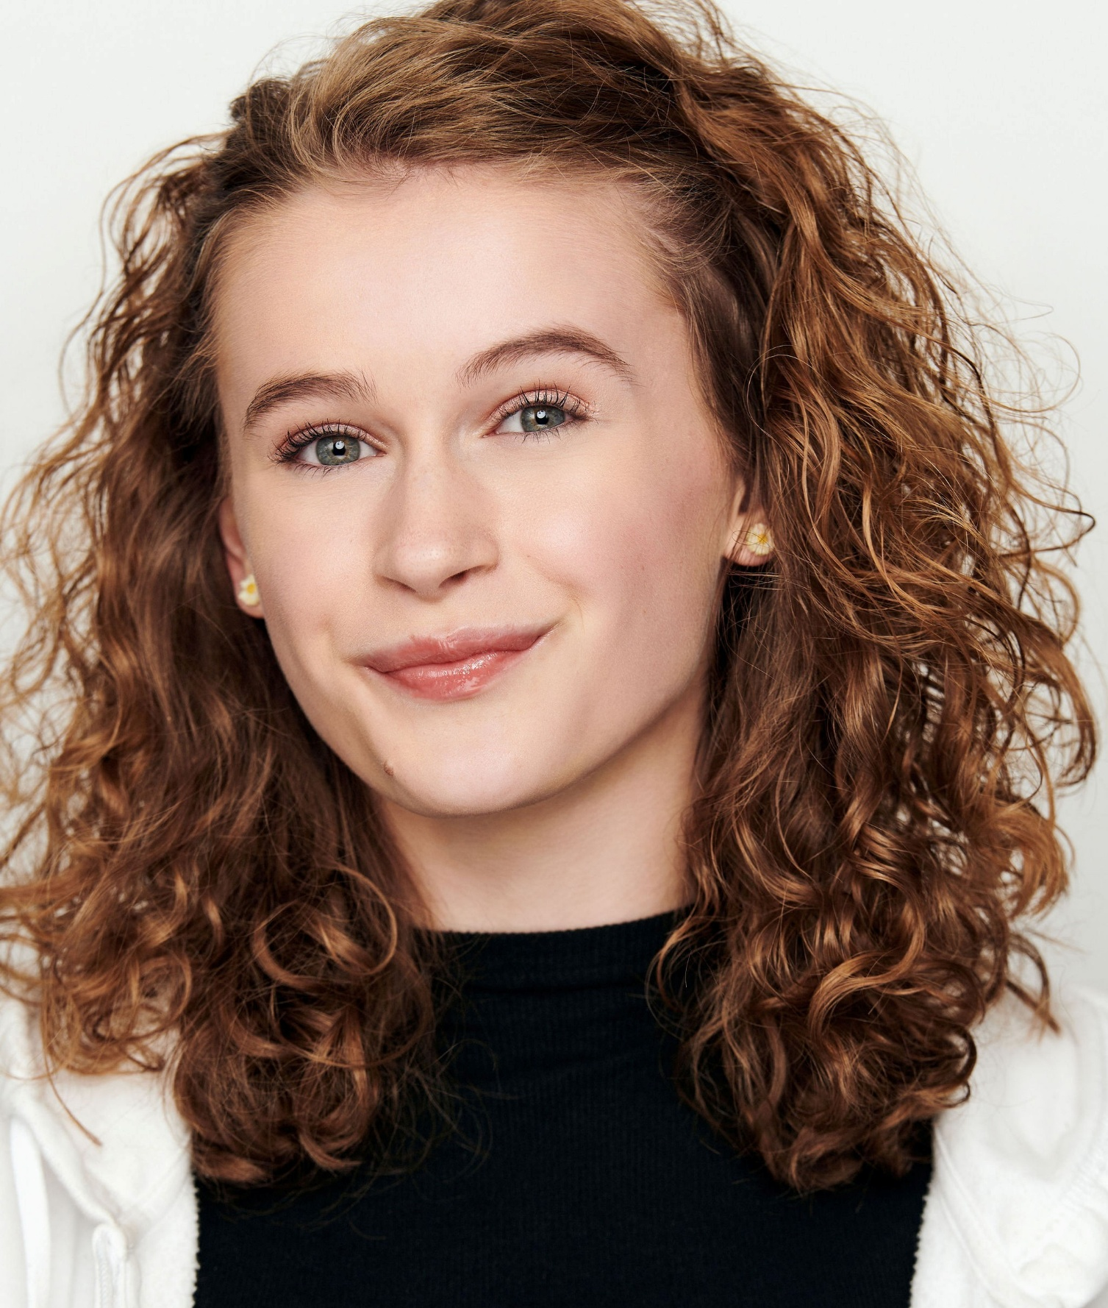
Riley Parks

