**Additional Resources in Gwinnett County**

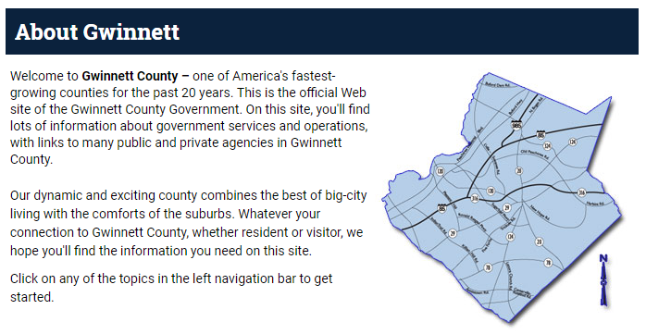

Click on the link below to go directly to the Gwinnett County Home Page

<https://www.gwinnettcounty.com/web/gwinnett/Home>

Advance Disposal

<https://www.advanceddisposal.com/ga/lawrenceville>

Gwinnett County Utilities and Cable TV

<https://www.gwinnettcounty.com/web/gwinnett/aboutgwinnett/utilities>