Consistency:

* 6 to 7 days of some form of exercise.
* 3 to 4 days of resistance training (circuit style training) with 2 to 3 days of interval or steady state cardio
* Consistent balanced nutrition daily. Remaining organized and prepared to have meals that include, carbs, fats, proteins, vitamins, minerals and water intake spread evenly throughout the day to suit your dietary needs and fitness goals. EVERYDAY.
* Cheat meals are only acceptable if they don't derail your progress and typically should follow a hard resistance training session

Daily workout process:

* General warm up (increase heart rate/blood flow, warm cool muscles progressively. Treadmill, bike, elliptical
* Foam rolling/myofascial release: using a foam roller or any other massage apparatus apply pressure to large main muscle groups or any other "trouble areas" 30 seconds to 1 minute in each area should suffice. Relax and breath. Apply enough pressure to break up trigger points and relax tight muscles
* Dynamic warm-up: include 10 to 15 dynamic bodyweight or light resistance movements for each body part. Jogging, skipping, shuffling, leg swinging. Pushups etc will suffice. Include dynamic stretches for each warmed up area. Dynamic stretches shouldn't be held for any more than 2 to 3 seconds. Stay moving. Your heart rate should be increasing enough to induce sweat. Don't forget to warm up and stretch the upper body dynamically.
* Workouts: depending on your skill level combine 3 to 4 exercises in a circuit 1 exercise for each body part or several for a particular region. 12-15 reps with minimal rest between sets will do for increasing heart rate and creating enough muscular breakdown to generate muscular stimulus. For extra cardio and intensity add a metabolic movement to keep the heart rate up.

Example: 3 to 4 rounds

* Cable rows 15 reps
* Rubber band pull aparts 15 reps
* Dumbell squats 15 reps
* Stability ball crunches 15 reps
* Stationary bike 1/4 mile fast
* The average 1 hour workout can include 3 to 4 circuits like this and focus on various regions of the body to make a total body workout worthy of the highest level athlete.

Cool down:

* Take 5 to 10 minutes to slowly return to a recovery heart rate. Include plenty of static stretches for each region of the body especially muscles on the front side of the body as these typically cause most postural issues. Static stretches should ideally last about 1 minute each area. Use stretching bands or an adjustable bench to make positioning for these stretches more efficient. Partner stretching is best for achieving maximum passive range of motion

Foam roll:

* To finish a complete workout and move lactic acid/excess blood out of muscles and increase blood flow as well as recovery time to reduce delayed onset muscular soreness

Workout progression:

* General a warm up
* Foam rolling
* Dynamic warm up/dynamic stretches
* 3 to 4 Resistance/metabolic circuits
* Cool down: static stretches/foam rolling

Rest/Recovery/Nutrition

Rest:

* ideally get 6 to 8 hours of sleep depending on your schedule and needs. Make this a priority by having a nightly cut off for technology etc.
* Avoiding working the same muscle groups two days in a row to avoid over training and minimize injury risk.
* Avoid high intensity training too many days in a row without recovery days in between especially when beginning an exercise program for the first time.
* Make sure have some form of nutrition in your system prior to a workout. This should ideally include carbohydrates, protein, and electrolytes to avoid excessive muscular breakdown DURING the workout. This can achieved one of two ways:

Supplementation:

* protein shake that includes vital fuel nutrients about 45 to 60 minutes prior to workout amino acid supplements can be very helpful in this
* If Supplementation isn't available a small snack of fruit, whole grain bread or oatmeal/rice or pasta with some form of nut butter etc can be helpful. Keep the amounts very small, enough to satiate hunger and prevent your body from breaking down muscle during the workout

Complete meal:

* carbs, proteins, fruits or veggies 2 and a half to 3 hours prior to a work-out to allow for digestion.
* Apps like myfitnesspal be very helpful in calculating your general dietary needs to meet your fitness and body composition goals.
* Generally the easiest way to achieve this is to prepare food in bulk and keep in Tupper ware contains that travel easily. Also supplement when needed. Most nutritional needs should be met through wholesome clean foods.
* Reserve supplements for times when a whole meal simply isn't accessible or practical.

Post workout (within 30 to 60 minutes):

* Is the optimal time to take in vital muscle building/fat burning nutrition. Do not miss out on the opportunity. A 3:1 ratio of carbohydrates to protein is necessary to achieve maximum refueling results.

Water intake and electrolytes replenishment:

* are a must. Aim to drink about 1 gallon (128 fluid oz) per day and replenish any water lost during workouts. Dehydration and poor nutrition habits are a major risk factor for causing muscular strains, tears, light headedness etc.

Protein:

* Adequate protein intake cannot be ignored when attempting to achieve maximum results in building lean muscle, burning fat, improving performance and recovering from intense workouts. The ideal minimum protein intake requirements for males and females are as follows regardless of one’s goal.

Males:

* at least 1 gram of protein for every Lb of bodyweight. Example: 180 lb male – 180 grams of protein per day

Females:

* at least 80% of one’s bodyweight in grams of protein per day. Example: 120 lb female – 96 grams of protein per day

List of High-Protein Foods and Protein in Each

Beef

• Hamburger patty, 4 oz – 28 grams protein

• Steak, 6 oz – 42 grams

• Most cuts of beef – 7 grams of protein per ounce

Chicken

• Chicken breast, 3.5 oz - 30 grams protein

• Chicken thigh – 10 grams (for average size)

• Drumstick – 11 grams

• Wing – 6 grams

• Chicken meat, cooked, 4 oz – 35 grams

Fish

• Most fish fillets or steaks are about 22 grams of protein for 3 ½ oz (100 grams) of cooked fish, or 6 grams per ounce

• Tuna, 6 oz can - 40 grams of protein

Pork

• Pork chop, average - 22 grams protein

• Pork loin or tenderloin, 4 oz – 29 grams

• Ham, 3 oz serving – 19 grams

• Ground pork, 1 oz raw – 5 grams; 3 oz cooked – 22 grams

• Bacon, 1 slice – 3 grams

• Canadian-style bacon (back bacon), slice – 5 – 6 grams

Dining Services 1 Eggs and Dairy

• Egg, large - 6 grams protein

• Milk, 1 cup - 8 grams

• Cottage cheese, ½ cup - 15 grams

• Yogurt, 1 cup – usually 8-12 grams, check label

• Soft cheeses (Mozzarella, Brie, Camembert) – 6 grams per oz

• Medium cheeses (Cheddar, Swiss) – 7 or 8 grams per oz

• Hard cheeses (Parmesan) – 10 grams per oz Beans (including soy)

• Tofu, ½ cup 20 grams protein

• Tofu, 1 oz, 2.3 grams

• Soy milk, 1 cup - 6 -10 grams

• Most beans (black, pinto, lentils, etc) about 7-10 grams protein per half cup of cooked beans

• Soy beans, ½ cup cooked – 14 grams protein

• Split peas, ½ cup cooked – 8 grams

Nuts and Seeds

• Peanut butter, 2 Tablespoons - 8 grams protein

• Almonds, ¼ cup – 8 grams

• Peanuts, ¼ cup – 9 grams

• Cashews, ¼ cup – 5 grams

• Pecans, ¼ cup – 2.5 grams

• Sunflower seeds, ¼ cup – 6 grams

• Pumpkin seeds, ¼ cup – 8 grams

• Flax seeds – ¼ cup – 8 grams

Recommendations

It’s recommended that 10–35% of your daily calories come from protein. Below is the Recommended Dietary Allowances (RDA) for different age groups. Recommended Dietary Allowance for Protein Grams of protein needed each day

Children ages 1 – 3: 13 grams

Children ages 4 – 8: 19 grams

Children ages 9 – 13: 34 grams

Girls ages 14 – 18: 46 grams

Boys ages 14 – 18: 52 grams

Women ages 19 – 70+: 46 grams

Men ages 19 – 70+: 56 grams

Sports Nutrition – Protein:

* Athletes need protein primarily to repair and rebuild muscle that is broken down during exercise and to help optimizes carbohydrate storage in the form of glycogen. Protein isn’t an ideal source of fuel for exercise, but can be used when the diet lacks adequate carbohydrate. This is detrimental, though, because if used for fuel, there isn’t enough available to repair and rebuild body tissues, including muscle.

Recommended Daily Protein Intake

• The average adult needs 0.8 grams per kilogram (2.2lbs) of body weight per day.

• Strength training athletes need about 1.4 to 1.8 grams per kilogram (2.2lbs) of body weight per day

• Endurance athletes need about 1.2 to 1.4 grams per kilogram (2.2lbs) of body weight per day

Injury response

Immediately post injury, be it a muscular strain, a joint sprain, spasm, cramping, concussion, heat sickness etc or any other sports related injury there are several question one must ask his/herself directly related to the injury itself. These questions should ideally be answered and evaluated by an athletic trainer or another certified/licensed healthcare professional to diagnose injury and prepare a plan of care. All injuries should be evaluated by a healthcare specialist to determine the plan of care despite the initial perceived level of severity.

Am I in a safe location where I could risk hurting myself or someone else further? If not am I capable of moving to a safe location despite the injury? If not emergency personnel should be contacted immediately.

Where is the injury?

What exactly happened to cause the injury?

How badly does it hurt? 1-10

Was there a snap, crackle, or pop?

Is there immediate swelling, redness, bruising, heat or touch sensitivity or throbbing on or around the injury location?

Am I experiencing any dizziness, nausea, light headedness, memory loss, feel like blacking out as a result of the injury?

Can the injured joint or muscle move? If so, with or without pain? If so how much does it hurt?

Can pressure be applied to injured area and does it have full range of motion in comparison to uninjured limb?

* If weight bearing cannot be applied to the limb it is advisable to see an orthopedic specialist immediately. If it is suspected that a bone fracture or dislocation has occurred seek emergency medical care, if not and the pain can be managed, time and money can be saved by seeing an orthopedic specialist first to avoid emergency medical care costs that will ultimately result in a referral to a specialist anyway.

Sprains, strains, and Soft tissue injuries:

* The first 48-72 hours of a soft tissue injury is crucial to the recovery process. Immediately injury occurs, the body responds by rushing blood and fluid to the area to begin the process of recovery, sometimes excessively so. Swelling, depending on the area (I.e joint) can cause excessive pressure which will cause discomfort and or pain.  To reduce initial swelling caused by a soft tissue injury, one should apply ice to the area for about 20 minutes and elevate the injury body part. This process recovery process is commonly known as R.I.C.E. and applies mostly to the first 48-72 hours immediately after a soft tissue injury has occurred. AGAIN having the injury properly evaluated and diagnosed is vital to understanding the correct method and plan of care.

Rest – Limiting use of the injured area to only essential movements. Immobilization may be necessary to prevent further injury or re-injury

Ice – Typically done in 10-15 minute intervals- Gel ice packs should have a thin cloth barrier between the pack and skin to prevent frost burns – Phase 1 Cold, phase 2 burning, phase 3 numbness. Phase 3 must be reached to ensure efficacy.

Compression – using either an ace bandage or compression sleeve of some sort apply a constant amount of comfortable pressure on the affected area by wrapping it snugly. Ideally pressure should be applied moving up toward the heart and should not be tight enough to occlude blood flow – leave shoe on or compression bandage etc on until the limb can be evaluated.

Elevation – keep the affected area elevated if possible during extended rest periods to promote blood flow and prevent pooling of waste product and swelling response.

* In the days following the initial recovery period it’s essential to begin the process of fortifying the body against further injury. When injuries occur the body begins to compensate in other areas to pick up the slack for the limb and muscles that are currently out of commission. This is where the need for a physical therapist and/or proper exercise prescription by a USI professional trainer is instrumental in the plan of care.
* This approach also affords one the opportunity to learn more about his/her body’s response to injury the processes involved with their personal journey to recovery as this can often be a highly personalized experience. Not every person will recover in the same way or time period or even respond to the same plan of care and protocols.

Mobilization timing – external vs internal support isometrics first - once you can bear weight do so without extra

* Pain and inflammation are a normal part of the therapeutic and strengthening stage of recovery. Finding balance between rehabilitating the injured area and managing the swelling response will be helpful in expediting recovery.
* An active approach to recovery is preferred over a passive one though it is important to listen to the body and know when to allow it to rest and heal. Initially rest is essential, however movement and promotion of blood flow to the affected tissues becomes equally important in the therapeutic stage of recovery. If the pain grade of the injured area and surrounding muscles or joints begins to worsen again it may be a good time to back off to ensure overtraining does not occur.

Therapeutic modalities administered by a certified or licensed professional such as:

* Massage
* Electrical stimulation
* Supportive taping
* Directed strengthening and stretching program
* Anti-inflammatory medication (as long as no known allergies are involved) ask healthcare professional about proper dosage – NO ANTI-Inflammatory for ligament injuries – impedes recovery.
* Ice (10 minutes) then heat (10 minutes) alternation modalities – Ice to reduce inflammation from stretching and strengthening the injury and heat to promote new blood flow and further healing or improve pliability of a stiff and tight muscle. Calf or hamstrings or quad if theres blood build to promote blow flow back into system, use proper insulation – swelling could occur for 6 months up to a year for lower extremity or distal limb.
* Suction cupping
* A.R.T (active release techniques)
* Muscle activation techniques

During this period of recovery IE from the initial moment of injury or occurrence of an apparent chronic pain cycle proper nutrition and hydration to promote healing becomes of utmost importance. Below is an info-graphic to provide nutritional guidance geared towards injury recovery

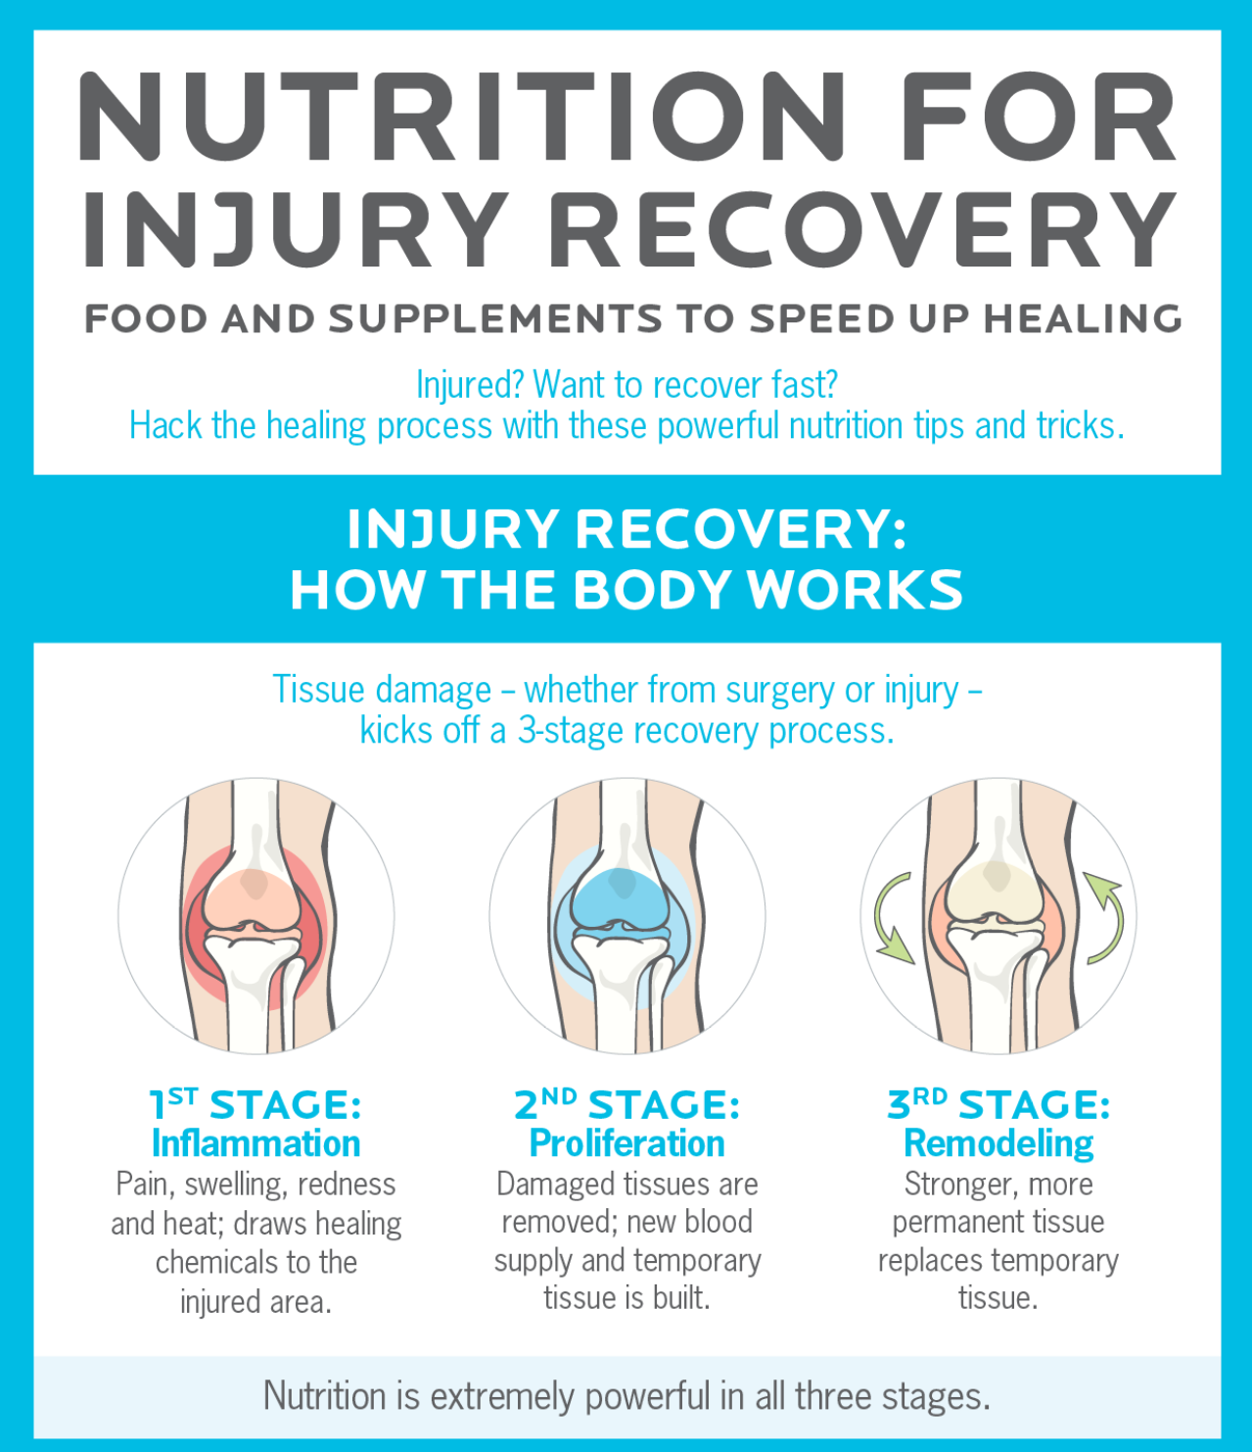

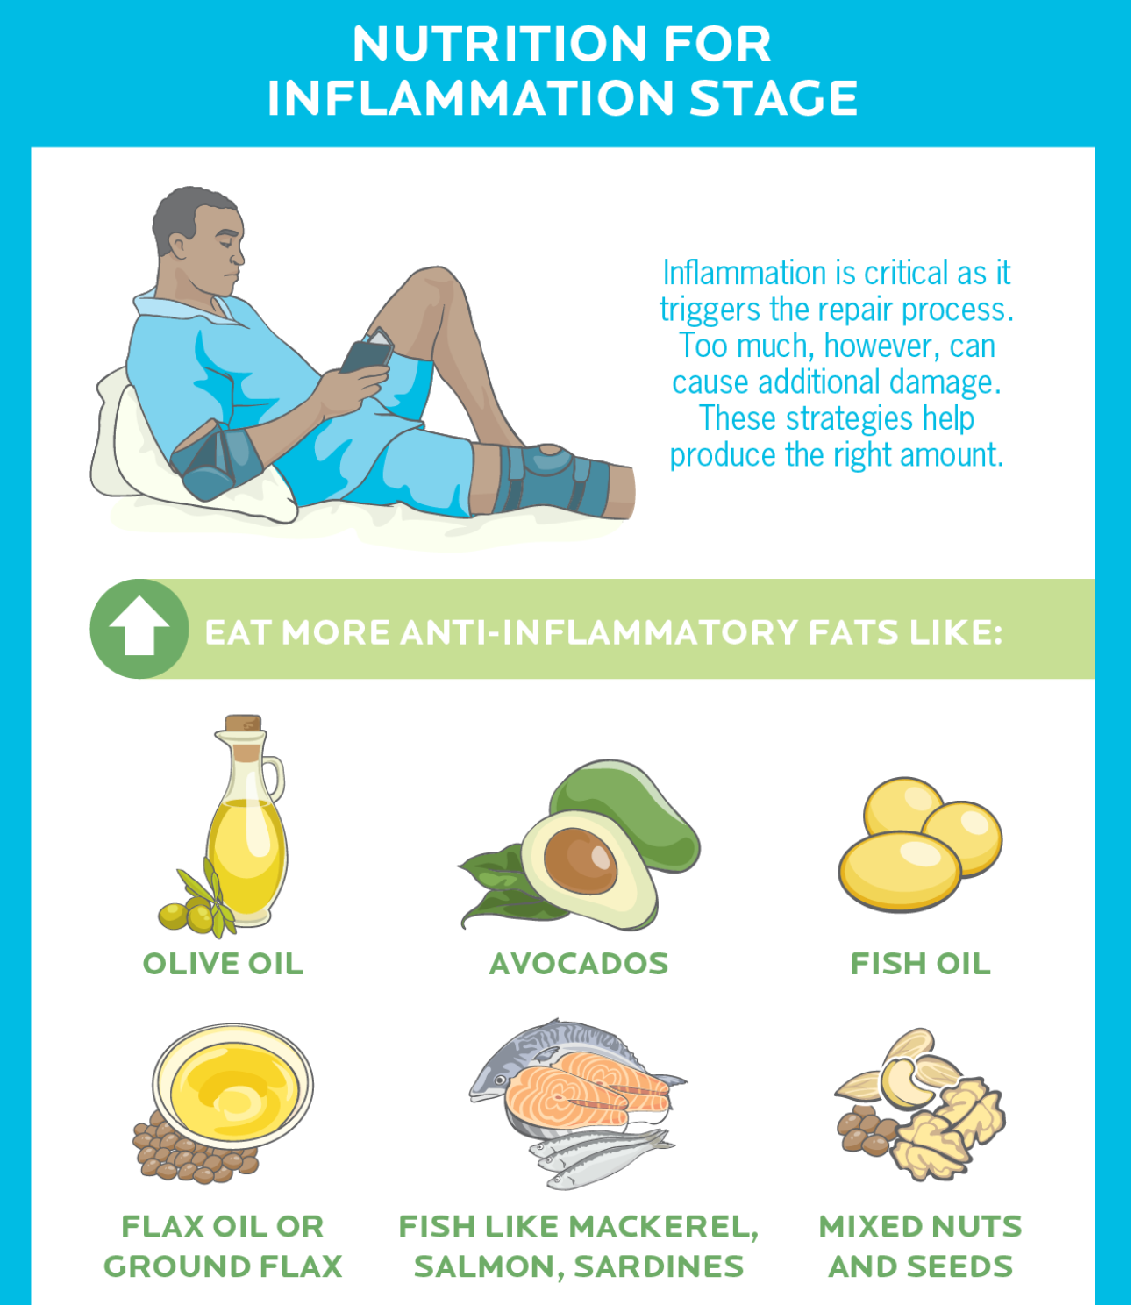

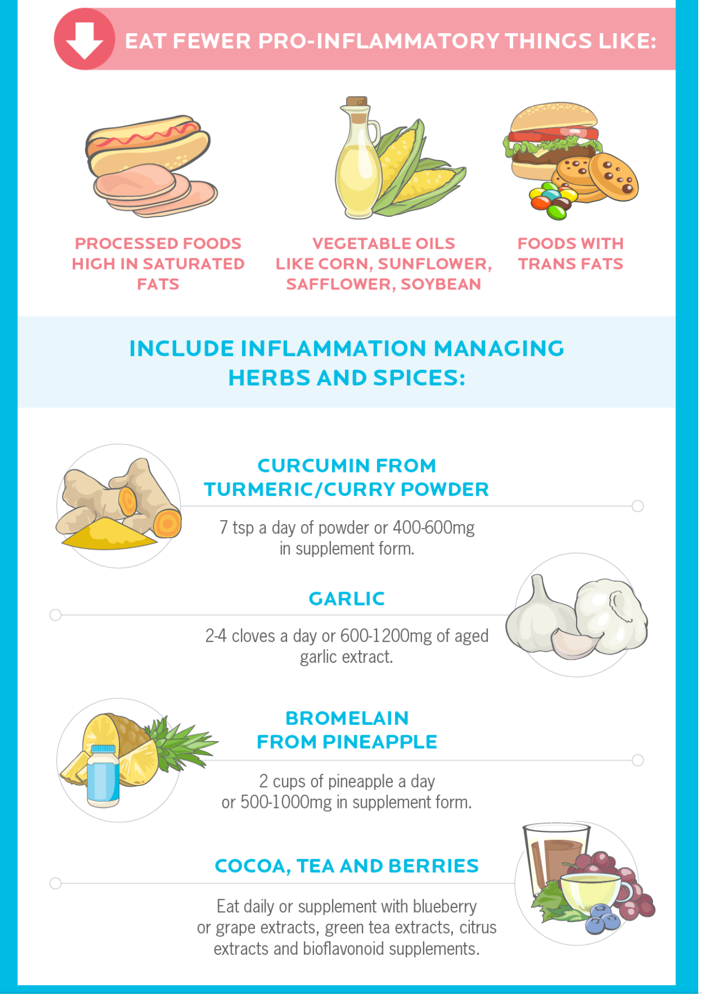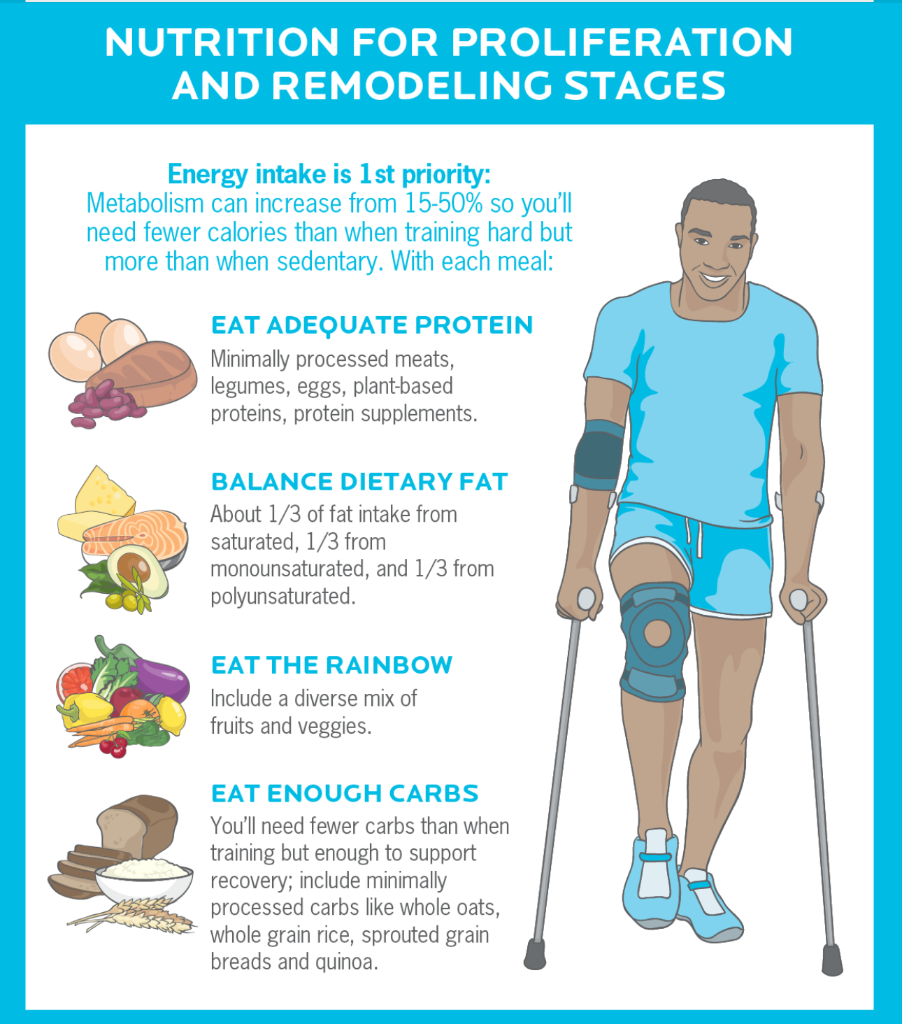

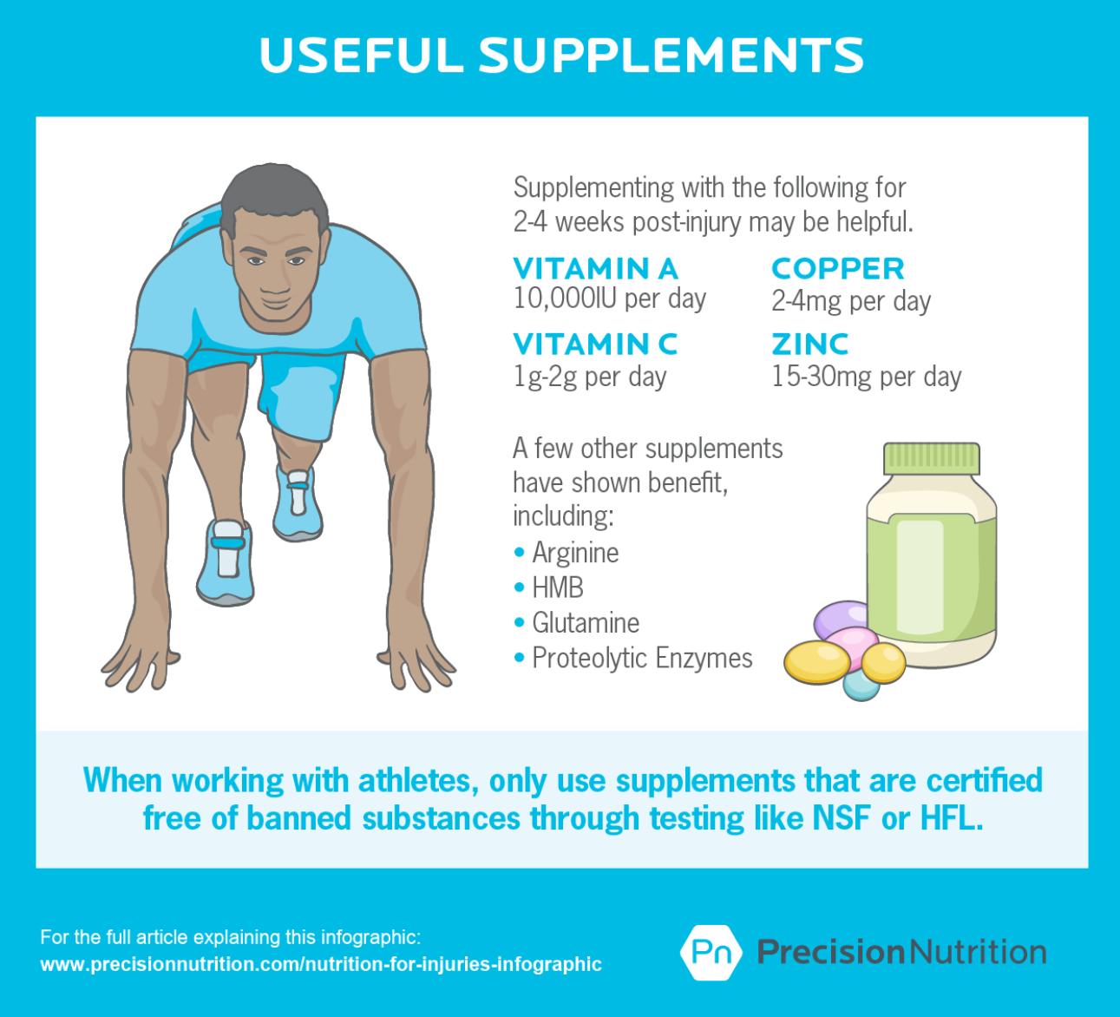

Common Joint Issues; Recommended Exercises & Stretches

Hip and Lumbo-Pelvic Complex:

Common Issues

- General Tightness of Hip Flexors & Piriformis

- Hip Bursitis

- Lumbar disc bulges and herniations

- sportsmans hernias

- Chronic hip flexor, groin, and QL/lumbar extensor strains

- Chronic and frequent spasms

- piriformis syndrome

- gluteal amnesia

- Lower cross syndrome

- Lack of abdominal control, ability to brace core, or perform supine pelvic tilt

Hip and Lumbo-Pelvic Complex

STRETCHING & ROLLING

- 5-7 inch ball roller on hip flexors and piriformis/ glutes & hamstrings

- rolling quads and IT bands

- Gently rolling lower and middle back

- World’s Greatest Stretch

- Hip flexor and hamstring stretches

- lateral lunge adductor stretch

- Piriformis stretches

MOBILITIES AND STRENGTHENING

- Quadruped Series – Cat and camel – bird dogs- knee circles- donkey kicks- fire hydrants

- Supine pelvic tilts

- glute bridges 2 legged - > 1 legged

- front and side planks

- Single leg balance exercises with hip/core stabilization as focus

- paloff press/ anti-rotations

- rotational oblique exercises

- multi-planar squat and lunge variations

- RDL’s 2 legged and 1 legged

Foot and Ankle:

Common Issues:

- Various calf strains/tears

- Achilles tendonitis

- Shin splints

- Plantar fasciitis

- Posterior tibialis tendonitis

- Neuropathies

- Plantar warts

- Various stress fractures

- Sprains, strains and tears via inversion due to general tightness, weakness, imbalances, and poor hydration

- Compartment syndrome

- Gastroc, soleus, anterior tib, and peroneal stretching/ smr

- Toe walks w/ dorsi-flexion (linear & lateral)

- Heel walks

- Full dorsi-flexed full Rom calf raise with ball between heels

- ABC's w/ big toe

- wall sit dorsi-flexion

- barefoot towel pulls w/big toe

- barefoot marble pickups

- SL balance progressions

- jump roping (only for asymptomatic)

- various plyometric and "good form running technique training

Knee:

Common issues:

- Patellar tendonitis

- Quad tendonitis

- Osgood schlatters (usually pubescent populations

- MCL, ACL, PCL tears (MCL & ACL more common in female populations due to wider hip angle

- Mensicus wear & tear or full tearing

- bakers cysts

- IT band syndrome

- Various strains sprains, & tears due to common tightness, weakness, imbalances, and poor hydration

- Quad dominance

Strengthening & Pre/Rehabilitative Exercises & Stretches;

STRETCHING/ROLLING

- quad stretches (not with severe Osgood schlatters only massage and foam rolling recommended)

- hip flexor & external rotator/piriformis stretches (world's greatest stretch)

- hamstring and groin/adductor stretches

- SMR & massage of all areas listed above

MOBILITIES & STRENGTHENING

- Pelvic bracing and core engagement

- lateral band walks

- quadruped series

- glute bridging (bent & straight knee)

- AB & AD - Ductor exercises (lateral or medial dominant dependent)

- heel drags

- hamstring curls

- RDL's 2&1 legged

- controlled knee extensions

- squat & lunge progressions (asymptomatic)

- "good form running" progressions and training

- plyomteric, agility, and COD work

Thoracic Region/ Shoulder complex/ Elbow and Wrist/ Cervical Region:

Common Issues:

- Reversed cervical curve

- forward head (cell phone/computer neck)

- rounded shoulders (kyphosis of the thoracic spine and internal rotation of shoulders)

- upper cross syndrome (over active traps, pectorals and lats)

- winged scapulas

- Brachial Plexus syndrome or neuropathy

- cubital tunnel syndrome

- carpal tunnel syndrome

- Chronic tightness of chest, lats, traps, rhomboids, posterior delts, shoulder capsules, biceps, triceps, wrist flexors and extensors

- Arthritic shoulder, elbows, wrists and fingers

Stretching and Rolling:

- percussion based self massagers can be very helpful for areas that are difficult to reach with a standard foam rolling device

- rolling upper back and lats on long roller or ball roller depending on density of the roller and pain response

- Dowel rollers or small 2-3 inch diameters balls are effective for rolling biceps, and wrist extensors

- stretching chest, lats, traps, rhomboids, posterior delts, shoulder capsules, biceps, triceps, wrist flexors and extensors

- 4-way neck and trap stretches also add shoulder internal rotation

Strengthening and Mobilization

- scapular protraction and retraction

- quadruped cat and cow for thoracic flexion, thoracic extension, and scapular protraction and retraction

- shoulder scaption series – scaption – external rotation – T-fly – band pull aparts Y-T-A band series

- Rowing 2 arm and 1 arm variations multi-angular

- scapular push-ups for serratus anterior engagement

- push-up position stabilization variations and push-up variations with minimal scapular movement

- chin-up variations

- resisted wrist flexion and extension/ grip training

Beginner Program Schedule: Example

Monday: 30-45 min of resistance training full body circuits

Tuesday: cardio 30-45 minutes interval cardio

Wednesday: 30-45 min of resistance training full body circuits

Thursday: rest/active recovery (warm-up and stretch/roll comprehensively)

Light cardio

Friday: cardio 30-45 min interval cardio

Saturday: resistance training full body circuits

Sunday: active recovery

Intermediate Program Schedule Example

Monday:  60 min of resistance training full body circuits

Tuesday: cardio 30-45 minutes interval cardio

Wednesday: 60 min of resistance training full body circuits

Thursday: rest/active recovery (warm-up and stretch/roll comprehensively)

Light cardio

Friday: cardio 60 min resistance training full body circuits

Saturday: interval cardio 30-45 mins.

Sunday: active recovery

Advanced Program Schedule Example

Monday:  60 min of resistance circuits posterior chain (pulling exercises)

Tuesday: 60 minutes resistance circuits (pushing anterior chain)

Wednesday: 30 minutes light cardio/active recovery & comprehensive stretching/rolling

Thursday:  60 min of resistance circuits posterior chain (pulling exercises)

Friday: cardio 60 min resistance circuits (pushing exercises)

Saturday: interval cardio 60 mins.

Sunday: active recovery stretching/rolling

Elite Program Schedule Example

Monday:  AM or PM 60 min of resistance circuits posterior chain (pulling exercises)

30 minutes interval cardio AM or PM

Tuesday: 60 minutes resistance circuits (pushing anterior chain)

Wednesday: 30 HIIT  (HIGH INTENSITY INTERVAL TRAINING) functional bodyweight calisthenics/core training

Thursday: AM or PM  60 min of resistance circuits posterior chain (pulling exercises)

30 minutes interval cardio  AM or PM

Friday: cardio 60 min resistance circuits (pushing exercises)

Saturday: interval cardio 60 mins.

Sunday: active recovery stretching/rolling

Black Ops Elite Program Schedule Example

Monday:  AM or PM 60 min of resistance circuits posterior chain (pulling exercises)

30-60 minutes interval cardio AM or PM

Tuesday: AM or PM 60 minutes resistance circuits (pushing anterior chain)

30 minutes cardio AM or PM

Wednesday: 45 HIIT  (HIGH INTENSITY INTERVAL TRAINING) functional bodyweight calisthenics/core training

Thursday: AM or PM  60 min of resistance circuits posterior chain (pulling exercises)

60 minutes interval cardio  AM or PM

Friday: cardio 60 min resistance circuits (pushing exercises)

30 minutes cardio AM or PM

Saturday:  45 HIIT  (HIGH INTENSITY INTERVAL TRAINING) functional bodyweight calisthenics/core training

Sunday: light cardio 30 min/active recovery stretching/rolling

**Below is an example of a program specifically designed for pull-up development. Following the rest periods and tempo notations is essential to proper execution of the program. This highlights the need for calculated progression, understanding the process of loading and progressing a relatively untrained individual, and applying training phase principles to allow for optimal growth.**

**Phase 1: Weeks 1-4, Accumulation 1**

A1. Chin-Up, Neutral Grip

Week 1: 4 x 1, 20-0-1-1, rest 60 seconds

Week 2: 4 x 1, 20-0-1-1, rest 60 seconds

Week 3: 4 x 1, 20-0-1-1, rest 60 seconds

Week 4: 4 x 1, 20-0-1-1, rest 60 seconds

*Note:* Use a parallel grip with the hands shoulder-width apart

A2. Bench Press, Thick DB, Neutral Grip

Week 1: 4 x 4-6, 5110, rest 60 seconds

Week 2: 4 x 4-6, 5110, rest 60 seconds

Week 3: 2 x 4-6, 5110, rest 60 seconds

Week 4: 4 x 4-6, 5110, rest 60 seconds

B1. Semi-Stiff-Arm Pulldown

Week 1: 4 x 15-17, 4020, rest 60 seconds

Week 2: 4 x 15-17, 4020, rest 60 seconds

Week 3: 2 x 15-17, 4020, rest 60 seconds

Week 4: 4 x 15-17, 4020, rest 60 seconds

B2. Flye, 30-Degree Incline, Thick DB, Unrolling Grip

Week 1: 4 x 12-15, 3120, rest 60 seconds

Week 2: 4 x 12-15, 3120, rest 60 seconds

Week 3: 2 x 12-15, 3120, rest 60 seconds

Week 4: 4 x 12-15, 3120, rest 60 seconds

*Note:*At the bottom, the elbows should be in line with the ears.

C. Sideways External Rotation, Low Pulley, Thick Handle

Week 1: 3 x 12-15, 3010, rest 60 seconds

Week 2: 3 x 12-15, 3010, rest 60 seconds

Week 3: 2 x 12-15, 3010, rest 60 seconds

Week 4: 3 x 12-15, 3010, rest 60 seconds

D1. Scott Curl, Seated, 45-Degree, Thick DB, Neutral Grip

Week 1: 3 x 12-15, 4010, rest 60 seconds

Week 2: 3 x 12-15, 4010, rest 60 seconds

Week 3: 2 x 12-15, 4010, rest 60 seconds

Week 4: 3 x 12-15, 4010, rest 60 seconds

D2. Triceps Extension, 15-Degree Decline, Thick DB, Neutral Grip

Week 1: 3 x 12-15, 4010, rest 60 seconds

Week 2: 3 x 12-15, 4010, rest 60 seconds

Week 3: 2 x 12-15, 4010, rest 60 seconds

Week 4: 3 x 12-15, 4010, rest 60 seconds

*Note:* Dumbbells must touch the shoulders.

**Phase 2: Weeks 5-8, Intensification 1**

A1. Pull-Up, Thick Bar, Pronated Grip

Week 1: 5 x 2-4, 6010, rest 90 seconds

Week 2: 5 x 2-4, 6010, rest 90 seconds

Week 3: 3 x 2-4, 6010, rest 90 seconds

Week 4: 5 x 2-4, 6010, rest 90 seconds

*Note:* Hands are shoulder-width apart and pronated. Extend the arms fully at the bottom position.

A2. Bench Press, 30-Degree Incline, Thick Multi-Grip Bar, Mid Grip

Week 1: 5 x 5-7, 5010, rest 90 seconds

Week 2: 5 x 5-7, 5010, rest 90 seconds

Week 3: 3 x 5-7, 5010, rest 90 seconds

Week 4: 5 x 5-7, 5010, rest 90 seconds

B1. Rowing, Bent-Over, Kneeling, Thick DB, Scott Bench, Unilateral, Neutral Grip

Week 1: 5 x 6-8, 3011, rest 90 seconds

Week 2: 5 x 6-8, 3011, rest 90 seconds

Week 3: 3 x 6-8, 3011, rest 90 seconds

Week 4: 5 x 6-8, 3011, rest 90 seconds

*Note:* Bring dumbbell forward before pulling it to the hip.

B2. Flye, Supine, Thick DB

Week 1: 5 x 7-9, 4020, rest 90 seconds

Week 2: 5 x 7-9, 4020, rest 90 seconds

Week 3: 3 x 7-9, 4020, rest 90 seconds

Week 4: 5 x 7-9, 4020, rest 90 seconds

*Note:* At the bottom the elbows are in line with the ears.

phase 2 Cont..

C1. Incline Curl, 45-Degree, Dual Pulley, D-Handle, Supinated Grip (1 ¼ top) Week 1: 4 x 6-8, 4010, rest 60 seconds

Week 2: 4 x 6-8, 4010, rest 60 seconds

Week 3: 2 x 6-8, 4010, rest 60 seconds

Week 4: 4 x 6-8, 4010, rest 60 seconds

*Note:* Pulleys are behind the bench, one handle per hand. Keep upper arms as perpendicular to the floor as possible.

C2. Triceps Extension, Supine, EZ Bar, Mid Pronated Grip to Forehead

Week 1: 4 x 6-8, 4010, rest 60 seconds

Week 2: 4 x 6-8, 4010, rest 60 seconds

Week 3: 2 x 6-8, 4010, rest 60 seconds

Week 4: 4 x 6-8, 4010, rest 60 seconds

*Note:* Bring bar to the forehead.

**Phase 3: Weeks 9-12, Accumulation 2**

A1. Chin-Up, Supinated Narrow Grip

Week 1: 4 x 6-8, 3011, rest 75 seconds

Week 2: 4 x 6-8, 3011, rest 75 seconds

Week 3: 2 x 6-8, 3011, rest 75 seconds

Week 4: 4 x 6-8, 3011, rest 75 seconds

*Note:*Hands should be 10-15 cm (4-6 inches) apart and supinated.

A2. Bench Press 15-Degree, Thick Bar, Mid Grip

Week 1: 4 x 7-9, 4210, rest 75 seconds

Week 2: 4 x 7-9, 4210, rest 75 seconds

Week 3: 2 x 7-9, 4210, rest 75 seconds

Week 4: 4 x 7-9, 4210, rest 75 seconds

*Note:* Bring the bar to a point slightly lower than the nipple line.

B1. Rowing, Seated, Pronated Wide Grip

Week 1: 4 x 10-12, 3011, rest 75 seconds

Week 2: 4 x 10-12, 3011, rest 75 seconds

Week 3: 2 x 10-12, 3011, rest 75 seconds

Week 4: 4 x 10-12, 3011, rest 75 seconds

*Note:*Bring handle to waist. Hands should be outside the shoulders.

B2. Flye, 30-Degree, Rope, Pronated Grip

Week 1: 4 x 10-12, 3020, rest 75 seconds

Week 2: 4 x 10-12, 3020, rest 75 seconds

Week 3: 2 x 10-12, 3020, rest 75 seconds

Week 4: 4 x 10-12, 3020, rest 75 seconds

*Note:* At the bottom the elbows should be in line with the ears.

C1. Standing Curl, Pulley, Neutral Close Grip

Week 1: 3 x 8/8/8, 3010, rest 60 seconds

Week 2: 3 x 8/8/8, 3010, rest 60 seconds

Week 3: 2 x 8/8/8, 3010, rest 60 seconds

Week 4: 3 x 8/8/8, 3010, rest 60 seconds

*Note:*Palms are facing each other and closer than shoulder-width apart.

C2. Pressdown, Standing, V-Handle, Neutral Grip

Week 1: 3 x 8/8/8, 3010, rest 60 seconds

Week 2: 3 x 8/8/8, 3010, rest 60 seconds

Week 3: 2 x 8/8/8, 3010, rest 60 seconds

Week 4: 3 x 8/8/8, 3010, rest 60 seconds

*Note:* Hinge at the elbow. Forearms must cover as much of the biceps as possible.

**Phase 4: Week 13-16, Intensification 2**

A1. Pull-Up, Subscapularis, Wide Grip Week 1: 7,5,3,7,5,3, 3010, rest 100 seconds

Week 2: 7,5,3,7,5,3, 3010, rest 100 seconds

Week 3: 7,5,3,3, 3010, rest 100 seconds

Week 4: 7,5,3,7,5,3, 3010, rest 100 seconds

*Note:* Hands are outside your shoulders and pronated. Push yourself away from the bar upon lowering.

A2. Chest Dips, V-Bar

Week 1: 7,5,3,7,5,3, 3110, rest 100 seconds

Week 2: 7,5,3,7,5,3, 3110, rest 100 seconds

Week 3: 7,5,3,3, 3110, rest 100 seconds

Week 4: 7,5,3,7,5,3, 3110, rest 100 seconds

*Note:* Lean forward slightly. Elbows flare out. Grip is one palms-width outside shoulder distance.

B1. Rowing, Bent-Over, Kneeling, Thick DB, Unilateral Arc, Neutral Grip Week 1: 4 x 4-6, 3012, rest 90 seconds

Week 2: 4 x 4-6, 3012, rest 90 seconds

Week 3: 2 x 4-6, 3012, rest 90 seconds

Week 4: 4 x 4-6, 3012, rest 90 seconds

*Note:* Bring dumbbell to the hip.

B2. Bench Press, Supine, Thick DB, Full Stretch Grip

Week 1: 4 x 5-7, 4020, rest 90 seconds

Week 2: 4 x 5-7, 4020, rest 90 seconds

Week 3: 2 x 5-7, 4020, rest 90 seconds

Week 4: 4 x 5-7, 4020, rest 90 seconds

*Note*: Supinate your hands 15 degrees at the bottom position for maximal stretch of pecs.

C1. Standing Curls, Thick BB, Wide and Supinated Grip

Week 1: 4 x 6-8, 3010, rest 75 seconds

Week 2: 4 x 6-8, 3010, rest 75 seconds

Week 3: 2 x 6-8, 3010, rest 75 seconds

Week 4: 4 x 6-8, 3010, rest 75 seconds

*Note:*Keep wrists cocked back and hands shoulder-width apart.

C2. Incline Bench Press 30 degrees, BB, Close Grip from Pins

Week 1: 4 x 6-8, 3010, rest 75 seconds

Week 2: 4 x 6-8, 3010, rest 75 seconds

Week 3: 2 x 6-8, 3010, rest 75 seconds

Week 4: 4 x 6-8, 3010, rest 75 seconds