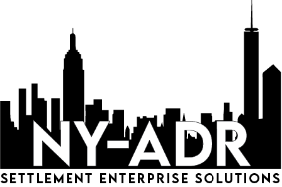

Settlement Enterprise Solutions

16 Court Street, Suite 2506,

Brooklyn, New York 11241

Phone: (646) 475-3500

[www.NY-ADR.com](http://www.NY-ADR.com)

Neutral Questionnaire

Name: Click or tap here to enter text.

Address: Click or tap here to enter text.

Telephone: Click or tap here to enter text.

Cell Phone: Click or tap here to enter text.

Employer: Click or tap here to enter text.

Business Address: Click or tap here to enter text.

Business Phone: Click or tap here to enter text.

Practice Area(s): Click or tap here to enter text.

Professional Association(s): Click or tap here to enter text.