MONDAY | TUESDAY | WEDNESDAY | THURSDAY | FRIDAY
 | 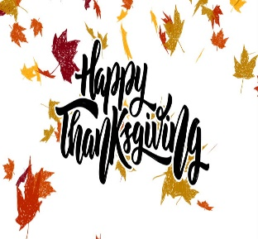 | 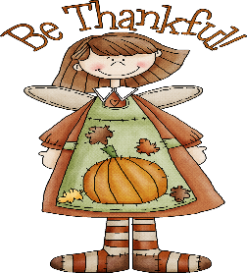  This Photo by Unknown Author is licensed under CC BY-SA-NC | 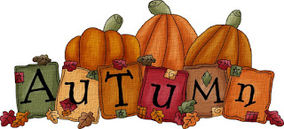
3  WG TANGERINE CHIX  WG EGG ROLL  BROCCOLI  CELERY STICKS & DIP  APPLE WEDGES  MILK  6 OZ APPLE JUICE  ALT: PIZZABOLI | 4  BBQ PULLED PORK  ON A WG ROLL  SIDEWINDER FRIES  BAKED BEANS  MANDARIN ORANGES  MILK  6 OZ FT PUNCH JUICE  ALT: WALKING TACO  (CHICKEN) | 5  TURKEY BACON HOAGIE  ON A WG ROLL  LETTUCE & TOMATO  PICKLES  CHIPS  MIXED FRUIT  MILK  6 OZ GRAPE JUICE  ALT: RAVIOLI/DINNER ROLL | 6  WG FEISTA PIZZA  TOSTITOS & SALSA  GREEN BEANS  RST CHICKPEAS  ICEE SIDEKICK  MILK  6 OZ FT PUNCH JUICE  ALT: CHEESEBURGER/  ROLL  9-12: DELI HOAGIE | 7  WG BAKED PIEROGIES  MEATBALLS & SAUCE (6)  SWEET CORN  ASST: RAW VEGGIES  ASST: FRUIT CUP  MILK  ASST: 6 OZ FRUIT JUICE  ALT: BBQ GRILLED CHIX  PATTY/ROLL
10  CHICKEN TACO  ON WG WRAP  LETTUCE & TOMATO  MEXACALI CORN  APPLE WEDGES  MILK  6 OZ APPLE JUICE  ALT: PIZZA | 11  CHEESEBURGER  ON A WG ROLL  TRI TATER STICKS  RST CHICKPEAS (HOT)  DICED PEARS  MILK  6 OZ FT PUNCH JUICE  ALT: WALKING TACO  (BEEF) | 12  SLOPPY JOE  ON A WG ROLL  OVEN FRIES  BAG CARROTS & DIP  MIXED FRUIT  MILK  6 OZ GRAPE JUICE  ALT: TACO CRISP UPS | 13  WG PASTA & MEAT SAUCE  WG GARLIC BREAD  BROCCOLI  RED BEETS  DICED PEACHES  MILK  6 OZ FT PUNCH JUICE  ALT: HOT DOG/ROLL  9-12: DELI HOAGIE | 14  WG PIZZA CRUNCHERS  MIXED VEGGIES  ASST: RAW VEGGIES  ASST: FRUIT CUP  MILK  ASST: 6 OZ FRUIT JUICE  ALT: RANCH GRILLED CHIX PATTY/ROLL
17  WG BONELESS CHIX WINGS  WG SEASON NOODLES  SWEET PEAS  BAG CARROTS & DIP  APPLE WEDGES  MILK  6 OZ APPLE JUICE  ALT: STROMBOLI W/  MARINARA SAUCE | 18  MEATBALLS W/ SAUCE  WG DINNER ROLL  SWEET POTATO FRIES  RST CHICKPEAS (RANCH)  DICED PEARS  MILK  6 OZ FT PUNCH JUICE  ALT: WALKING TACO  (CHICKEN) | 19  ITALIAN HOAGIE  ON A WG ROLL  GREEN BEANS  PICKLE  CHIP  MIXED FRUIT  MILK  6 OZ GRAPE JUICE  ALT: RAVIOLI/DINNER ROLL | 20  OPEN FACE TURKEY  SANDWICH W/ GRAVY  ON WG SLICE BREAD  MASHED POTATOES  SWEET CORN  ICEE SIDEKICK  MILK  6 OZ FT PUNCH JUICE  ALT: SLOPPY JOE/ROLL  9-12: DELI HOAGIE | 21  WG MINI CALZONES  BROCCOLI  ASST: RAW VEGGIES  ASST: FRUIT CUP  MILK  ASST: 6 OZ FRUIT JUICE  ALT: BUFFALO GRILLED CHIX PATTY/ROLL
24  WG CHICKEN NUGGETS  TRI TATERS (2)  GRAHAM ITEM  RST CHICKPEAS  APPLE WEDGES  MILK  6 OZ APPLE JUICE  ALT: PIZZA | 25  MINI CORN DOGS  BAKED BEANS  BAG CARROTS & DIP  DICED PEARS  MILK  6 OZ FT PUNCH JUICE  ALT: WALKING TACO  (BEEF) | 26  WG STROMBOLI  MARINARA SAUCE  BROCCOLI  MIXED FRUIT  MILK  6 OZ GRAPE JUICE  ALT: TACO CRISP UPS | 27  NO  SCHOOL  HAPPY  THANKSGIVING | 28  NO  SCHOOL
SHENANDOAH VALLEY SCHOOL DISTRICT
LUNCH MENU GRADES 7 THUR 12

NOVEMBER 2025
What makes a meal? You must choose at least 3 to 5 components available for school lunch. Choice of Meat or meat alternate, whole grains, vegetable, fruit, and milk. Students must choose at least one fruit or vegetable. SALADS & FRESH FRUIT AVAILABLE DAILY
LUNCH IS FREE TO ALL STUDENTS. MENU IS SUBJECT TO CHANGE WITHOUT NOTICE

