MONDAY | TUESDAY | WEDNESDAY | THURSDAY | FRIDAY
 | 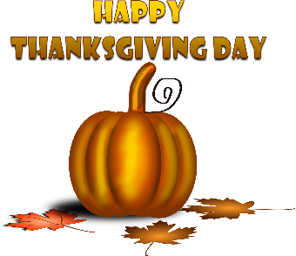 | 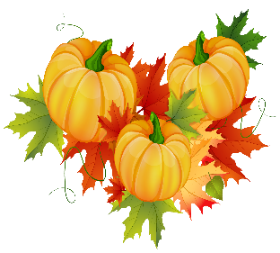  This Photo by Unknown Author is licensed under CC BY-NC | 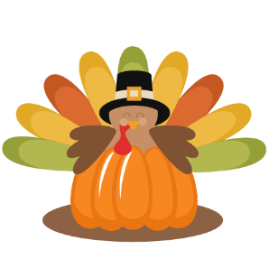  This Photo by Unknown Author is licensed under CC BY-NC
3  WG FUNNEL CAKE  4 OZ APPLE JUICE  APPLE WEDGES  MILK | 4  WG BREAKFAST SAND.  4 OZ FT PUNCH JUICE  DICED PEARS  MILK | 5  WG GRAPE CRESCENT  4 OZ GRAPE JUICE  MIXED FRUIT  MILK | 6  WG BREAKFAST BREAK  (INCLUDES CEREAL, JUICE, & GRAHAM ITEM)  ORANGE SMLIES  MILK | 7  WG CHERRY FRUDEL  4 OZ APPLE JUICE  DICED PEARS  MILK
10  WG COCOA PUFF  2 OZ CEREAL BAR  4 OZ APPLE JUICE  APPLE WEDGES  MILK | 11  WG CINN RAISIN BAGEL  CREAM CHEESE PACKET  4 OZ FT PUNCH JUICE  DICED PEARS  MILK  VETERANS DAY | 12  WG FRENCH TST STICKS  SYRUP PACKET  4 OZ GRAPE JUICE  MIXED FRUIT  MILK | 13  WG BREAKFAST BAR  4 OZ FT PUNCH JUICE  DICED PEACHES  MILK | 14  WG CINN TST CRUNCH MUFFIN  4 OZ APPLE JUICE  BERRY APPLESAUCE  MILK
17  WG TRIX  2 OZ CEREAL BOWL  4 OZ APPLE JUICE  APPLE WEDGES  MILK | 18  WG BREAKFAST PIZZA  4 OZ FT PUNCH JUICE  DICED PEARS  MILK | 19  WG MINI CHOC GLAZED  DONUT HOLES  4 OZ GRAPE JUICE  MIXED FRUIT  MILK | 20  WG MINI CINNI  4 OZ FT PUNCH JUICE  DICED PEACHES  MILK | 21  WG MINI BLUEBERRY BASH WAFFLES  4 OZ APPLE JUICE  MANDARIN ORANGES  MILK
24  WG POPTARTS (2)  4 OZ APPLE JUICE  APPLE WEDGES  MILK | 25  WG APPLE FRUDEL  4 OZ FT PUNCH JUICE  DICED PEARS  MILK | 26  WG CINNAMON ROLL  4 OZ GRAPE JUICE  MIXED FRUIT  MILK | 27  NO  SCHOOL  HAPPY  THANKSGIVING | 28  NO  SCHOOL
SHENANDOAH VALLEY SCHOOL DISTRICT
BREAKFAST MENU PRE-K THRU 12

NOVEMBER 2025
What makes a meal? You must choose at least 3 to 4 components available for school breakfast. Choice of Meat or meat alternate, whole grains, vegetable, fruit, and milk. Students must choose at least one fruit or vegetable.
BREAKFAST IS FREE TO ALL STUDENTS. MENU IS SUBJECT TO CHANGE WITHOUT NOTICE

