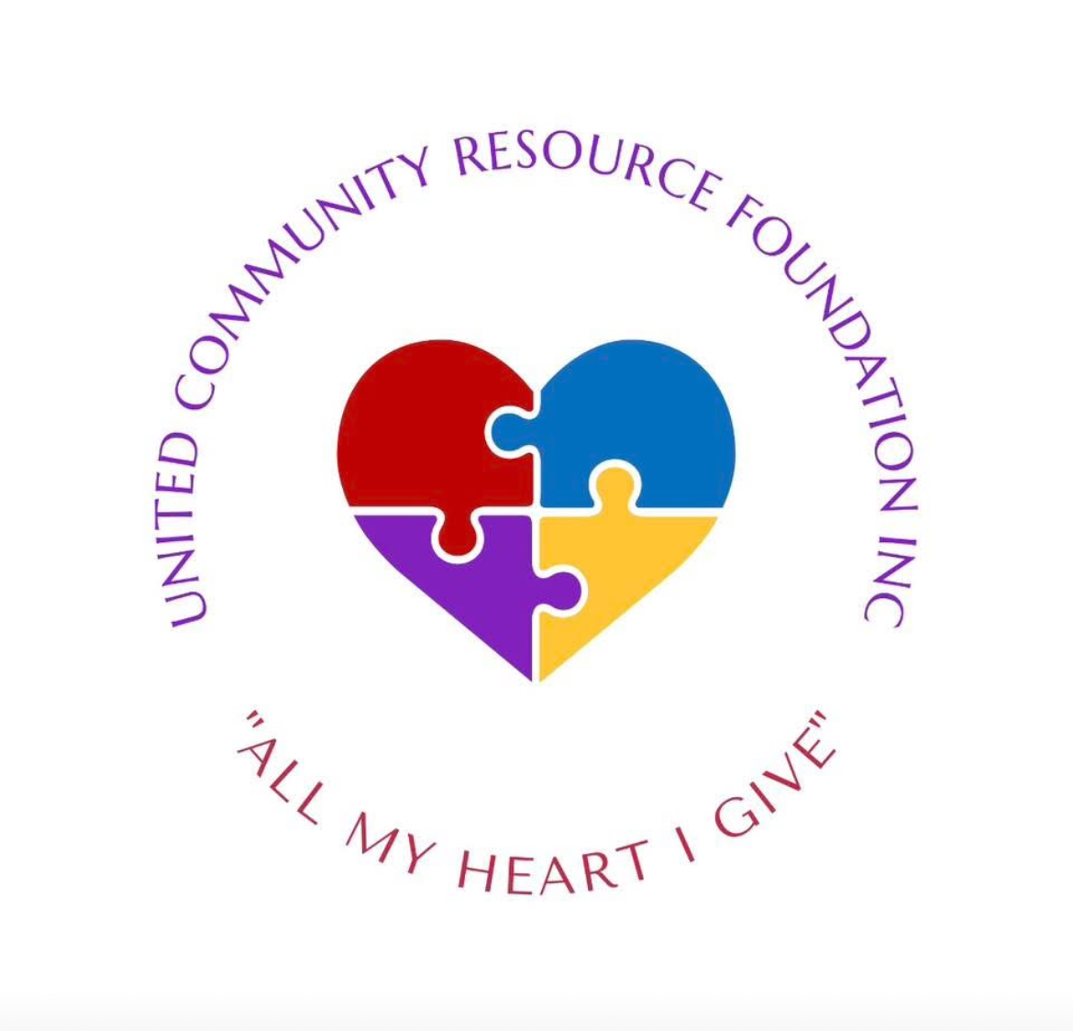

**UNITED COMMUNITY RESOURCE FOUNDATION INC  
“All My Heart I Give”**

**Contact Information:**📞 Stacy Harris | (270) 401-3064 | ✉️ stacy@noir-realty.com  
📞 Aubrey Milner | (502) 340-0679 | ✉️ ucrfinc@gmail.com  
🌐 Website: www.unitedcommunityresourcefoundation.org  
📘 Facebook: www.facebook.com/st.harris.9

# About Us

United Community Resource Foundation is a non-profit organization based in Louisville, Kentucky, committed to improving the lives of underserved communities in the United States through sustainable solutions and collaborative partnerships.  
  
Founded in 2024, United Community Resource Foundation began with a vision to be a beacon of hope for individuals and families facing adversity—empowering them to thrive and succeed.  
  
We have served countless individuals and families in underserved communities, providing them with resources, assistance, and support to overcome challenges and build a better future.

# Our Mission Statement

The United Community Resource Foundation Inc is dedicated to fostering inclusive and empowered communities, striving for social justice and equality. Through collaboration and resource mobilization, we work toward the holistic development of individuals by promoting education, health, and economic empowerment. Our ultimate goal is to provide access to safe and affordable housing for all, ensuring a strong foundation for vibrant and sustainable communities.

# Our Vision Statement

We envision a world where every individual has equal opportunities and access to thriving communities. We see inclusive, socially just, and sustainable neighborhoods where education, health, and economic empowerment are fundamental rights. Our goal is a future where safe and affordable housing is universally available, providing a foundation for individuals and families to grow, flourish, and contribute meaningfully to society.

# A Call to Local Businesses

We’re reaching out for sponsorship support—whether through cash donations, new or discounted food, or even items close to expiration that can help fight hunger and reduce waste.  
  
You can help in many ways, including:  
- Allowing us to place a donation box at your location  
- Asking for spare change or checkout donations  
- Hosting us for a booth to engage your community  
- Donating food or goods for distribution  
  
Every donation is tax-deductible and we will provide a receipt from our registered 501(c)(3) nonprofit. In return, we offer marketing opportunities to highlight your business’s commitment to social good.  
  
Together, we can fight hunger, homelessness, and so much more.  
Thank you for your time and heart. Let’s build stronger communities—one step at a time.