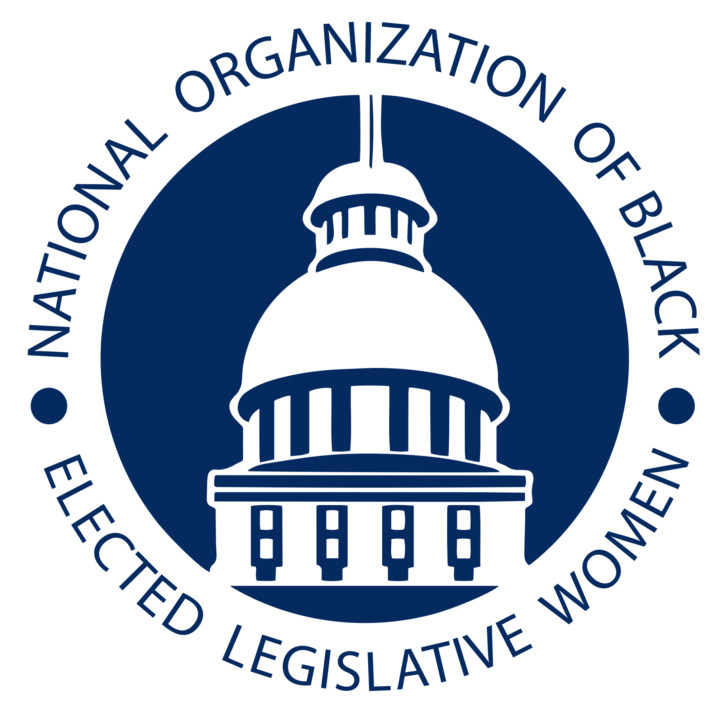
Jointly Addressing Health Disparities in Response to COVID-19
and Other Potential Pandemics

Committee: Health Resolution: HEA-21-01
- WHEREAS, African Americans, Hispanic Americans and other people of color have
- been disproportionately affected by the COVID-19 pandemic; and,
- WHEREAS, a growing amount of data suggests that this is due to the well-known \
- social determinants of health disproportionately affecting people of color in the United
- States, the socioeconomic disadvantages, like wage disparities, racial disparities in
- housing and decreased access to healthcare, including as a consequence of bias, that have
- long affected their health outcomes; and,
- WHEREAS, for example, African Americans have been more likely to be exposed to
- COVID-19 because they are proportionally more likely to be, or to live with someone
- considered to be, part of the essential workforce unable to work from home; and,
- WHEREAS, African Americans disproportionately lack access to paid sick leave despite
- their risk of exposure to COVID-19 in frontline jobs, this includes many essential
- workers like food-delivery workers; and,
- WHEREAS, people of color are more likely to live in densely populated areas and in
- crowded living conditions including multigenerational housing situations, all of which
- create a higher risk for the spread of highly contagious diseases like COVID-19; and,
- WHEREAS, many urban African American and Latino families double- and triple-up in
- homes when rent is unaffordable, thus making distancing in the home impossible; and,
- WHEREAS, that includes caregivers, cashiers, sanitation workers, farm workers and
- public transit employees; and,
- WHEREAS, poor housing availability and violations of residential codes for asbestos,
- mold and cockroaches increase the risk and prevalence of chronic respiratory and
- pulmonary diseases.; and,
- WHEREAS, economic inequality also impacts access to healthy foods, leading to other
- chronic conditions such as cardiovascular disease, obesity and diabetes; and,
- WHEREAS, known as comorbidities, many of those chronic diseases predispose to more
- serious complications from COVID-19, a situation that is likely to recur in future
- pandemics; and,
- WHEREAS, for example, the Centers for Disease Control released information that
- people with asthma may be at greater risk of dying from COVID-19; and,
- WHEREAS, according to the Asthma and Allergy Foundation of America, compared to \
- non-Hispanic whites, African Americans with asthma are nearly five times as likely to
- visit the emergency department, an indication of poor asthma control that is likely \
- affected by less access to healthcare; and,\
- WHEREAS, despite bearing the brunt of the front-line work, African Americans still lost
- jobs and income as as result of COVID-19 at a higher rate than other groups, with 44%
- African Americans (and 61% Hispanics) reporting they or someone in their household
- experienced a job or wage loss in the initial weeks of the pandemic, compared to 38% of
- white adults; and,
- WHEREAS, according to the U.S. Bureau of Labor Statistics, by November 2020, over \
- 2 million African Americans or 10.3 percent were unemployed, compared to 8.4 percent
- for Hispanic/Latinos, 6.7 percent for Asians and 5.9 percent for whites; and,
- THEREFORE, BE IT RESOLVED, that the National Organization of Black Elected \
- Officials - Women Legislators calls on lawmakers to ensure that all Americans have
- access to affordable health care, portable benefits like paid sick leave and family leave,
- and stronger protections from workplace hazards and discrimination, during and after the
- pandemic; and,
- BE IT FURTHER RESOLVED, that we call on our organization to establish a Task
- Force on Racial Disparities that will, (1) Study the root causes of health disparities
- based on race that lead to comorbidity issues for communities of color to address the
- impact of COVID-19 and recommend actions to address the social determinants that lead
- to health disparities. (2) Identify metrics and measurable outcomes to tackle the issues of
- health disparity; (Wage inequality, Access to care, Rising rents, Comorbidity, Social
- determinants of health; (3) Recommend actions to increase transparency in reporting data
- regarding the racial and ethnic impact of hypertension, cancers, asthma, COVID-19,
- remove barriers to accessing physical and mental health care; (4) Identify ways to reduce
- the impact of medical bias that lead to bias toward white patients over patients of color in
- all areas in the delivery of health services ie. testing and treatment; (5) Create pathways
- to solve the environmental and infrastructure factors contributing to increased exposure
- during pandemics resulting in mortality; and develop and improve systems for supporting
- long-term economic recovery and physical and mental health care following a pandemic;
- (6) Conduct virtual and if and when possible in person meetings with stakeholders who
- are are informed, educated, and empowered in impacted areas to identify and address
- solutions. Stakeholder outreach will include, but is not limited to, community leaders,
- partner organizations, tribal governments, local government officials, and other elected
- officials representing the impacted areas; (7) Perform outreach to ensure the general
- public is informed about racial disparities, social determinants of health are engaged and
- empowered in the impact of COVID-19, and the work of the Task Force; (8) Identify
- avenues of funding for combating health disparities in the impact of COVID-19; (9)
- Recommend changes in state and federal laws relevant to combating racial disparities in
- the impact of and response to pandemics; (10) Identify other issues and provide
- recommendations on any other matters relevant to addressing racial disparities in the
- impact of and response to pandemics.
Introduced by The Honorable Kamia Brown
Florida House of Representatives

Asthma and Allergy Foundation of America. 2020 Asthma disparities in America, a roadmap to reducing burden on racial and ethnic minorities. www.aafa.org/asthmadisparities.
Pew Research Center
https://www.bls.gov/news.release/pdf/empsit.pdf

