
REPUBLICAN WOMEN OF
WORCESTER COUNTY
www.gopwomenofworcester.org

JANUARY NEWSLETTER (2021 Issue 1)

Gloria Moyer, Editor 410-208-3786

We will be holding a ZOOM General Membership Meeting on Thursday, January 28 at 11:00 am. This will be our first attempt to get us all together again. We have much to discuss and we hope everyone will be able to attend. You will receive an email notification next week of the link needed to access the meeting. In the meantime, you should download the zoom app to your computer, phone, tablet or whatever device you will be using. On the morning of the meeting some time before 11:00 you should go to the email we sent and click on the zoom link to join the meeting.

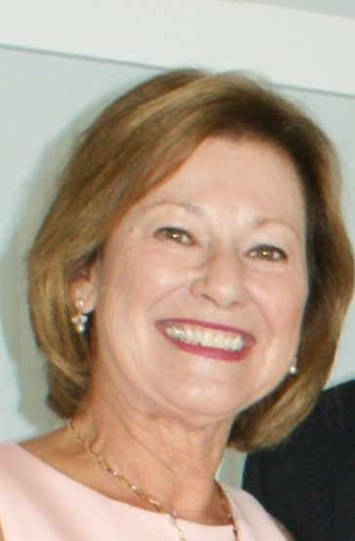
PRESIDENT’S MESSAGE: This time last year, we looked forward with hope and positivity to a future centered on America First. As we begin 2021, we are a nation divided and in desperate need of healing. What happened at the US Capitol was tragic, needless and incomprehensible. There are plenty of opinions about the cause but one thing which holds true is that there is no place for violence in American politics.

As Republicans, we celebrated the incredible accomplishments of the past four years. Now, we need to accept that the next four years are not what we anticipated.

We need to go forward in good faith. We have heard the call from our Republican leaders to set aside party vitriol. It is time to come together in the tradition of American democracy to air our differences with respect. Our challenge is huge and will be difficult in the aftermath of the outcome of the Republican rally in DC. We must remain focused on our conservative values, support our Republican leaders, and continue to voice our opposition to the progressive agenda.

As Republican women, we can be strong examples of conservatism. As the Republican Women of Worcester County, we will uphold our mission:

“The object of the Club shall be to unite Republican Women into an effective and active part of the Republican Party; to assist in the political education of its members; to broaden the understanding of Republican aims in government; to foster loyalty to and promote the ideals of the Republican Party; and to increase the number of registered Republicans.”

Let’s stay strong together. Let’s do the good work of Republicans right here in Worcester County to support our elected officials. Let’s remain engaged; RWWC will host meetings via Zoom when necessary and in-person as soon as the gathering regulations are lifted.
May 2021 bring peace and unity to our Nation, may we conquer COVID-19, may we return to normalcy.
Happy New Year!

Beth Rodier
President

MEMBERSHIP: Happy New Year to all! I hope you had a good holiday. As we ring in 2021 our membership rolls are open and waiting for you to sign up. As of this date we already have 16 renewals and 11 new members, but we miss you. Come join the team and make our club the biggest and best in MFRW. We have great plans for the coming year, but success is only possible with your support. Now more than ever Republican women should stand together and carry out our mission to promote the ideals of the Republican Party. Please send your check to the P.O. Box 1292, Berlin, MD, 21811. Dues are the same as last year. Full membership is $35 and Associate membership is $20. I am looking forward to adding your name to our list and hopefully, seeing all of you in the near future. Check out our website at www.gopwomenofworcester.org.

Mary Adair
Membership Chair

FUNDRAISING: Please mark your calendar for the Patriot Day Fashion Show Luncheon on September 16 at the Ocean Pines Yacht Club. We are really looking forward to this.
Susan Ostrowski
2nd Vice President


VOLUNTEER HOURS/AWARDS: WAY TO GO RWWC! Our Awards documents were submitted to MFRW in May 2020 for the 2019 year’s activities and events. We should be proud of our accomplishments based on our awards earned.

Maryland Shield Award—This is the highest award that can be received for 40 requirements such as number of volunteer hours, Caring for America activities, Americanism presentations at meetings, speakers at the general meetings, maintaining publicity and much more.

Most Worthwhile Club Meeting Recognition—Our Red, White, and Blue meeting held in June 2019, at the Germantown Berlin One Room School House received this recognition.

Newsletter Recognition—I submitted three of our RWWC newsletters for this recognition. They are judged on content, variety of news, photos, presentation, etc.

Website Recognition—RWWC one of three clubs receiving this award out of a total of 13 clubs in Maryland.

Raye Simpson
Awards Chair



LITERACY: THE RED SHOE BOOK CLUB is Ready to Launch! The RWWC Literacy Committee is launching the Red Shoe Book Club (RSBC) this month! The National Federation of Republican Women (NFRW) created the RSBC to help members join together to discuss books of merit and note— exemplifying that “Leaders are Readers.” The following books have been selected from the Mamie Eisenhower Library Project (MELP) lists as interesting and timely topics for members of Republican women’s clubs throughout America.

Frequently Asked Questions about the RWWC Red Shoe Book Club:

- What are the titles that the RSBC will read?


Clinton Cash: The Untold Story of How and Why Foreign Governments and Businesses
Helped Make Bill and Hillary Rich — Peter Schweizer, 201 “Clinton Cash will make for a
lively discussion in your book club! Just when you thought you knew it all … and an
easy read to boot!” Mollie Hemingway & Carrie Severino, 2019


Justice on Trial opened my eyes to the interworking and politics of nominating and
confirming Supreme Court justices for the last half of the 21st century. The book takes
the reader back to the modern history of the Court, its members, and its decisions. A
timely read for 2020 and 2021.”


Blackout: How Black America can Make Its Second Escape from the Democrat Plantation —
Candace Owens, 2020

“More than any other group in this country, blacks have had to place an unnatural
amount of faith in the American government. We needed the government to free us
from the shackles of slavery, to afford us the right to vote, and grant us the same rights
and privileges as white citizens.” — from Blackout, p. 123

2. When and where do we meet?

The meeting dates are March 9, June 9, and October 13, 2021. The March 9, 2021 will
either be an in-person meeting or a ZOOM meeting based on COVID-19 status and
updates in our area. The June and October meeting locations will be determined at a later date.

3. What do I have to do to sign up for the Red Shoe Book Club?

An RWWC member has to be in good standing in the club. Then, send a check for
$20.00 to Jean Delcher, P.O. Box 1292, Berlin, MD 21811 and list your 1st, 2nd, and 3rd
choice of books that you want to read. First come, first serve on book choices.
(Non-transferable to other members.) Groups are limited to 6 with a group leader and will
meet simultaneously on the above dates.

The sign-up for the date CLOSES on Thursday, February 4. RSBC needs 18
members to sign-up for the meetings to be held.

4. When and where will I get my book?

Books will be available the second week of February 2021. They can be picked up
at various locations or delivered to the northern Worcester area.

5. Can I buy my own book and then join in?

The books will be the ownership of the RWWC Literacy Committee during the 2021
meeting cycle. This event has been created to support the NFRW’s initiative on
Literacy for all of its member clubs at the local level.

PLEASE Join me for the January 28, 2021 RWWC meeting via ZOOM for more information.
Any questions you may have can be answered at that time!

Liz Mumford
Literacy Chair

CARING FOR AMERICA: Unfortunately, we will not be doing Valentines for Vets this February. With the schools not in session we lost our main source of valentines. Also, the hospitals are unable to handle the distribution of the cards with the added burden of Covid 19. We hope to resume this activity next year.

Vera Beck
Chair

TREASURER’S REPORT:

The Bank Balance as of December 22, 2020: $10,351.28
We had deposits of: $0
We dispersed checks in the amount of: $1,439.96
Balance as of January 5, 2021: $8,911.32

Jean Delcher
Treasurer

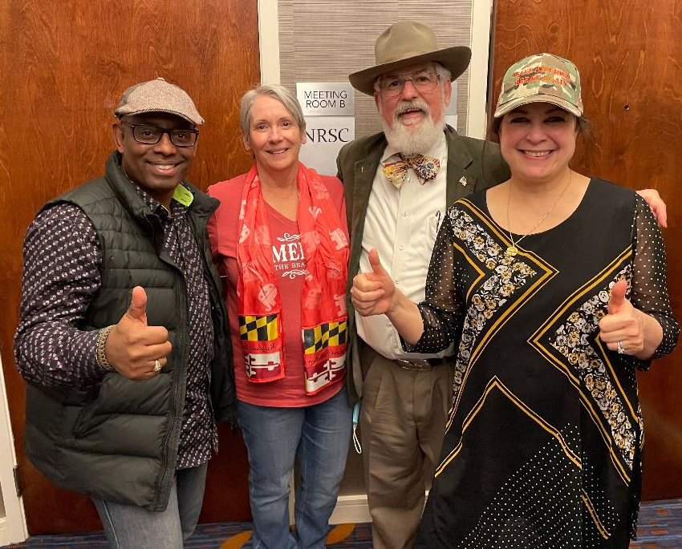

Our Legislative Chair, Carol Frazier went to Georgia to help in the campaign to keep our majority in the Senate. Even though the results of the run-off were disappointing, we applaud Carol’s efforts and spirit and we’re glad to have her back home again. Pictured with Carol are Mike Farrell (Frederick County), Jim Wass (Prince George’s County) and Eleni Dorian.



SUNSHINE: Please call Corresponding Secretary, Terry Denshuick at 410-208-4825 whenever you learn that one of our members is ill or has had a death in the family. Thanks for your help.

We are saddened to report the passing of two long-time members.




Margaret Hudson
Ellie Loechel

Margaret Hudson, 96 on December 26.
She was instrumental in establishing the Republican Women of Worcester Count and served as its first president.

Ellie Loechel, also 96 on December 5.
She attended our meetings until about two years ago when she moved to Severna Park.



2020—2021 RWWC BOARD

ELECTED OFFICERS:
President Beth Rodier
First Vice President Sandy Zitzer
Second Vice President Susan Ostrowski
Treasurer Jean Delcher
Assistant Treasurer Mary Adair
Recording Secretary VACANT
Corresponding Secretary Theresa Denshuick

APPOINTED OFFICERS:
Historian Leith Clinton
Parliamentarian Ann Lutz
Sgt. at Arms Amy Mike

COMMITTEE CHAIRS:
Americanism Charlotte Cathell
Awards Raye Simpson
Budget and Finance Treasurer and Assistant Treasurer
Bylaws Merilee Horvat
Campaign Activities VACANT
Caring for America Vera Beck
Chaplain Jan Kolesky
Hospitality Merilee Horvat
Legislative Carol Frazier
Literacy Liz Mumford
Luncheon/Dinner Charlotte Cathell
Sandy Zitzer
Membership Mary Adair
Newsletter Gloria Moyer
Publicity VACANT
Social Media Elena McComas
Webmaster Beth Rodier

