 ***REPUBLICAN WOMEN OF***

***WORCESTER COUNTY***

[www.gopwomenofwocester.org](http://www.gopwomenofwocester.org)

MARCH NEWSLETTER 2023 *Mary Louise Carey, Editor 410-632-2501*

Card and Game Party

Thursday, March 23, 2023

The Grand Hotel Terrace Room

1200 Baltimore Ave. Ocean City, MD 21842

11:00 a.m. – 2:30 p.m.

Doors open at 10:30

**PRESIDENT’S MESSAGE**

March is Women’s History Month, a time to celebrate the contributions of women to our society, those

elected to public office, and those of us who work behind the scenes. We are fortunate to be a part of

the RWWC, which allows us to actively participate in the political process at the local level, develop our

leadership skills and network with like-minded women.

If you missed our February meeting, you missed a great lunch thanks to Chef Cropper and the culinary

students of Worcester Tech. Our speakers Julie Giordano, Wicomico County Executive and Patrick Kerr,

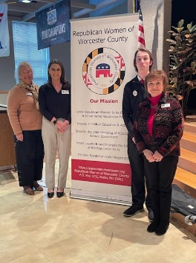President of The Salisbury University College Republicans, were both informative and delightful. Presentations of $500 each were given to Patrick for the College Republicans and to Chef Cropper for the Culinary Arts Department and another to the Technology Department of Worcester Tech.

On March 6, another $500 donation was presented to the Grace Center as part of our Caring for America efforts. We have worked hard this year and are so happy that we could donate to these worthy causes.

It’s not too late to get involved with this legislative session. Make a phone call or write a letter to our elected officials in Annapolis voicing your opinion on pending legislation. This is an easy way to get involved and not leave your home. For more information see our Legislative Chair’s report in the Newsletter.

I hope to see many of you at Game Day on March 23rd . If you have not registered and would like to reserve a table, please call Merilee Horvat at 410-641-6110 or Jean Delcher at 410-641-8927 before the 17th .

Happy Saint Patrick’s Day! God bless each of you and God Bless America!

Sandy Zitzer, President



Caring For Our Members

 5 get well and thinking of you cards combined

    2 sympathy cards

15 welcome letters

If you learn of a member who is ill, or has a member of the family who they have lost, please let me know by e-mail at [tdenshuick@yahoo.com](mailto:tdenshuick@yahoo.com) or text 410-430 1456.

Theresa Denshuick

**Awards Chair Update**



RWWC Awards and Volunteer Hours March 2023 Newsletter

Seeking Volunteer Hours For February 2023



Spring Forward and help your local RWWC by volunteering your time for committee work, reading, researching, and/or responding to MFRW/NFRW legislative updates, attending Republican Central Committee meetings, MFRW state meetings, taking online classes offered by NFRW, such as Campaign

Management Programs, attending Red Scarf Day, and ETC.

Please report your hours on our web site, [www.gopwomenofworcester.org](http://www.gopwomenofworcester.org), or if needed, to me at [rayesimpson@aol.com](mailto:rayesimpson@aol.com)

Thank you for your help. Remember to classify your hours as Political and/or Non-Political.

Raye Simpson

Awards Chair

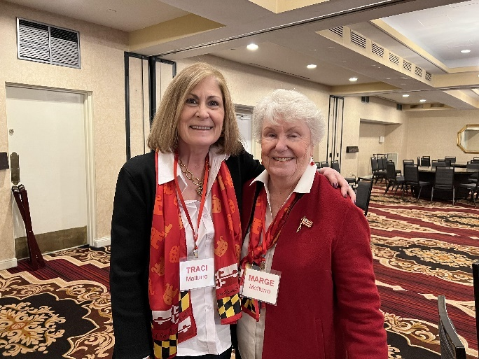**RWWC Out and About in our state**

"All in the family -- Mother and Daughter meet-up at MFRW Red Scarf Day 2023 in Annapolis.  Left, Traci Matturro, Republican Women of Arundel County and Marge Matturro, Republican Women of Worcester County Literacy Committee member."

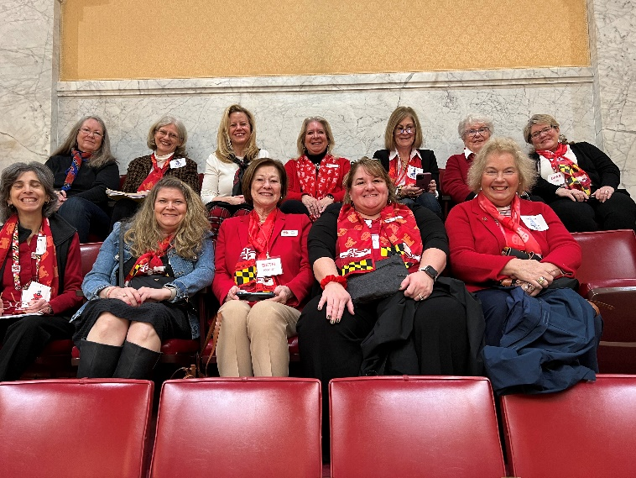

Joining several other members from various clubs from around the Eastern Shore region for Red Scarf Day in Annapolis are RWWC members Beth Rodier, Jana Hobbs, and Liz Mumford.

Seated in the back row, second from right is Marge Matturro, RWWC.  As part of the Red Scarf Day, members were seated in the Senate Gallery awaiting the Senate meeting scheduled for that day.  State Senator MaryBeth Carozza welcomed members from the Eastern Shore District at the opening of the Senate's meeting.

|  |
| --- |
|  |



The Red Shoe Book Club will meet Tues. March 28 at noon at the OP Library. Brown bag lunch. Our book discussion will be The Killer Angels by Michael Shaara about the Battle at Gettysburg.  
Questions?  
[posoem@icloud.com](mailto:posoem@icloud.com)

**2nd Vice President Update**

2nd Vice President. Merilee Horvat

**Congratulations to our Valentine Raffle Winners:**

Deanna Lowe $200.00

Carol Krueger $100.00

Susan Seifer   $50.00

A big Thank You to all who participated in the first Fundraiser of 2023. It was a big success.



Our next fun event is the **Card and Game Day**at the **Grand Hotel** on **March 23, 2023.**  Tickets are $30.00 and include Lunch.  Please see the website to download the information or call Merilee Horvat at: 410-641-6110 before March 17th..  [gopwomenofworcester.org](http://gopwomenofworcester.org/).

Save the Date: **Patriot Day Fashion Show**

**September 14, 2023**

**Fontaine Bleu Resorts**

**Ocean City, MD**

**Reserve your table early**, as we sold out last year before the Due Date.

More info to follow.....

Reminder: Fashion Show: September 14, 2023 (Tables of 10)

A Request: (Please start saving the empty bottles from Classico Spaghetti Sauce or quart size Ball jars for Jean Scanlon for the Centerpieces) Thank You

RWWC Want Ads

Needed: Webmaster

The webmaster serves as the primary contact for all aspects of the RWWC website. They would need to be able to handle a range of responsibilities that may include web design and development, routine site and content maintenance, and various updates that ensure the site aligns with the goals and objectives of the organization.

Fundraising Needs:

Basket donations – We need items that can be used to fill theme baskets. Some of the suggested themes are Beach Getaway, Wine and Dine, Mexican Vaca, Road Trip, Get Cooking, Movie Night In, Game Night, Gardening, Craft Corner, Spa Day, as well as many other possibilities.



Gift Cards needed:

Gift cards with a value of $10.00 or more are needed for the Fashion Show Gift Boxes.

Carol Frazier’s Letter to the Editor

Dear Editor:

I am writing again to inform your readers of some pending legislation in Maryland which may be of concern. Over 1,200 bills have been filed in MD this year, most of which are at best questionable.

I wrote previously about HB119/SB199 - “Primary and Secondary Education - Health Education Framework - Established” which would require all counties in Maryland to create an “age-appropriate” curriculum that is consistent with the Comprehensive Health Education Framework. Our county commissioners and school board, thankfully, are in unanimous opposition to this legislation, but Delegates and Senators in other parts of the state need to hear from their constituents also. Perhaps your readers might reach out to friends and family in central and southern Maryland to make sure they are aware of the legislation and ask them to let their legislators know how they feel about requiring 7th grade students to “identify solo, vaginal, anal, and oral sex along with possible outcomes of each”. In addition, the Framework requires that students in Kindergarten through 2nd grade “recognize” and “identify a range of ways people identify and express their gender”.

Another bill of concern is SB0460/HB0283 “Maryland Medical Assistance Program - Gender Affirming Treatment (Trans Health Equity Act)”. This legislation would require that all recipients of the program be provided gender-affirming treatment if medically necessary, including transgender, non-binary, intersex, two-spirit and other gender diverse individuals. The bill does not exclude children or teens under 21 years of age from puberty blockers, cross sex hormones or surgery to remove breasts of reproductive organs for Sexual Dysphoria or Sexual Identity. I have to ask - on what planet would people consider a 16 or 17-year-old qualified to make a life-altering, permanent decision to amputate breasts or organs or take puberty blockers, which would permanently alter their bodies? I can’t believe that a majority of Maryland voters would agree with this, but, of course, they have to know about it. So, again, perhaps your readers can make sure family and friends in other parts of the state are aware of this legislation.

Legislation to support (in light of recent laws and proposed bills as above restricting parents’ knowledge, guidance or consent for minor children to make decisions for their mental or physical care of their identity) would be SB0566/HB0666-”Family Law - Fundamental Parental Rights”, This legislation would establish that a parent has the fundamental right to direct the upbringing, education, care and welfare of the parent’s child, and prohibit the State or a political subdivision from infringing on these fundamental parental rights unless the State or political subdivision can demonstrate by clear and convincing evidence that this infringement is necessary to achieve a compelling government interest and is narrowly tailored. Wasn’t it just a few years ago that we had a nationwide problem with young people eating laundry detergent pods, i.e. the “Tide Pod Challenge”?

Finally, there is SB0803 “Labor and Employment - Payment of Minimum Wage - Tipped Employees” which would completely change the restaurant industry and which has been shown, in states where similar legislation has been enacted, the drastically reduce the income of tipped employees.

The full text and status of these bills can be read at mgaleg.maryland.gov. You can also get the contact information for the sponsoring Delegates and Senators.

Sincerely,

Carol Frazier

64 Bramblewood Drive

Ocean Pines, MD 21811

410-430-4456

carol.frazier54@gmail.com

News from our Legislature

HB 119 on Comprehensive Health Education Framework – **Oppose** - [https://mgaleg.maryland.gov/mgawebsite/Legislation/Details/hb0119?ys=2023RS](https://gopwomenofworcester.us17.list-manage.com/track/click?u=b53f84effe6f992dab0394fd5&id=f678f07d95&e=60e054daac)

Please consider sending this letter to a representative on the Maryland State Board of Education.

To the Maryland State Board of Education

and Accountability and Implementation Board Members,

As a Maryland resident and taxpayer, I demand that State Superintendent Mohammed Choudhury be immediately removed and barred from his position.

In the Superintendent’s short tenure, he has proven to be an ineffective leader of our state education system who, rather than partner with local education systems, has taken unprecedented steps to erode the rights of locally elected school boards, teachers, and parents.

House Bill 119, Choudhury’s latest attempt to takeover local education, would grant absolute authority to his office to dictate every aspect of curriculum, frameworks, standards and instructional materials for all classroom topics including gender identity.  HB119 would allow Choudhury to withhold millions of dollars from local school systems deemed by his office to be “non-compliant” with state standards, impacting teacher salaries and children’s education.

The Superintendent’s attack on local rights comes as counties grapple with the policies and financial deficits of the state-mandated Education Blueprint.  It is critically important that locally elected school boards be given the authority to implement these standards in a way that best fits their communities and budgets.   Choudhury’s attempt to enforce strict application of these standards thru financial penalties will further exacerbate the challenges faced by local jurisdictions and directly harm students.

Choudhury’s pattern of tyrannical behavior began from the onset of his tenure.  In one of his first moves as Superintendent, he issued an unprecedented, statewide emergency regulation to mandate school masking, taking away the ability for local boards to manage COVID policy when it was clear there was not a “one size fits all” solution to the pandemic.

Teachers, parents, and local school boards across the state have lost confidence in Superintendent Choudhury’s ability to lead the Maryland State Department of Education.  His self-obsession with top-down control has proven him to be incapable of his post and a danger to Maryland students and teachers.

It is for these reasons that we demand for the immediate removal of State Superintendent Mohammed Choudhury.

Regards,

Maryland Taxpayer for Local Education





**March MEMBERSHIP**

Hello everyone. Thank you to all our members who have renewed their membership and a warm welcome to our new members: Deborah Bloom and Catherine Willis. Our current active membership is 120. We welcome Susan Beauchamp, Hans Beck, and Patricia Winkleman as new associate members. I wish to send special thanks to Ann Lutz for her most generous help in phoning all members to remind them to renew for 2023. We are striving to be the largest club in MFRW. We held that position many years ago and I think it would be great if we could achieve that once more. With your help, I know it is possible. If you have not renewed your membership, we will be removing your name from our active list and you will no longer receive our emails or emails from MFRW and NFRW, so it is important to remit your dues as soon as possible. If you are unsure about your status, please feel free to call me at 410-208-0376 and I will be happy to help you. It is important to be kept informed so that you are knowledgeable about the issues in our state and our nation. I look forward to working with you so that we do our part in making a difference in our country and bringing it back to the land that our forefathers envisioned. You may pay your dues by sending $40.00 for full membership or $20.00 for associate membership to RWWC at Post Office Box 1292, Berlin MD 21811 and mark the envelope, membership. You may also renew your membership at our website:[www.gopwomenofworcester.org](http://www.gopwomenofworcester.org/). There will be a small service charge if you choose to pay with a credit card. We are hoping to see many renewals and new members in the coming days. It has been brought to my attention that many would like to have more information about our mission or would like to help on a committee. I have included my home phone number above and would love to hear from you. Happy St. Patrick’s Day! See you on Game Day.

Mary Adair

Membership Chair



Republican Women of Worcester County

March Board Meeting

March 1, 2023

MINUTES

8 members present: Sandy Zitzer, Amy Mike, Jean Delcher, Mary Adair, Liz Mumford, Jean Scanlon, Susan Ostrowski, Weezie Carey

Excused: Ann Lutz, Theresa Denshuick, Merilee Horvat, Beth Rodier, Raye Simpson, Carol Frazier, Vera Beck, Leith Clinton, Barb Loffler

Absent: Jan Kolesky, Charlotte Cathell, Gina Shaffer

The meeting was called to order by President, Sandy Zitzer at 9:38 AM.

In the absence of Chaplain, Jan Kolesky, Jean Delcher led the group in prayer followed by the

Pledge of Allegiance led by Amy Mike, Sgt. At Arms.

Executive Committee

* Approval of Minutes - Amy Mike, Recording Secretary, asked for the approval of the minutes from the last board meeting held on February 7, 2023. Mary Adair so moved. Jean Delcher seconded the motion. MCU.
* President - Sandy Zitzer announced that in the absence of a quorum we would not be able proceed with any other matters requiring a vote. There were several items that she brought to everyone’s attention:
* We have a Happy Hour scheduled for this Friday evening at Fager’s Island from 5 to 7 PM. She encouraged everyone to attend. We discussed the need to have name tags since this is billed as a Meet &amp; Greet opportunity. We need to have a small table in the gathering area for name tags, membership forms, and “Why I Am a Republican” flyers.
* Sandy deferred until April discussion as to how much we should donate to the MDGOP since we cannot vote on the matter at this time.
* Sandy encouraged board members to participate in obtaining/donating gift cards for the Fashion Show. She is in the process of compiling a list of businesses who have been approached so that we don’t duplicate. This will be raised at the next board meeting. She is asking each board member to get at least five (5) cards.
* Treasurer - Jean Delcher provided the group with our financial current status. The balance as of February 25, 2023 was $21,712.75. Deposits amounted to $498.50. Disbursements came to $3,515.73. The balance as of March 1, 2023 stands at $18,695.52. Jean shared that Mary Adair and Amy Mike reviewed the books for the second half of the year and everything looked good.
* Membership - Mary Adair shared that we currently have 117 members – 108 renewals and 9 new members. According to MFRW we currently stand in first place statewide. We picked up 3 more associate members to join the 5 renewals. Our grand total currently stands at 125 members. We need to give a SHOUT OUT to Ann Lutz who did a herculean job of calling everyone who had not yet renewed their membership in two days.
* 1st Vice President - Liz Mumford has confirmed two of the speakers for the April General Meeting when we “Welcome Home” our legislators. Both Mary Beth Carozza and Wayne Hartman have confirmed. She is waiting to hear back from Charles Otto. Nicole Bennett, the Vice-Chair of MDGOP will speak at our May meeting. Liz is still in the process of identifying someone for the June meeting. She has arranged a speaker for October – the guy who recently spoke to the Republican Women of Sussex County and came to us very highly recommended.
* MFRW Eastern Region Chair – In the absence of Beth Rodier, Sandy reported that the MFRW is changing the designation of Corresponding Secretary to Communications Director. Sandy reminded everyone about Red Scarf Day on March 7 th when Beth and Mary Adair are planning to attend. Governor Wes Moore is scheduled to speak at this event.

Committee Updates

* Hospitality - Jean Scanlon questioned about a budget for centerpieces for the Fashion to collect mason jars to be used for this event.
* Literacy – Susan Ostrowski deferred to Liz Mumford who had made contact with the Social Studies Coordinator for Worcester County Public Schools regarding a possible Essay Contest that was discussed at our last meeting. Jessica McInerney suggested a January time frame to invite 8th graders to participate. There are three public middle schools. The committee will decide regarding the inclusion of non-public schools. The topic should be government related. The group is proposing three monetary awards of $250, $100, and $50. This could also fulfill several categories for our Awards submissions by Raye.
* Newsletter – Weezie Carey requested that everyone have items for the next newsletter to her by March 14th

Closing Remarks

* Sandy Zitzer shared that Patrick Kerr had sent an acknowledgement for the first check we presented to him. She shared that Andy Harris is having an event to mark his 66th Birthday on March 15 th . With so many people currently experiencing major health issues, we need to keep everyone in our prayers.

Calendar

March 1 Board Meeting

3 Happy Hour at Fager’s Island

7 Red Scarf Day, Annapolis

23 Card &amp; Game Party, Grand Hotel

April 4 Board Meeting

27 General Luncheon Meeting, Welcome Home Legislators

29 Central Committee Event

Adjourn The meeting was adjourned by President, Sandy Zitzer at 10:36 AM.

Respectfully Submitted,

Amy Mike

Recording Secretary

**Card and Game Party**

**The Grand Hotel Terrace Room 1200 Baltimore Ave. Ocean City, MD**

**Multi-level parking adjacent to the hotel**

**Thursday March 23, 2023**

**11:00 am--2:30 pm**

**$30.00 per person**

**\* Please sign up and pay per table. Let us know what game you will be playing and circle each person’s lunch choice.**

**Lunch Choices**

All selections come with homemade potato chips and pickle spear.

Coffee, Tea and Iced Tea /Cookies for Dessert

1. Ham & Swiss on Rye with lettuce and tomato
2. Classic Roasted Turkey Club on white bread with lettuce, tomato, bacon, and mayo
3. Tuna Salad served on lettuce with a croissant

**Game** __________________________

**1. Captain’s Name _____________________________ 1 2 3 5. Player’s Name ____________________________ 1 2 3**

**2. Player’s Name ______________________________ 1 2 3 6. Player’s Name____________________________ 1 2 3**

**3. Player’s Name_______________________________ 1 2 3 7. Player’s Name____________________________ 1 2 3**

**4. Player’s Name_______________________________ 1 2 3 8. Player’s Name____________________________ 1 2 3**

**\*Please Mail Checks with all Player’s Together to: RWWC Card Party P.O. Box 1292, Berlin, MD 21811 by March 17.**

**Questions call: Merilee Horvat 410-641-6110 Sponsored by: Republican Women of Worcester County**

2023-2024 RWWC BOARD

President Sandy Zitzer

First Vice President Liz Mumford

Second Vice President Merilee Horvat

Treasurer Jean Delcher

Assistant Treasurer Mary Adair

Recording Secretary Amy Mike

Corresponding Sec. Theresa Denshuick

APPOINTED OFFICERS

Parliamentarian Ann Lutz

Historian Leith Clinton

Sgt.at Arms Amy Mike

COMMITTEE CHAIRS

Americanism Charlotte Cathell

Awards Raye Simpson

Budget & Finance Treasurer & Asst. Treasurer

Bylaws Vacant

Campaign Activities Carol Frazier

Caring for America Vera Beck

Chaplain Jan Kolesky

Hospitality Jean Scanlon

Legislative Gina Shaffer

Literacy Susan Ostrowski

Luncheon/Dinner Charlotte Cathell

Membership Mary Adair

Newsletter Mary Louise (Weezie) Carey

Publicity Barbara Loffler

Social Media Elena McComas

Webmaster Beth Rodier