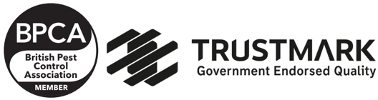  SINIYON SERVICES  Nuneaton, CV11 4SX  www.siniyonservices.co.uk  Email siniyon.services@gmail.com |   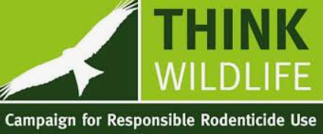

What is a Guarantee?

This is sometimes misunderstood by customers and made confusing by businesses. A guarantee is to give a consumer peace of mind when purchasing a service or product from a business.
Regards to a pest control guarantee, there are limitations that should be explained.
What happens when you have a pest treatment carried out and pests come back?
Should you expect to see pests again after a professional pest control treatment?

Here is where it can sometimes become confusing.

Guarantee no pests after treatment

Guarantying to see no more pests after treatment is bordering on Absurd for industry professionals. There is no way any pest company can give assurances you will never to see pests again no matter what products are sprayed or Rodent Treatments used.
Some pests are more easily bought under control than others. Some pests may require follow-up treatments. The guarantee will be determined by the type of pest problem we are dealing with at the time of treatment.
The guarantee is really that your pest company or technician will return if pests become a nuisance after a treatment. So really it is only as good as the company you hire. SINIYON Services ltd are fully complaint to the Consumer Rights Act 2015 for goods and services.

As mentioned earlier no one can give 100% assurance that you’ll never see another pest again. But they can guarantee that they will return if the problem persists. So let me say this again, the guarantee is that your pest company will return, not that you will never see pests again. If you are considering other pest control companies that give a lifetime guarantee please consider this promise carefully.

Seeing pests after treatment.
It is normal to still see pests after a pest control service has been carried out. Pests such as ants can be visible up to 3 weeks after the use of dust or gel treatments however they should be greatly reduced.

The reason for this is the type of product being used, most pest companies these days use (non-repellents).
Non-repellents work in a way that gives a much better result. With these types of products, there is delayed mortality. This means the pest in question has time to spread the product around to other colony members before they die. This method helps to eliminate a whole colony, not just the ones you see on the day.
Other products that will knock down pests instantly just don’t work over the long term. In an infestation, fast knockdown products may be used initially and followed up with treatment with non-repellents.

Conclusion
The short of this age-old question about a guarantee will always come down to the company you use.
Anyone can give a guarantee but if they don’t back it up then it’s of no use. Here at SINIYON Services Ltd, we give our customers a 100% guarantee of compliance to the Consumer Rights Act 2015
We don’t guarantee that you will never see another pest for 3 months, but we do guarantee that we will return if you do.
When we visit depending on your type of pest you will always be provided with a Treatment Plan/Report and you will always be given an explanation of your rights to honour this commitment.

