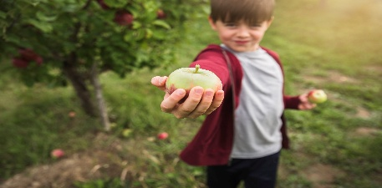

U-Pick

September 6th, 7th and 13th

9-2pm

* We are so excited to offer this fun, family-friendly activity for the 2025 Apple Season!
* Picking conditions can change day by day depending on weather and customer traffic. Please check our website /Facebook prior to your arrival to make sure U pick is open on that specific day. You can also call the farm directly. We are only doing U Pick on the above listed dates
* Unfortunately, we have had limited watering capability this year, so our apples are small, but plentiful and quite tasty!!
* Upon arrival to Hays Honey & Apple Farm, please check in with an orchard staff member. Everyone in the group needs to be present, as liability waivers will need to be completed prior to entering the orchard. We will have these onsite.
* We have pre-purchased bags for sale to be used for picking. Please do not bring your own bags.
* Please exit the orchard once your bags are full. If you need to purchase extra bags, our orchard staff will be happy to help.
* Wagons or strollers are permitted

**Please be mindful of the following:**

* We love our four legged critters but please leave yours at home.
* Be gentle on the trees! How you treat the trees has a lot to do with their blossom ability next Spring. Please do not climb the trees or shake the branches.
* Only pick in the designated areas as not all apples are ripe at the same time.
* Dress properly, long pants, closed toe shoes and sunscreen are recommended.
* Please wash fruit prior to consumption

And lastly.. We hope you have FUN!