ARTICLE VIII

Eminent Domain, Compliance with _Local Laws and Assessments for Street Lights, Roadways and Easements

(a} In the event it shall become necessary for any public agency to acquire all or any part of the property herein conveyed to the Trustees, for any public purpose, the Trustees, during the period of Trust as well as the times fixed for the appointment or election of Trustees, are hereby authorized to negotiate with such public agency for such acquisition and to execute instruments necessary for that purpose. Should acquisition by eminent domain become necessary, only the Trustees need be made parties, and in any event the proceeds received shall be held by the. Trustees for the benefit of those entitled to the use of the Common Ground, roads, easements, and other areas provided here­ under for the common and joint use of the lot owners.

(b} Notwithstanding any other condition herein, the Trustees shall make suitable provisions for compliance with all subdivision and other ordinances, rules and regulations of St. Louis County or any other municipality of which the subdivision may become a part and for such purposes shall not be limited to the maxim m assessment provided for herein. Specifically and not by way of limitation, the Trustees shall make provision for the maintenance and operation of all street lights, roadways and easements, unless the obligation for such maintenance and operation be assumed and accepted by a public authority.

ARTICLE IX

Detention Basin

Allocated Storm Water Retention Agreement. In addition to annual assessments herein otherwise authorized, the Trustees shall make assessments in the manner provided for herein for the repair, operation and maintenance of storm water control easements, including all underground and above ground facilities and pipes used in connection therewith and access easements to such storm water control easements. The maximum amount of such assessment shall be an amount equal to five percent (5%} of the annual assessment for each lot and living unit, and such assessments shall be made until such easements shall be accepted for maintenance by the Metropolitan St. Louis Sewer District or other public authority.

In the case of the subdivision encumbered hereby, storm water detention basins have been shown on the plat(s) and identified as "Storm Water Control & Detention Easement."

IN WITNESS WHEREOF, Owner has caused this Indenture to be duly signed by its President and its corporate seal to be hereto affixed, attested by its Secretary, and the Trustees have also hereto set their hands this day and year first in this Indenture written.

SOUTHERN WINDS ASSOCIATES, a

Missouri Joint Venture,

By: SOUTHERN WINDS DEVELOPMENT

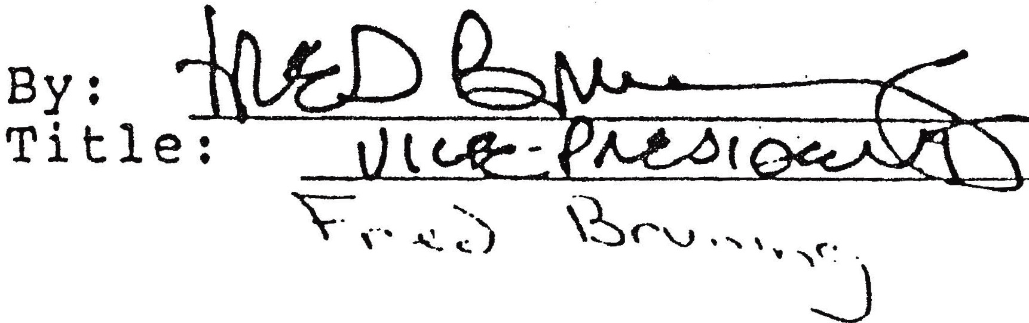COMPANY, Joint Venturer