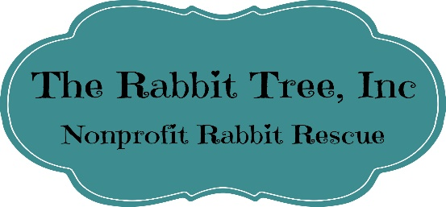
Rabbit Tree Adoption Application
Thank you for your interest in adopting one of wonderful bunnies! Please take a moment to fill out this application and send it back to the rescue. We do realize that this application is daunting, but we want to ensure that our bunnies go to a home where people are knowledgeable or are willing to take the effort to learn how to properly care for their new fluffy friend.

Thank you,

The Rabbit Tree Staff

Name
Address
Email
Phone (and type)

Question | Yes | No
- Are you aware that rabbits can be as much work as having a cat or dog?
- Will the rabbit be indoors or outdoors? | Inside | Outside
- Do you need a recommendation for a rabbit savvy vet?
  - If No, which vet do you plan to use?
- Do you have experience with rabbits as pets?
  - If Yes, please provide a brief description of your experience.
- Do you currently have rabbits?
- If Yes, how many?
  - If Yes, are they spayed/neutered?
- Is this bunny intended to be a companion to another rabbit?
- Are you aware of the proper diet for a rabbit?
  - If No, do you need assistance with resources?
- Are you aware that they must have unlimited access to hay?
- Who will be the primary caregiver for the rabbit/rabbits?
  - Is the primary caregiver a responsible adult?
  - If you go away on vacation, is there a plan to have the rabbits taken care of?
- What type of enclosure do you plan to or currently use for your rabbit?
- Do you have a plan on what you will do to ensure they get playtime on a daily basis?
- Are there cats in the household?
- Are there dogs in the household?
  - If no to 12 &13, what pets do you have?
- Are there children in the household?
- Does anyone in the household have an allergy to animals or hay?
- Do you own or rent your residence? If you rent, provide documentation stating that a pet is permitted. | Own | Rent
- Do you need assistance with rabbit-proofing your residence?
- Do you have a plan if one or more of the following situations occur?
  - An apartment or rental no longer allows pets?
  - A family member or roommate is allergic to pets?
  - There is a separation in the household?
- Do you need assistance in researching the care for domestic rabbits?

If you find yourself in a position where a rabbit adopted from our facility cannot be properly taken care of anymore, please contact us at 304-579-0662 in order to arrange a return.

Signature Date

