CUB SCOUT PACK 95 PINEWOOD DERBY RULES

PURPOSE:
The Cub Scout should have fun racing a car he has built from materials in the Pinewood Derby Kit. Adults should work with the Scout and make the car as a project together, allowing the Scout to lead with his own creative ability. Adults should always supervise the use of any sharp or powered tools (drills, saws, sanders, etc.), but let the Scout get as much fun and experience out of building the car as possible. Cars must be newly built from scratch this Scout year by the Scout entering the competition. Cars built before the current Scout year are strictly prohibited. Any questions regarding rules or implementation should be presented to the Pinewood Derby Chair (referred to as the Chair in the rest of these rules.)

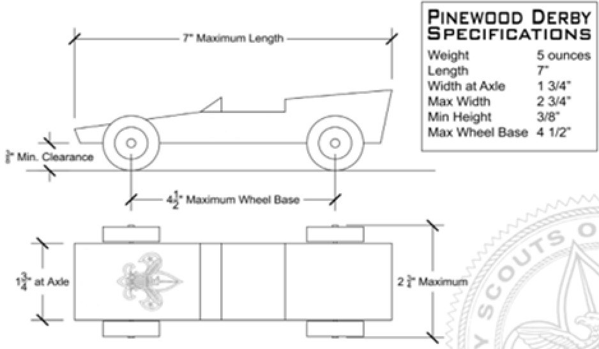

GENERAL SPECIFICATIONS:
- Width: The car cannot be more than 2 ¾” wide.
- Length: The car cannot be more than 7” long.
- Weight: The car cannot exceed 5.0 ounces.
- Height: The car must fit underneath the electronic timing device.
- Wheelbase: No more than 4 ½ inches between the front and rear axles.
- Clearance: A clearance of ⅜" is required beneath the car, between the wheels.

WEIGHT:
The official weight cannot exceed 5 ounces, and will be determined at weigh-in, prior to the race, by the use of scales approved by the Pack. The weight shown on this scale is final. At the time of final weigh-in, all car parts and materials must be firmly attached to the car. If the car is over or under the weight limit, weight may be removed or added. Once the car has been weighed and approved it is impounded until the race and no additional modifications can be made.

WHEELBASE:
The wheelbase is defined as the distance between the front and rear axles of the car, and cannot exceed 4 ½ inches. Wheelbase will be verified on all cars at the official check-in. Non-conforming cars will be rejected unless the wheelbase is adjusted.

WHEELS AND AXLES:
The car must be 1 ¾” wide at the point where the axle enters the body and the car must have four wheels. This is to ensure that the wheels will straddle the lane guide on the racetrack. (Note: This is the original width of the car body.) Only Official BSA Pinewood Derby wheels and axles may be used. Axles may be sanded and/or polished to remove manufacturing defects and improve surface smoothness.

Wheels may be lightly sanded to remove the molding seam on the tread and hub. Wheel tread (the flat surface of the wheel) may not be rounded or otherwise shaped (convex or concave sanding/shaping). Wheels may not be narrowed. All wheel markings, including tread bumps, must remain on the wheel. No modifications may reduce the weight of the wheels below 2.4 grams. If there is any suspicion of illegal wheel modifications, race officials reserve the right to withhold awards prior to verifying wheel legality.

The length of the axle may not be notched, grooved or channeled. The use of bearings, bushings, spacers and/or washers is prohibited.

SPRINGING:
The car may not ride on any type of spring or suspension. The car must be freewheeling with no propulsion devices to push or enhance its travel down the track.

DETAILING:
Details such as steering wheels, drivers, decals, painting, etc. are all acceptable. The finished car with all details must meet all previously mentioned registration requirements.

FRONT NOSE STARTING CONDITION:
The car must retain a blunt surface at the center of the front “bumper” (recommend ¼” wide minimum) to contact the track starting peg. Cars that are shaped to a sharp point, or in a “V” may tend to slip off the peg which causes an unreliable and possibly unfair starting condition. The front also shall not be shaped in a concave condition which allows any part of the vehicle to extend forward of the starting peg contact point. Cars that do not sit properly on the starting peg will be tried in the backward position by the race officials to attempt to correct the problem. If neither position works acceptably, the car will have to be modified by its owner or disqualified from race standings.

Magnets in the front of the car to pull towards the starting pin are not permitted.

LUBRICATION:
The only lubricants allowed are dry, powdered variety, such as graphite or the dry Teflon-based lubricant. Do not use other lubricants such as oils or silicone sprays. These can cause the wheels on the car to deteriorate, collect dust, and can cause damage to or alter the track. No hubcaps or coverings of any kind will be placed on the wheels to hold additional lubricant.

SPORTSMANSHIP AND BEHAVIOR:
Good sportsmanship and behavior are expected from all participants. Cars will be disqualified if the Scout or his parent(s) display unsportsmanlike conduct at the races. Race officials may ask anyone not following this rule to leave the activity.

CHECK IN:
Check in will take place the day before the race. (Friday, January 14, 2022). All cars will be inspected and weighted to be sure they meet race requirements. All cars will be numbered with removable stickers with the racers assigned number at this time. All adjustments, with the exception of lubricating the wheels will be done before check in. You must provide the weights for your cars. The pack does not provide weights. Cars will be impounded and will be not be touched by the scouts after check in.

RACE DAY PROCEDURES: (Saturday, January 15, 2022)
Only activity representatives are allowed inside the track area and will move all cars to the track staging area. Nobody, other than race officials, will be permitted to handle any checked-in car until the race is complete, except for sanctioned repairs if a car has been damaged. The Staging Crew will ensure that cars are properly placed on the track prior to beginning the race. After each race, only activity representatives will return the cars to the track staging area. The Scouts who’s cars are racing may watch the race from the “Pits” this will be a long the side of the track.

An electronic finish line device will determine the winner and/or times of each race. The race will be run again if there is a failure of the timing device. Each car will race in multiple lanes of the track to eliminate any lane advantage. The car with the best score as determined by the race software will be declared the winner. In case of a tie, one additional race will be run with only the affected cars racing. Race officials will provide a full explanation of the scoring methodology on request, but final scoring calculation is the decision of the Pinewood Derby Committee.

In the event of a total failure of the electronic finish line device, race officials may select finish line judges to call the results of each heat and enter manually into the software. In this case, all decisions agreed upon by judges are considered final.

If any car jumps off the track or interferes with another car, the heat will be run again. If the
same car again jumps the track or interferes, that car will be removed and considered to come in last for that heat. If a car is damaged during any race, the Scout/parent team is allowed to repair only the damage incurred during that race. An activity representative will assist the Scout in the repair session. No other modifications or adjustments to the car are allowed. The car must be repaired prior to being called for its next race or race in its damaged condition.

MASTERS CATEGORY:
The Masters races are for non-Cub Scout participants to race their cars (Moms, Dads, siblings, etc.). These cars will be subject to all of the aforementioned rules and regulations including that the car must have been built this Scouting Year, using official BSA Pinewood Derby parts, by the entrant.

AWARDS:
An awards ceremony will be held at the completion of race and show judging. Additional awards will be given based on creativity and craftsmanship as determined by the Pinewood Derby Committee. While the winners of all categories will be announced at the conclusion of the race, the Pinewood Derby Committee reserves the right to present physical awards at a later date.

