Youth Imagine the Future

June 2024 Newsletter

|  |
| --- |
| CFKA Grant! |
|  |
|  |

Pivot Green presents YIF with award. Above: CFKA staff present grant.

# June News 2024

We have been very honoured to have won Second Place in the Pivot Green Youth Climate Action Awards across Canada, then to receive a grant from the Community Foundation for Kingston & Area, and recently, to receive a donation from kind local donors’ “Global Heating Fund.” You can bet we will use these all wisely to reach more youth this year! 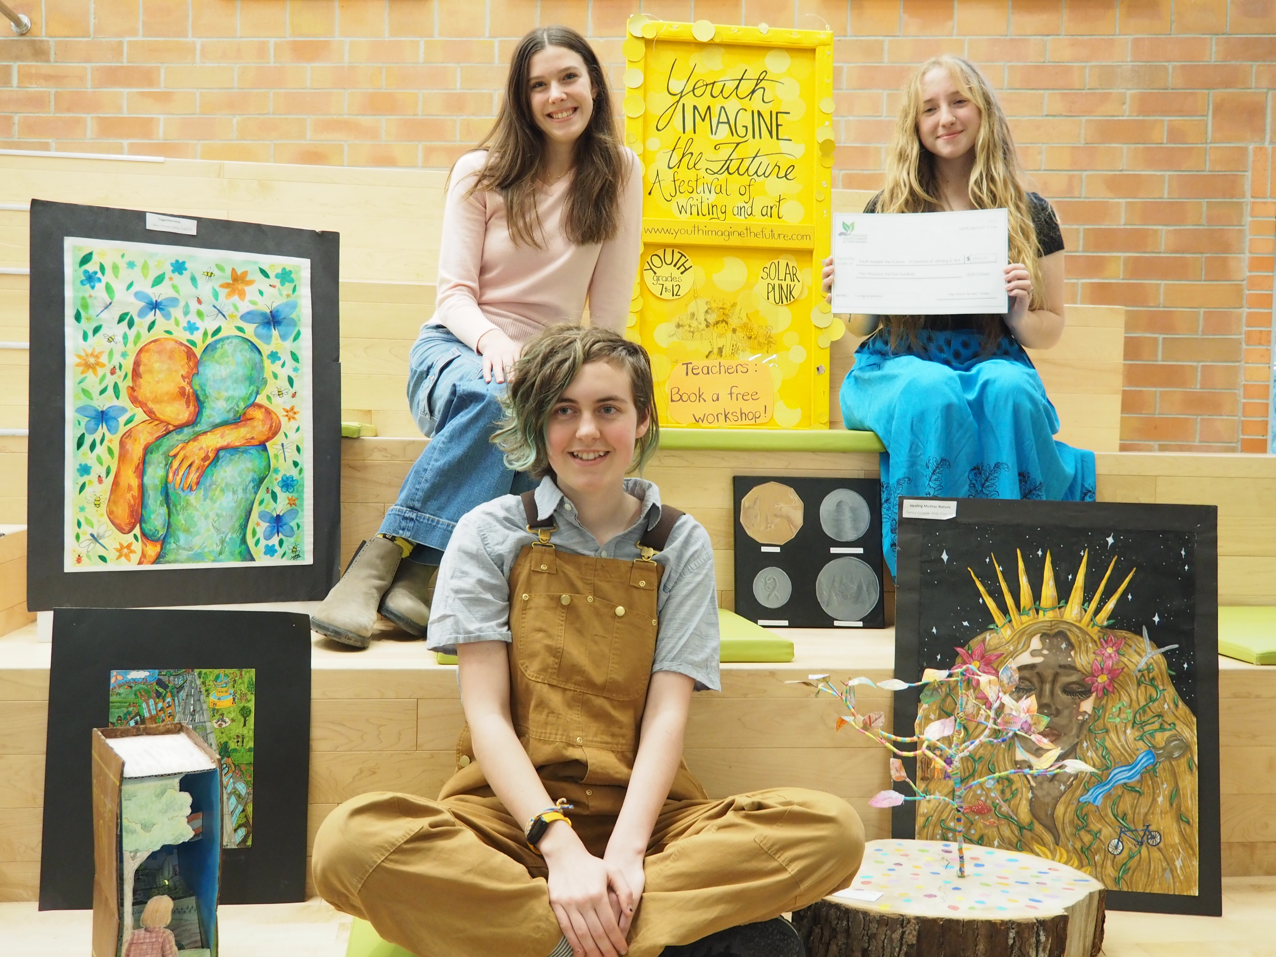

## Youth Imagine the Future Festival (YIF) has Youth Ambassadors!

It’s true! Above are pictured Emily Booth (Regi-ND), Abbie Miolee (LaSalle SS) and Hazel Taylor-Quick (KSS). They are excited to help us to reach more youth in their schools and other schools, talk it up to teachers, and friends. Sometimes we can drag them from all their charitable work in for a photo.

### YIF is on Social Media now!

Thanks to the volunteer hard work of Prof. Michele Morningstar, one of our YIF Board of Directors, YIF is now on Facebook, Instagram and twitter. Sure, I have mixed feelings about each of those, (especially Elon Musk’s X). However, most local high schools are using X and most students and a few high schools are on Instagram. Old folx like us use Facebook!

Look us up! Follow us!

Instagram: @youthimaginethefuture X @YouthImagFuture

Facebook: Youth Imagine the Future Festival

### Email letters have already gone out to last year’s teachers, asking them to reserve a day in September for their school and have other teachers join in. Here is part of the letter:

*When I was in grade 7, a large intermediate school, I was invited to an evening assembly for the community to recite a poem I’d written about a rainbow. Sure, it was hokey, but it had a nice rhythm, and I was nervous at a microphone, speaking to hundreds of strangers. My mom and I took a bus to get there.*

*After that evening, I began to write in earnest, making sense of the world.*

***Youth Imagine the Future*** *tries to give that kind of experience to our youth—to create something that moves people, this time about how to fix our future collectively. We give out rather a lot of prizes, to honour the hard work and creativity. We show all the art and stories for 2 weeks at a proper art gallery and invite the top 10 story writers to read aloud to the public.*

*Behind the scenes, we send out invitations to both the Mayor and Council of Kingston and of South Frontenac, to local organizations for their newsletters, including KFPL library this year, and try to bring in the larger community to see and feel the work our youth have created.*

*Students who engage with this kind of positive, purposeful work have told us that they, like our visitors to the gallery, feel more hopeful, afterward.*

***Please reserve a rough day in September*** *for us to give free hour workshops and slideshows at your school for your English/Visual Art/Geography/World Issues/Environmental Studies classes and Eco Teams 2024. We need to sketch out our September, although, if a school assembly or event botches the plans, we can shift things.*

**KFPL JOINS YIF!**

Two keen librarians who work with teens, Max Manga and Quang Bui, have offered support through the use of their KFPL newsletters and Events page on their website. As well, they offered us the use of the large (grand piano) room at the Central Branch on Johnson St. for our awards ceremony to young artists and writers. Free!

**SAVE THE DATE: Sunday December 15th, YIF AWARDS! (afternoon)**

# Union Gallery Exhibition CollaboratES with YIF

Queen’s Student Art Gallery, in Stauffer Library, created a complex, brilliant exhibition for most of June. They approached us and asked if they could possibly use some of our winning stories published on our website and invite other youth in to read a story and create art inspired by it. I contacted the students and parents, and it began. About 5 pieces of art in the gallery exhibition, titled, “Home, Sweet Home”, (referring to Earth) were created by students we’ve never met. Some of our winning writers decided to try to create art, often for someone else’s story. The results were incredible. I was awed by the full-sized bicycle, cut in half, emerging from a scene, and the farmhouse setting in minature, suspended in a cloud from the ceiling. Check out their website to see a few, but I’ll add some photos below.

# YIF’s TRAVELLING SHOW

# This year, we decided to bring some of the terrific, thought-provoking Youth art with some of the great quotes from stories, around town. We had a large display at the Kingston Climate Symposium, then 2 weeks a full window at Novel Idea, then in Nosh Bagel, at Bayridge High School’s Eco-Conference (we gave 2 workshops there). Next, Minotaur Gifts has invited us to fill a window at the end of AUgust/Sept to tell people about YIF. As well, Prof. Tiina Kukkonen of Queen’s is flying to Halifax next week to show some of our youth art to Arts Educators who are also keen on teaching the United Nations Sustainability Goals to the next generation.

# YIF In THE NEWS:

1. See an article in ETFO VOICE Magazine, Spring 2024, written by participating teacher Dawn Williams (Calvin Park) with Jerri J. This article reached 85,000 teachers and we have had a few emails across the province to ask how to do something similar in their school. (Online & in print)

**https://etfovoice.ca/issue/spring-2024**

1. YIF is in the KNOWLEDGE FORUM, a journal by Queen’s Faculty of Education:

<https://educ.queensu.ca/research/knowledge-forum/knowledge-forum-2023-24>

Scroll to my article . Please send to anyone in the Education field, anywhere.

1. Here was one directed at Science Fiction Writers (no more dystopias, please,) librarians and teachers:

**https://onspec.ca/why-we-need-solarpunk-stories/**

1. Here is the Kingstonist article about YIF winning the Pivot Green award.

https://www.kingstonist.com/news/kingston-youth-festival-ambassadors-take-second-place-in-canadian-youth-climate-action-awards/

# Thank you SO MUCH for supporting Youth Imagine the Future!

|  |
| --- |
|  |

Jerri Jerreat, Director of YIF

*"Pessimism doesn't help anything."*

- from a story by Charlotte Stroud,  2023

*"She knew that she could be the change."*

- from a story by Angela Ge, Kingston, 2023

Youth Imagine the Future (YIF)

<https://youthimaginethefuture.com/>

Living gratefully on Anishinaabe and Haudenosaunee territory

Art: 2 are at the Union Gallery. 2 photos are of YIF filling Novel Idea’s window



      
      
      
      