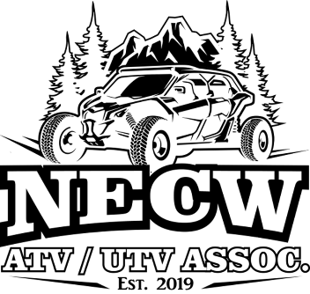
Northeast & Central Wisconsin ATV/UTV Association
Membership Application
January 1, 2023 – December 31, 2023
If not filled out and paid in-person please mail form to:
NECW ATV-UTV Assoc.
P.O. Box 454
Fremont, WI 54940
If sending a check please make payable to: NECW
If you have any questions please contact us at: necwisatv.utv@gmail.com
By signing this form you agree to abide by the Bylaws of the NECW ATV/UTV Association and conduct yourself accordingly when representing the Association. Membership can be revoked for reasons deemed unbecoming, non-payment of dues or other reasons according to the Bylaws determined by the Board.
You also agree to not hold a landowner or the Association liable for injuries suffered while riding on established trails. Members will abide by all WI State laws including but not limited to minors under 18 wearing helmets on all association rides.
Please Check One:
Individual Membership: $20 _____ Family Membership: $30______
NOTE: Memberships purchased within 60 days to end of current membership year will be included as part of the next year’s dues.
Member 1 (Primary) Name:___________________________________________________
Address: __________________________________________________________________
Phone: ___________________________Email: ___________________________________
Member 2 Name:____________________________________________________
Address: ___________________________________________________________________
Phone: ___________________________Email: ____________________________________
Minor member names:________________________________________________________
___________________________________________________________________________

Signature: ____________________________________________Date _________________
Signature: ____________________________________________Date _________________

