**First Fulshear Early Learning Center**

**A Preschool Ministry of First United Methodist Church, Fulshear**

**PARENT HANDBOOK**

**2022-2023**

**Director- Jill Samoff**

**30610 2nd Street**

**PO Box 1023 Fulshear, Texas 77441**

**281-533-0100**

***First Fulshear Early Learning Center,*** a Christ Centered Preschool Program will be hereinafter referred to as **FFELC** and First United Methodist Church of Fulshear will be referred to as **FUMCF**.

Others -

Texas State Department of Families and Child Protective Services **DFPS**

Lamar Consolidated Independent School District **LCISD**

Texas Education Association **TEA**

National Association for the Education of Young Children **NAEYC**

Community-Based Child Abuse Prevention Program **CBCAP**

Welcome,

I would like to personally welcome you to the First Fulshear Early Learning Center Family. We are so glad that you have chosen our school to meet your child’s educational needs for the 2022-2023 school year. I am starting my 26th year directing faith based early childhood centers. This is my 6th school year with First Fulshear.

You will find our teachers are experienced, nurturing and knowledgeable. All lead teachers in our program hold degrees in early childhood education, and we use Frog Street Curriculum as well as our own faith based curriculum that ties in with our academic curriculum.

I know that it can be stressful to leave your child, but I assure you that I will work very hard to make this a place where you feel confident leaving your child.  I am so excited to get to know each of you and your children!

Please know that I am available if you have any questions or concerns, you can visit me in my office here at the school or reach me by phone 281-533-0100 or email at fmelc.info@gmail.com

Sincerely,

Jill Samoff

Director, First Fulshear Early Learning Center

**Table of Contents**

**I. General FFELC Information**

Mission and Purpose 3

Our Goals 3

FFELC Governing Body 4

Our Staff 4

Licensing 4

Safe Sanctuary 4

Statement of Inclusion 4

Communication 5

Grounds for Removal from Program 5

Grievance Procedures 5

Gang Free Zone 5

**II. Admission Procedures**

Registration Procedures 6

Programs and Age Requirements 6

Forms 6

Immunizations 7

**III. Financial Procedures**

Tuition and Fees 7

Scholarships 8

Withdrawals/Refunds 8

**IV. Arrival and Dismissal Procedures**

Days and Hours of Operation 8

Inclement Weather Policy 9

Arrival and Dismissal 9

**V. Classroom Information**

What to Bring to School 9

What not to Bring to School 10

Dress Code 10

Toilet Habits 10

Our Curriculum 10

Special Class Activities 11

Rest Time 11

Guidance and Discipline 11

Parent Conferences 11

Family Involvement 11

**V. Classroom Information, continued**

Birthdays 12

Videos 12

Water Activity 12

Animals in the Classroom 12

Field Trips 12

Transportation 12

**VI. Food and Nutrition**

Lunch 12

Snacks 13

Nutritional Information 13

Food Allergies 13

Breast Feeding Policy 13

**VII. Health and Safety**

Cleanliness 13

Illness 13

Medical Emergency 14

Medications 14

Allergies 14

Immunizations 14

Vision and Hearing Screening 15

Tuberculin Testing Requirements 15

Emergency Preparedness Plan 15

Fire and Severe Weather Drills 15

Emergency Relocation Site 15

Playground Impact Material 15

Sunscreen and Insect Repellent 15

Social Networking Policy 16

Abuse and Neglect of Children 16

Attachment 1 – DFPS Guide for 16

Reporting Abuse/Neglect

Attachment 2 – A Parent’s Guide 19

To Daycare

1. **General FFELC Information**

**Mission and Purpose**

FFELC was established as an outreach ministry of FUMCF. Our purpose is to provide an opportunity for preschool age children in our community to work, play, learn and worship in a loving, safe, and caring Christian environment through experiences intended to foster a lifetime love for learning and create leaders in Christ. The FUMCF and the FFELC share a common mission of reaching ordinary people with the love of Christ and journeying with them in becoming extraordinary Christians. We are a caring organization where God ignites faith, changes lives and empowers people to reach children and families with the love of Christ.

**Our Goals**

-To provide learning experiences based on current child development theory within an environment where children are nurtured in the faith and grow as children of God.

-To aid each child in understanding cooperative relationships with other students and provide opportunities to learn about fairness, independence, cooperation, trust, self-control, empathy, sharing and kindness.

-To help each child begin an understanding of his/her emotions and how to creatively express them in constructive ways.

-To provide a stress-free environment that supports initiative, creativity, autonomy, and self-esteem.

-To stimulate curiosity for developing a greater understanding of the world in which the child lives.

-To equip children with language and perception skills that will lead to success in academic learning. -To encourage the development of small and large motor skills through a wide variety of indoor and outdoor activities.

**Our Staff**

The teaching staff of FFELC is selected on the basis of education, experience and the qualities of love and dedication to helping children grow in the early years. We believe the most important asset of our school is the quality of our teachers. All staff members are required to be CPR/First Aid certified, and have eight hours of pre-service training. Each year they must complete at least 24 hours of additional continuing education. As required by the state of Texas, all staff members are fingerprinted and have a background check in place. Substitutes are needed at times. We require that our substitutes have the same standards that we require of our permanent staff.

**Licensing**

We are licensed by DFPS. The FFELC is inspected by the DFPS, county health, and local fire departments. We follow the guidelines set out for us regarding staff qualifications, facility, playground, health, safety, school and personnel records, schedules and rates. A copy of the Texas State Minimum Standards for Child Care Centers is available in the FFELC office for your review at any time. Our most recent Licensing Inspection Report is available to you any time our center is open. Please ask the Director if you would like to review the report. Information about this facility is also available on the Texas Department of Protective and Regulatory Services website at [www.tdprs.state.tx.us.gov](http://www.tdprs.state.tx.us.gov). The Local DFPS phone number is 1-800-595-3007. To report child abuse use the toll-free Child Abuse Hotline number 1-800-252-5400 available 24 hours a day.

**Safe Sanctuary**

We follow the Safe Sanctuary guidelines set by FUMCF. A copy of this policy is kept in the FFELC office and can be viewed any time the FFELC is open. Our staff has completed training in the Safe Sanctuary guidelines.

**Statement of Inclusion**

FFELC is a ministry of FUMCF and an outreach to the community. All programs are open to all children, regardless of race, nationality, creed, or physical abilities provided the program can meet the needs of the child. For whatever reasons, if your child requires an additional aide to be with he/she at all times, this aide will be provided at the parent’s expense. We will handle each child on a case by case basis.

**Communication**

**Policy Changes:** Any policy changes will be provided to you in writing and posted. You must sign an acknowledgement form stating that you have received the notification. We will post any changes or events on our front door and next to our sign in sheet.

**Records Update:** We notify you by telephone if we need to reach you immediately. Please make sure you notify the Director of any phone number changes. **This includes work, home, and cell phone for you, the parents, as well as those of your emergency contacts.** Please also notify us of any change in your email address. We will occasionally contact you by email for non-emergency matters.

**Grounds for Removal from the Program**

Occasionally it may become necessary to remove a child from our program. Children may be removed from the program for the following reasons:

1. If a child is excessively or repeatedly abusive to our teachers or other children of FFELC.

2. If a child’s parent or guardian is rude or disrespectful to our staff including the use of

Profanity in our school building or grounds

3. for nonpayment of tuition

4. If it is determined by the Director that the child has developmental, medical or special needs that we cannot reasonably accommodate.

**Grievance Procedures**

All parents are encouraged to express questions, comments and concerns as they arise. In general, classroom issues should first be addressed with the teacher. If this does not result in a satisfactory resolution, or if the situation warrants another approach, parents should contact the Director. If still unresolved, the matter may be taken up as a last resort with the Senior Pastor Cary Wilkins. The Senior Pastor may be contacted through the church office at 8201 Harris Street, Fulshear.

Every effort will be made to resolve problems and issues related to the children, the FFELC, and the staff. The best interest of the children will be of highest importance.

**Gang Free Zone**

A gang free zone is a designated area around a specific location where prohibited gang related activity is subject to increased penalty under Texas law. The specific locations include day care centers. The gang free zone is within 1,000 feet of your child care center. For more information about what constitutes a gang free zone, please consult sections 71.028 and 71.029 of the Texas Penal Code. The local municipal or court house may produce and update maps for the purpose of prosecution. Parents may contact their local municipality or court house for information about obtaining a copy of a map if they choose to do so.

**II. Admission Procedures**

**Registration Procedures**

Registration for FFELC begins in January of the previous school year. At that time enrollment forms are available at the FFELC along with a form to specify your choice of program for the next school year. During the first two weeks of this registration period only current students and children of FUMCF members are enrolled. After the two-week period, registration is open to the community at large. During each enrollment period, enrollment is on a first come, first served basis. Your place will be held only upon payment in full of your non-refundable registration fee as well as receipt of your completed enrollment forms. You must complete new forms each year of attendance.

The FFELC reserves the right to cancel a program if there is not sufficient enrollment for that program during the enrollment period. If a program is cancelled by the FFELC, the registration fee will be refunded to the parent.

Children may be enrolled for the current FFELC session anytime vacancies are available.

Waitlist priority is given first to five day, second to three day and followed by two day program.

**Programs and Age Requirements**

**Preschool Program:** FFELC operates from 8:45 A.M. to 2:45 P.M. The two-day program meets on Tuesday/Thursday, the three-day program meets on Monday/Wednesday/Friday and the five day program meets Monday through Friday. We offer a two-year old program, a three-year old program, a four-year old program, and a kinder-bridge program. Children must have attained the age of their program on or before September 1, of the year they enter the program.

**Early Morning Care:** This program operates from 7:00 to 8:45 A.M. and is for FFELC preschool children, aged 2-5 only. There is an additional charge for Early Morning Care, and children must be enrolled to attend.

**After School Preschool Program:** This program operates from 2:45-6:00 P.M. and is for children enrolled in our preschool program. Limited numbers and enrollment required.

**After School K-5th Program:** This program operates from 2:45 to 6:00 P.M. and is for students enrolled at Morgan Elementary. (Homework time, snacks provided by parents, indoor/outdoor supervised play in gym or playground, board games, puzzles, construction toys, crafts and movie time are provided for these students.)

**Forms**

Enrollment Forms are available in the FFELC office or on the FFELC website at www.firstfulshearearlylearningcenter.com All forms necessary for enrollment, including immunization forms and Parent Handbook Acknowledgement Page, must be received in the office prior to the child being admitted to class. There are no exceptions.

**Immunizations**

You are required to provide us a record of your child’s immunizations signed by their physician. Children must meet applicable immunization requirements specified by the Texas Department of State Health Services in 25 TAC 97, Subchapter B from birth to 14 years. Only affidavits signed by a physician for medical reasons will be accepted. All immunizations required for your child’s age must be completed by the date of admission to our center. **No child may attend school without an up to date immunization record signed by their physician.**

**III. Financial Procedures**

**Tuition and Fees**

The monthly tuition for all programs is an annual amount divided into 9 equal payments. The first monthly tuition is due September 1st and the last month’s tuition is due May 1st. Credits or discounts cannot be given for absence due to illness, vacations, scheduled holidays, LCISD emergency closings or any FFELC emergency closings.

**Billing:** You will NOT be invoiced at the beginning of each month. You will receive a reminder invoice if payment is not received by the 3rd of the month, and late fee will be assessed if payments are not received by the 5th of the month.

**Payment:** We only accept payments by automatic bank draft or credit card. Credit card payments will include a 2.75% service fee.

**Late payment fee:** A $15.00 late payment fee will be assessed if tuition is not paid by the 5th working day of the month.

**Removal from program for nonpayment:** If payment is not made by the 15th calendar day of the month, your child may be removed for non-payment. If you need to set up a payment plan or pay at a different time, please call the Director to discuss options.

**Registration Fee:** Registration fees must be paid upon enrollment and are non-refundable.

**Supply Fee:** A supply fee is charged each semester for each program. The supply fees must be paid by the first day of attendance for each semester. The supply fees are non-refundable.

**Late Pick up Fee:** The fee is $1.00 for each minute you are late and is due on the day that you arrive late or will be billed on the next month’s invoice.

**Scholarships**

When funds are available, the FFELC BOD will award full or partial scholarships for preschool tuition based on demonstrated need. You may request a scholarship application from our Director.

**Withdrawals/Refunds**

Please notify us in writing to withdraw your child from our program. Be sure to date your letter and specify the last day your child will attend our school. **Registration and supply fees are non-refundable.** We require a 30 day notice of withdrawal be given.

Refunds are not given for absence due to illness, vacations, scheduled holidays, LCISD emergency closings or any FFELC emergency closings.

**IV. Arrival and Dismissal Procedures**

**Days and Hours of Operation**

We are open Monday through Friday, 7:00 A.M. to 6:00 P.M. We **generally** follow the schedule set by LCISD, including opening and closing day, but the calendar is set at the discretion of the Director. **We are closed on all student holidays set by the district**. The school calendar will be made available by the first week of school.

All doors are locked between the hours of 7:00 A.M. and 6:00 P.M. Parents are welcome to visit the FFELC at any time during our operating hours but during these hours you must enter at the main entrance and sign in at the FFELC office. Please be sure to sign out when you leave.

**Inclement Weather Policy**

If LCISD closes because of inclement weather, our school will be closed. If LCISD delays the opening of school we will delay our opening accordingly. If LCISD releases students early because of inclement weather, we will call parents to pick up their children early from the FFELC. Regardless If LCISD schedules make up days, we will not schedule make up days for bad weather. The Director reserves the right to cancel or operate the school in weather situation at her best discretion. There are no refunds for days missed because of inclement weather or other emergency closures.

**Arrival and Dismissal**

**Arrival:** All children must be walked to their classroom each morning. If you arrive before 8:40 A.M. with your preschool child, you will be asked to wait with your child in the foyer until the teacher is ready. If you arrive between 9:00 am-9:15 am, your child will be taken in by staff and you will not be allowed to walk your child in. **NO CHILDREN WILL** **BE ALLOWED TO COME TO SCHOOL AFTER 9:15am** unless this is previously arranged with the Director.

**Dismissal:** All children must be picked up through the car line. There will not be any walk ins or walk up pick-ups allowed. Please use the provided tag on your rearview mirror to help make pick up quicker.

If someone else besides you, the parent, is picking up the child, they must be on your authorized pick up list and provide photo identification.

If you are unable to pick up your child on time, please notify the school. There will be a late pick-up fee of $1.00 for each minute that you are late. The late fees will be billed on your next month’s invoice.

**V. Classroom Information**

**What to Bring to School**

* A washable, clearly labeled mat and blanket for your child to use during rest time. Please bring it in the bag we provide to you.
* A bag or backpack in which to store your child’s belongings while at school.
* Preschool students should bring a lunch with a drink packed in containers that will keep food hot or cold as needed and two snacks. (All food should be ready to eat without cutting up or reheating and **cannot contain peanuts or tree nuts)**
* Huggins Elementary students should bring bulk snacks and we will let you know when we run low
* A complete set of labeled clothing, including socks, in a gallon size plastic zip closure bag.
* Sufficient disposable diapers if your child is under three years of age.

**What Not to Bring**

Please do not send special objects or toys with your child. The item could be lost or damaged and we cannot accept that responsibility. On occasion, we may ask for special items from home to support our curriculum. Please do not send heirloom quality things.

**Dress Code**

Please dress your child in washable play clothes that allow for freedom of movement. Please send your child in tennis shoes. **No sandals, flip flops or boots of any type**. Children will play outdoors during all seasons and should be dressed appropriately.

Every child should have a complete change of clothing in their backpack. All articles of clothing should be clearly marked with the child’s name.

Although we make every reasonable effort to protect their clothing during class activities, spills could still occur. FFELC will not be responsible for damaged clothing.

**Our Curriculum**

FFELC uses the **Frog Street** **curriculum** which is a comprehensive, research-based preschool curriculum for ages two-five that focuses on the whole child. The curriculum incorporates learning into the preschooler’s day and helps teachers implement developmentally appropriate activities. We also incorporate our own faith based portion of the curriculum that ties in with our academic curriculum, this teaches basic bible stories.

Children are introduced to the Bible and will know several Bible stories, memory verses, nursery rhymes, finger plays and songs. Academic activities will be worked on and explored through various hands on experiences. Fine and gross motor skills as well as basic manners and self-care will also be part of our curriculum. Each class will have a set of objectives that each child will be able to successfully work towards.

In addition, the guidelines of the TEA for pre-kindergarten children may be used in conjunction with the **Frog Street** curriculum in our four-year-old classrooms to make way for a smooth, successful transition to kindergarten. These guidelines may be viewed online through the TEA website: <http://www.tea.state.tx.us/index2.aspx?id=2147495508&menu_id=2147483718> .

**Special Class Activities**

The preschool day includes a variety of daily learning experiences and indoor/outdoor play planned by the classroom teacher. In addition, Susan Hall, Children’s Minister for the FUMCF will provide your child with monthly chapel experiences, as well as faith-based stories designed for children. Other FUMCF staff may assist with these chapel experiences. All children will also participate in Music and Movement each week.

**Rest Time**

**We are required by the State** to provide a supervised sleep or rest period after lunch for all children 2 years of age or older who are in care five or more consecutive hours. Please provide a clearly labeled, washable mat and blanket for your child to use during rest time. We will send this home at the end of your child’s school week for you to wash and return on Monday. All children must be able to rest quietly. If your child is routinely disruptive at nap time causing others not to nap, they will not be allowed to stay for nap time.

**Guidance and Discipline**

We use positive methods of discipline and guidance that foster self-esteem, self-control and self-direction. We use conscious discipline in our program, which teaches children how to use techniques to control themselves. Our methods include praise and encouragement of good behavior. We remind children of behavior expectations daily using clear, positive statements. We redirect behavior using positive statements. We may use brief supervised separation or time out from the group when appropriate for the child’s age and development. These time outs or supervised separation times are limited to no more than one minute per year of the child’s age.

**Parent Conferences**

Parents may request a conference with a teacher if they would like to discuss their child’s progress. Please call the FFELC to make an appointment with the teacher.

Teachers will schedule a conference with a child’s parents any time the teacher feels there is a need.

**Family Involvement**

Parents are welcome to visit the FFELC during our normal hours. Please check in with the Director when you enter the building, to sign in, before visiting your child’s classroom. Please sign out when you leave. If you would like to help your child’s classroom teacher, please let them know. Your participation and ideas are a valuable part of the learning experiences of our children here at FFELC. Your help is always appreciated! There will be several special events during the school year that you will want to attend with your child.

**Birthdays**

On your child’s birthday, you may send a birthday snack for your child’s classmates. All birthday snacks must be store bought and prepackaged with ingredients listed. Check with your child’s teacher for their preference**. Please do not send snacks containing peanuts or tree nuts.**

**Videos**

Occasionally the children will be shown videos at FFELC. We will follow state guidelines for the use of videos in our licensed center. Most videos will correspond to our curriculum or to a holiday.

**Water Activity**

The only water activity at FFELC may be sprinkler play or water tables. We will let you know well in advance if, and when this may happen. This will allow you to provide consent and send appropriate clothing and towel.

**Animals in the Classroom**

There are no live animals in our classrooms but we may have visits with live animals throughout the year to complement our thematic units. You will be made aware of this before it happens.

**Field Trips**

We may have off-campus walking tours. We will let you know when this may happen to allow you to provide consent.

**Transportation**

At this time, we do not provide transportation from elementary schools to our center.

**VI. Food and Nutrition**

**Lunch**

Each pre-school child needs to bring a lunch with a drink every day. Lunches should be nutritious and ready to eat without cutting up or reheating. Please do not send food that requires microwaving. Lunches should be packed in containers that will keep food cold or hot as needed. **Please do not send items containing peanuts or tree nuts in your child’s snack or meals.**

**Snacks**

Pre-school students need to bring two nutritious, ready to serve snacks each day, peanut and tree nut free.

After school students from Morgan Elementary, need to bring one nutritious, ready to serve snack each day, peanut and tree nut free.

**Nutritional Information**

Parents will provide their individual child’s lunch and snacks from home. We are not licensed for and therefore are not permitted to prepare nor provide food for our students on a regular basis. The parent understands that FFELC is not responsible for the nutritional value of their child’s lunch that is brought from home and is not responsible for meeting the child’s daily food needs. Preschool parents will be given a food guideline.

**Food Allergies**

Please keep FFELC informed about any allergies your child may have. It is extremely important that your child’s teacher be aware of anything your child may have a reaction to. A food allergy must be accompanied with a physician’s diagnoses and plan of action. If your child requires an Epi-Pen, an Emergency Plan of Action must be on file. Parents must fill out a severe allergy packet that will have to be signed by you and the doctor. We must have 2 Epi Pens and a bottle of Benadryl.

**VII. Health and Safety**

**Cleanliness**

We take precautions to provide a safe and healthy environment for your child. We employ a cleaning service to clean the classrooms and restrooms when the children are not present. We wash hands before and after meals, as well as after each restroom use. We also wash hands when entering the building from outside. We wipe our tables before meals.

**Illness**

If your child gets sick at school, we will notify you as soon as possible. If your child has a fever, they are not permitted to return to school until they have remained fever-free for 24 hours without medication. Any temperature 99 degrees or above is considered fever. Your child will not be allowed to attend school until it has been 24 hours since your child has last vomited or had diarrhea. If your child or immediate family member contracts a communicable disease, please notify us immediately. Following illness with a communicable disease, your child will not be readmitted to the center without a clearance note from your doctor. If we have any concerns about your child’s health, including signs of illness and injury in response to changes in your child’s behavior since last date of attendance, we will contact you. Please help us by keeping your child at home if he/she has a heavy nasal discharge, has a constant cough or is irritable or generally is not them self.

**Medical Emergency**

In the event of an accident or emergency, parents will be notified as quickly as possible. Teachers will administer minor first-aid. We will provide a report to you in the event of a minor accident at FFELC. In the event of a more serious injury, you will be notified and an emergency vehicle will be called to transport your child to a medical facility.

**Medications**

We do not administer medication unless it is for purposes where an epi-pen or inhaler needs to be used. If children have these medications, we much have a full asthma or allergy action plan from a doctor on file with the medications.

**Immunizations**

You are required to provide us a record of your child’s immunizations signed by their physician. Children must meet applicable immunization requirements specified by the Texas Department of State Health Services in 25 TAC 97, Subchapter B from birth to 14 years. All immunizations are required for your child’s age and must be completed by the date of admission to our center. **N**o **child may attend school without an up-to-date immunization record signed by their physician. If your child does not have immunizations due to a medical condition we must have a statement from your doctor on file.** The school does not allow a child to attend who has not had their immunizations due to personal beliefs. Please notify the Director of the FFELC to make arrangements. At this time, we do not require employees to provide record of immunizations.

**Vision and Hearing Screening**

State law requires all children that attend daycare, who are four-years-old by September 1st, to have a vision and hearing screening within 120 days of admission. These screenings are usually done by your physician at your child’s four-year-old well visit. Please have your physician provide you with a copy to put in your child’s file here at FFELC.

**Tuberculin Testing Requirements**

TB testing is required if the regional Texas Department of State Health Services or local health authority requires testing. At this time, testing is **not** required for admission.

**Emergency Preparedness Plan**

Emergency Plans, including evacuation routes, are posted in each classroom and in any area used by the staff and/or children of the FFELC. Emergency phone numbers are posted by each telephone. Teachers at FFELC keep a clipboard with them at all times which contains copies of your child’s contact information and authorization release to obtain emergency medical services.

**Emergency Drills**

Fire drills are practiced monthly at FFELC. Severe weather drills are held every three months.

Records of these drills are kept in the FFELC office and the Fire Marshal examines them on their annual visit. Lock down drills are held every three months. Records of these drill are kept in the FFELC office.

**Emergency Relocation Site**

Should we need to relocate our students, we will move with them to the Sanctuary of the FUMCF. If this is not possible, we will move to the Bob Lutts Fulshear/Simonton Public Library located at

8100 FM 359 South, Fulshear, TX 77441.

**Playground Impact Material**

The playground equipment at FFELC is surrounded with an area of playground impact material as required by the Texas State DFPS Minimum Standards.

**Social Networking Policy**

It is the policy of FFELC that our teachers and staff members do not “friend” the parents of the children in the center on Facebook or any other social media. We also request that you refrain from posting pictures of your child’s classmates on your Facebook page without specific permission from the child’s parent. We want to protect the privacy of all involved.

**Abuse and Neglect of Children**

Child abuse is any act that endangers or impairs a child’s physical or emotional health and development. Our staff is required to have one hour of training each year on preventing and responding to abuse and neglect of children. Some of the common signs of abused and neglected children are: overall poor care, child afraid of their parents, have injuries that seem inadequately treated, bear welts, bruises, or sores, sudden changes in behavior and absence of supervision. Any teacher must report child abuse or neglect to DFPS. The abuse hotline is available 24 hours a day, 365 days a year. They can be reached at 1-800-252-5400 or at [www.txabusehotline.org](http://www.txabusehotline.org) . For life threatening situations, call 911. Anyone can report abuse or neglect to DFPS. For assistance or intervention of abuse or neglect, you can contact the Fort Bend Women’s Center at 281-342-4357 at any time, 24 hours a day. For more information, please visit <http://www.dfps.state.tx.us>

For your information, we have enclosed in this handbook, Texas Department of Family & Protective Services (DFPS) Reporting Abuse/Neglect Guide which can also help you with some of the questions you may have.

There is a procedure in place for our Director and Staff members for reporting suspected abuse or neglect. Please keep in mind that due to the confidential nature of such reports, no information concerning the incident can be shared with other staff members or parents.

**Attachments**

1. Texas Department of Family & Protective Services (DFPS) Guide for Reporting Abuse/Neglect
2. A Parent’s Guide to Day Care
3. Parent Handbook Acknowledgement Page – which needs to be signed and returned to the school.

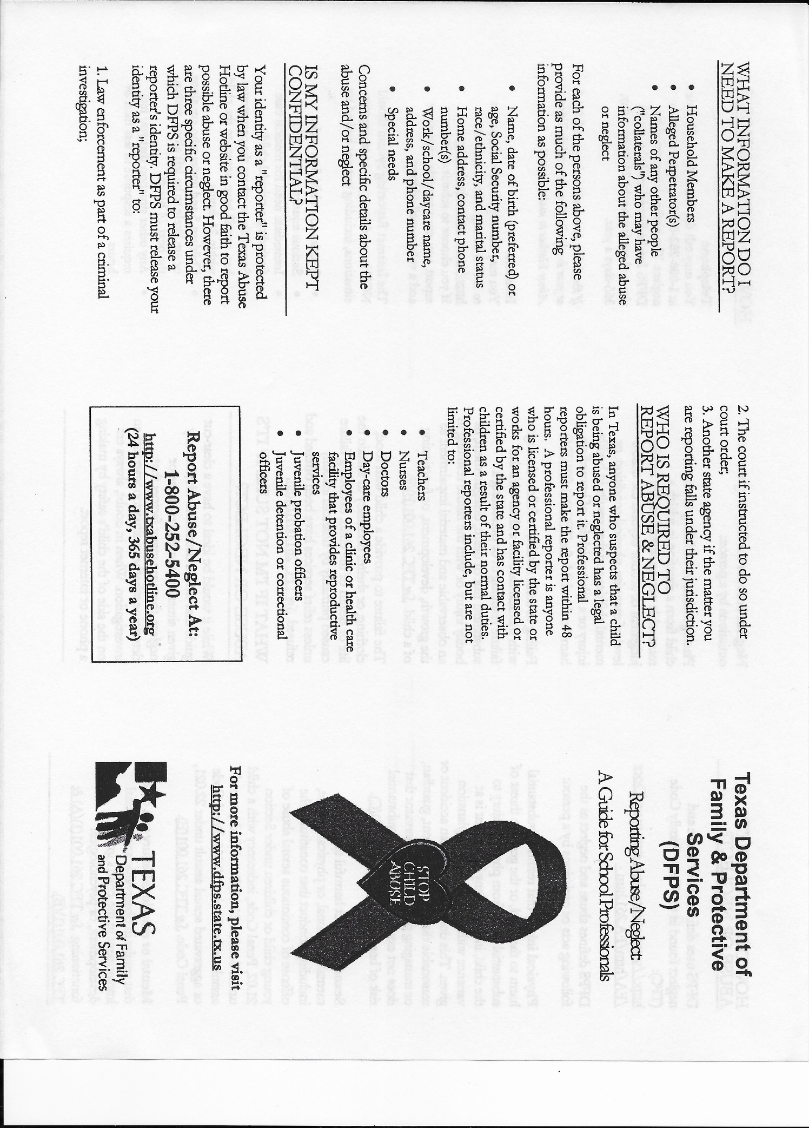

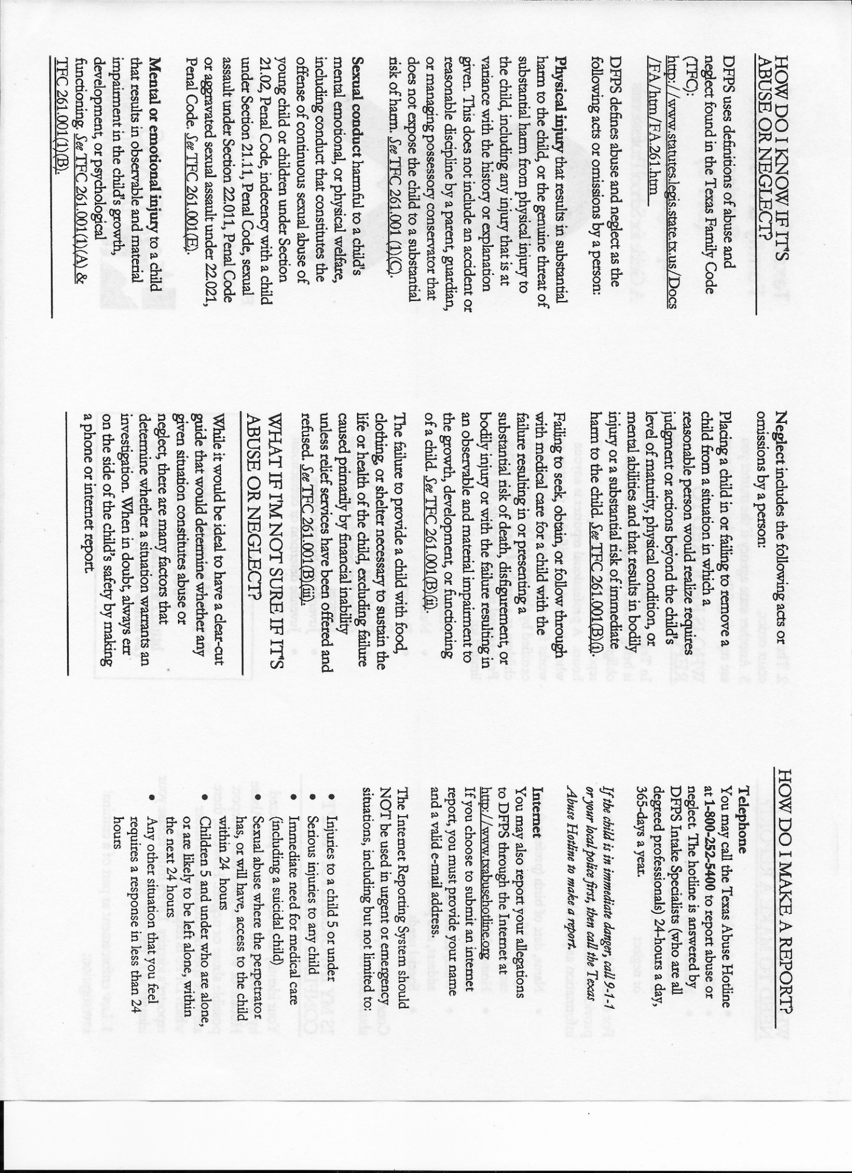



**Establish a good relationship with the day-care facility**

* Spend time at the day-care facility before you enroll your child. Ask questions about the program and observe the activities. Make sure the day-care facility has all the information needed about your child and family to provide good care.
* Work with the staff of the day-care facility you choose. Parent involvement is an important part of a successful experience with day care.
* Read all the material the day-care provider gives you. In addition to material required by licensing standards, each facility has its own policies and requirements. It’s important that you understand these requirements before you enroll your child. It’s equally important, once your child is in care, to read the notices, special requests, notes, and other materials the day-care provider sends home.
* Drop in occasionally during the day to observe how your child interacts with staff and other children, and get a good picture of the day-to-day activities at the center. Be careful not to disrupt activities.
* Keep your side of the bargain. Pick up your child on time.
* Discuss concerns with the day-care director. Be aware that the teacher’s main responsibility is working with the children. Don’t be offended if the teacher can’t spend much time talking with you when you drop off or pick up your child. If you need more time to talk about your child, set up a conference.
* It’s important to let the day-care facility know about things at home that may affect how your child is doing in day care.

**When your child starts day care**

* Remember that it’s normal for a child to have some fears and misgivings about starting day care. Children need time to get used to new situations. Prepare your children for the change as far in advance as possible. Discuss their concerns. If you’re enthusiastic, chances are they soon will be, too.
* Depending on their ages, some children will temporarily “act out” their feelings by clinging to you and refusing to let go, forgetting their toilet training, having bad dreams, sucking their thumbs, or other such behavior.
* Work with the day-care director and your child’s teacher on this.

**Talk things over with your child**

Make an opportunity each day to gently ask questions when your children are quiet and feeling secure and protected. Share their excitement about new friends, new skills, and new abilities; listen to their concerns; and give them a chance to boast about their achievements.

**Parent responsibilities**

The day-care facility must get certain information and records from parents to ensure the child’s health and safety, handle emergencies, and meet minimum standards. If you do not provide this material, the day-care facility will not be in compliance with the minimum standards.

* Complete an enrollment form that includes basic information about your child; telephone numbers where you can be reached during the day; authorization for emergency care for your child; and written permission for swimming, other water activities, and transportation services.
* Tell the caregiver about any special concerns or needs, including allergies, medical history, and current medications.
* Give the day-care facility a copy of your child’s immunization record showing immunizations against diphtheria, tetanus, pertussis, polio, measles, mumps, rubella, Hemophilus influenza type b, Hepatitis B and varicella. In some parts of Texas, a tuberculosis test report and Hepatitis A vaccine is also required. For school-age children, you can sign a statement that these records are on file at the school.
* Provide a doctor’s statement that your preschool child is physically able to participate in the day-care program.
* Inform the day-care facility in writing about who is permitted to take your child from the facility. Generally, the day-care facility may only release your child to you or to an adult you designate.
* The facility may allow a school-age child to leave the facility alone or allow an older brother or sister to pick up a child if you request this in writing. The facility is only allowed to do this when all safety considerations have been met.
* Make sure that child-care staff know the child has arrived. Make sure that staff are aware when you come to pick up your child. Don’t leave your child at the front door, and never leave your child at the facility before opening or after closing.
* Other requirements must be met if the day-care provider gives medication to your child, if your child is an infant, or if your child needs special care or a special diet.

**What happens if your child is ill or injured?**

* The day-care facility is not allowed to admit a child who seems to be sick unless a doctor or nurse gives approval in writing. This may cause problems for parents, but it is necessary to prevent a sick child from infecting other children.
* If your child has been absent because of a contagious illness, the day-care facility must follow guidelines concerning when the child can return to day care.
* If your child appears seriously sick or injured while at the center, the caregiver must call you immediately. It’s important that you pick up your child as soon as possible.
* If your child needs immediate medical attention, the center must call your child’s physician, take the child to the nearest emergency room or minor emergency clinic, or call for an ambulance. This is why the day-care facility must have your authorization for emergency medical care.

**Liability insurance requirements**

* Ask the day-care director whether or not the facility carries liability insurance. Texas law requires day-care facilities to carry liability coverage in the amount of $300,000 per occurrence to cover a child when the child is in care of the facility.
* Liability insurance coverage is not required if the insurance cannot be secured due to financial reasons; if the licensee is unable to locate an underwriter willing to issue a policy; or if the current policy limits have been extended. You are to be notified, in writing, that the coverage is not available.

**Take a good look**

As you become more familiar with your child’s day-care program, you will see many strong points. Almost all day-care facilities strive to provide a warm, loving, safe, and healthy environment for children. Look for these characteristics, but also be aware of warning signals that tell you something is wrong.

Feel secure when you see that:

* the facility welcomes you to visit any time, and you are invited to observe the class or participate in activities.
* staff are alert and involved with the children.
* staff seem warm and interested in the children. There is spontaneous laughter, hugging, and eye-to-eye contact.
* staff are gentle, but firm when necessary.
* the facility is clean and attractive.
* your child is relaxed and happy after the initial adjustment period.
* your child seems physically well cared for. Staff inform you of minor accidents and tell you when your child doesn’t feel well.
* children seem involved with constructive activities, and they get individual attention.

**Be seriously concerned when you see that:**

* parents are not encouraged to visit the facility.
* children are left without direct adult supervision.
* adults spend much time scolding, ordering, and yelling at children.
* adults are physically rough with children or allow rough play.
* the building is dirty, or you see unsafe conditions.
* your child is unhappy about being left at the facility, and this doesn’t improve with time.
* a child comes home bruised or injured, and the center can’t explain what happened. (The child may not remember minor bruises and scrapes received when playing, however.)
* children seem aimless, bored, angry, or frustrated, or there are too many children to supervise.

**When things aren’t going well**

You may find yourself displeased about something that has happened at the facility. Talk about these things with facility staff. There may be a misunderstanding that can easily be resolved.

If the situation isn’t resolved and you believe ­minimum standards are not being met, call the local day-care licensing office. They will handle your call discreetly.

A licensing representative will investigate your complaint. The licensing representative may need to interview you and your child and may also interview other children at the facility.

If the licensing representative finds that a standard has been violated, the facility will be notified and a time set for the facility to correct it.

Licensing staff may revoke a license if a facility doesn’t meet minimum standards. The

department does not take action to revoke a license unless children are in immediate danger or the licensee refuses to comply with standards.

**If you suspect child abuse**

Most day-care facilities, like most parents, take good care of children. Child abuse is rare, and it is very unlikely that anything like this will happen to your child.

If you do suspect that your child has been abused or sexually molested, report the situation immediately. Use the **toll-free Child Abuse Hotline number 1-800-252-5400 or 1-512-834-3784** to report abuse or neglect that has occurred in Texas. The situation will be investigated immediately, and you will be given referrals or recommendations for help for your child and family.

Should agency staff interview or examine your child during an abuse investigation, a reasonable effort will be made to notify you within 24 hours after the interview or examination.

Parents who suspect or believe that their child has been abused in day care sometimes remove their child from care, but don’t report the problem. This leaves other children in danger. State law requires everyone, including day-care providers, to report suspected child abuse or neglect immediately.

**Immunity**

When people make a report of suspected child abuse in good faith, they are immune from any liability when the department investigates a complaint, the identity of the complainant is not revealed.

<https://www.dfps.state.tx.us/Child_Care/Other_Child_Care_Information/parent-d.asp>

Child Care Information Line at 1-800-862-5252.

**This Parent Handbook is effective as of August 22, 2022, and replaces all previously issued Parent Handbooks of FFELC.**

**Acknowledgement Page**

Child’s Printed Name _______________________________________

I have received a copy of the FFELC Parent Handbook for the school year 2022-2023 and agree to abide by the policies and procedures stated in the Handbook.

Parent’s Printed Name___________________________________________

Parent’s Signature_______________________________________________

Date_________________________________

The original of this form must be submitted to the Director of the FFELC before the above-named child may attend the School.