Fulshear Early Learning Center
A Preschool Ministry of Union Chappel, A Global Methodist community Fulshear, Texas


PARENT HANDBOOK
2026-2027

Director- Jill Samoff

30610 2nd Street
Fulshear, Texas 77441
281-533-0100
Fulshear Early Learning Center, a Christ Centered Preschool Program will be hereinafter referred to as FELC and Union Chappel
Others -
Texas State Department of Families and Child Protective Services DFPS
Lamar Consolidated Independent School District LCISD
Texas Education Association TEA
National Association for the Education of Young Children NAEYC
Community-Based Child Abuse Prevention Program CBCAP

Welcome,

I would like to personally welcome you to the Fulshear Early Learning Center Family. We are so glad that you have chosen our school to meet your child’s educational needs for the 2026-2027 school year. I am currently in my 31st year of directing faith based early childhood programs. This is my 10th school year at First Fulshear.
You will find our teachers are experienced, nurturing and knowledgeable. All lead teachers in our program hold degrees in early childhood education, and we use Frog Street Curriculum as well as our own faith-based curriculum that ties in with our academic curriculum.
I know that it can be stressful to leave your child, but I assure you that I will work very hard to make this a place where you feel confident leaving your child. I am so excited to get to know each of you and your children!
Please know that I am available if you have any questions or concerns, you can visit me in my office here at the school or reach me by phone 281-533-0100 or email at fmelc.info@gmail.com

Sincerely,

Jill Samoff
Director, Fulshear Early Learning Center
Table of Contents

I. General FELC Information
Mission and Purpose 3
Our Goals 3
FELC Governing Body 4
Our Staff 4
Licensing 4
Safe Sanctuary 4
Statement of Inclusion 4
Communication 5
Grounds for Removal from Program 5
Grievance Procedures 5
Gang Free Zone 5
II. Admission Procedures
Registration Procedures 6
Programs and Age Requirements 6
Forms 6
Immunizations 7
III. Financial Procedures
Tuition and Fees 7
Scholarships 8
Withdrawals/Refunds 8
IV. Arrival and Dismissal Procedures
Days and Hours of Operation 8
Inclement Weather Policy 9
Arrival and Dismissal 9
V. Classroom Information
What to Bring to School 9
What not to Bring to School 10
Dress Code 10
Toilet Habits 10
Our Curriculum 10
Special Class Activities 11
Rest Time 11
Guidance and Discipline 11
Parent Conferences 11
Family Involvement 11

V. Classroom Information, continued
Birthdays 12
Videos 12
Water Activity 12
Animals in the Classroom 12
Field Trips 12
Transportation 12
VI. Food and Nutrition
Lunch 12
Snacks 13
Nutritional Information 13
Food Allergies 13
Breast Feeding Policy 13
VII. Health and Safety
Cleanliness 13
Illness 13
Medical Emergency 14
Medications 14
Allergies 14
Immunizations 14
Vision and Hearing Screening 15
Tuberculin Testing Requirements 15
Emergency Preparedness Plan 15
Fire and Severe Weather Drills 15
Emergency Relocation Site 15
Playground Impact Material 15
Sunscreen and Insect Repellent 15
Social Networking Policy 16
Abuse and Neglect of Children 16
Attachment 1 – DFPS Guide for 16
Reporting Abuse/Neglect
Attachment 2 – A Parent’s Guide 19
To Daycare

- General FFELC Information

Mission and Purpose
FELC was established as an outreach ministry of First Fulshear Methodist Church (now Union Chappel). Our purpose is to provide an opportunity for preschool age children in our community to work, play, learn and worship in a loving, safe, and caring Christian environment through experiences intended to foster a lifetime love for learning and create leaders in Christ. The church and the school share a common mission of reaching ordinary people with the love of Christ and journeying with them in becoming extraordinary Christians. We are a caring organization where God ignites faith, changes lives and empowers people to reach children and families with the love of Christ.

Our Goals
-To provide learning experiences based on current child development theory within an environment where children are nurtured in the faith and grow as children of God.
-To aid each child in understanding cooperative relationships with other students and provide opportunities to learn about fairness, independence, cooperation, trust, self-control, empathy, sharing and kindness.
-To help each child begin an understanding of his/her emotions and how to creatively express them in constructive ways.
-To provide a stress-free environment that supports initiative, creativity, autonomy, and self-esteem.
-To stimulate curiosity for developing a greater understanding of the world in which the child lives.
-To equip children with language and perception skills that will lead to success in academic learning. -To encourage the development of small and large motor skills through a wide variety of indoor and outdoor activities.

Our Staff
The teaching staff of FELC is selected on the basis of education, experience and the qualities of love and dedication to helping children grow in the early years. We believe the most important asset of our school is the quality of our teachers. All staff members are required to be CPR/First Aid certified, and have eight hours of pre-service training. Each year they must complete at least 24 hours of additional continuing education. As required by the state of Texas, all staff members are fingerprinted and have a background check in place. Substitutes are needed at times. We require that our substitutes have the same standards that we require of our permanent staff.

Licensing
We are licensed by DFPS. The FFELC is inspected by the DFPS, county health, and local fire departments. We follow the guidelines set out for us regarding staff qualifications, facility, playground, health, safety, school and personnel records, schedules and rates. A copy of the Texas State Minimum Standards for Child Care Centers is available in the FFELC office for your review at any time. Our most recent Licensing Inspection Report is available to you any time our center is open. Please ask the Director if you would like to review the report. Information about this facility is also available on the Texas Department of Protective and Regulatory Services website at www.tdprs.state.tx.us.gov. The Local DFPS phone number is 1-800-595-3007. To report child abuse use the toll-free Child Abuse Hotline number 1-800-252-5400 available 24 hours a day.
Your rights as a parent:

** Entering the operation without advance notice; you have a right to visit the operation without advance notice.
**Filing a complaint against the operation; You may file a complaint at https://www.dfps.texas.gov/Child_Care/ or by calling 713-287-3238
** You have a right to review: ▪ The operation’s publicly accessible records; ▪ Written records about the parent’s child; ▪ Any available video recordings maintained by the operation of an alleged incident of abuse or neglect involving the parent's child, with certain restrictions; and ▪ Staff training records and any in-house training curriculum;
** Receiving from the operation: HHSC inspection reports regarding the operation; and Information regarding how to access the operation’s compliance history online;
** Having the operation comply with a valid court order signed by a judge that prevents another parent from visiting or removing the parent’s child from the operation. The operation must comply with the court order as outlined in §§744.2801(b), 746.4101(b), or 747.3901(b), and keep a copy of the court order in the child’s file;
** Being free from retaliation for exercising the parent’s rights.

Safe Sanctuary
We follow the Safe Sanctuary guidelines set by Union Chappel. A copy of this policy is kept in the FELC office and can be viewed any time the FELC is open. Our staff has completed training in the Safe Sanctuary guidelines.

Statement of Inclusion
FELC is a ministry of Union Chappel and an outreach to the community. All programs are open to all children, regardless of race, nationality, creed, or physical abilities provided the program can meet the needs of the child. For whatever reasons, if your child requires an additional aide to be with he/she at all times, this aide will be provided at the parent’s expense. We will handle each child on a case by case basis.

Communication
Policy Changes: Any policy changes will be provided to you in writing and posted. You must sign an acknowledgement form stating that you have received the notification. We will post any changes or events on our front door and next to our sign in sheet.
Records Update: We notify you by telephone if we need to reach you immediately. Please make sure you notify the Director of any phone number changes. This includes work, home, and cell phone for you, the parents, as well as those of your emergency contacts. Please also notify us of any change in your email address. We will occasionally contact you by email for non-emergency matters.

Grounds for Removal from the Program
Occasionally it may become necessary to remove a child from our program. Children may be removed from the program for the following reasons:
1. If a child is excessively or repeatedly abusive to our teachers or other children of FELC.
2. If a child’s parent or guardian is rude or disrespectful to our staff including the use of
Profanity in our school building or grounds
3. for nonpayment of tuition
4. If it is determined by the Director that the child has developmental, medical or special needs that we cannot reasonably accommodate.

Grievance Procedures
All parents are encouraged to express questions, comments and concerns as they arise. In general, classroom issues should first be addressed with the teacher. If this does not result in a satisfactory resolution, or if the situation warrants another approach, parents should contact the Director. If still unresolved, the matter may be taken up as a last resort with the Senior Pastors Bill Hogan or Erik Gragert. The Senior Pastors may be contacted through the church office at 8201 Harris Street, Fulshear 281-346-1416
Every effort will be made to resolve problems and issues related to the children, the FELC, and the staff. The best interest of the children will be of highest importance.

Gang Free Zone
A gang free zone is a designated area around a specific location where prohibited gang related activity is subject to increased penalty under Texas law. The specific locations include day care centers. The gang free zone is within 1,000 feet of your child care center. For more information about what constitutes a gang free zone, please consult sections 71.028 and 71.029 of the Texas Penal Code. The local municipal or court house may produce and update maps for the purpose of prosecution. Parents may contact their local municipality or court house for information about obtaining a copy of a map if they choose to do so.

II. Admission Procedures

Registration Procedures
Registration for FELC begins in January of the previous school year. At that time enrollment forms are available at the FELC along with a form to specify your choice of program for the next school year. During the first week of this registration period only current students and children of Union Chappel members are enrolled. After the one week period, registration is open to the community at large. During each enrollment period, enrollment is on a first come, first served basis. Your place will be held only upon payment in full of your non-refundable registration fee as well as receipt of your completed enrollment forms. You must complete new forms each year of attendance.
The FELC reserves the right to cancel a program if there is not sufficient enrollment for that program during the enrollment period. If a program is cancelled by the FELC, the registration fee will be refunded to the parent.
Children may be enrolled for the current FELC session anytime vacancies are available.

Programs and Age Requirements
Preschool Program: FELC operates from 8:45 A.M. to 2:45 P.M. The two-day program meets on Tuesday/Thursday, the three-day program meets on Monday/Wednesday/Friday and the five day program meets Monday through Friday. We offer a two-year old program, a three-year old program, a four-year old program, and a kinder-bridge program. Children must have attained the age of their program on or before September 1, of the year they enter the program.
Early Morning Care: This program operates from 7:00 to 8:45 A.M. and is for FELC preschool children, aged 2-5 only. There is an additional charge for Early Morning Care, and children must be enrolled to attend.
After School Preschool Program: This program operates from 2:45-6:00 P.M. and is for children enrolled in our preschool program. Limited numbers and enrollment required.

Forms
Enrollment Forms are available in the FELC office or on the FELC website at www.firstfulshearearlylearningcenter.com All forms necessary for enrollment, including immunization forms and Parent Handbook Acknowledgement Page, must be received in the office prior to the child being admitted to class. There are no exceptions.

Immunizations
You are required to provide us a record of your child’s immunizations signed by their physician. Children must meet applicable immunization requirements specified by the Texas Department of State Health Services in 25 TAC 97, Subchapter B from birth to 14 years. Only affidavits signed by a physician for medical reasons will be accepted. All immunizations required for your child’s age must be completed by the date of admission to our center. No child may attend school without an up to date immunization record signed by their physician.

III. Financial Procedures

Tuition and Fees
The monthly tuition for all programs is an annual amount divided into 9 equal payments. The first monthly tuition is due September 1st and the last month’s tuition is due May 1st. Credits or discounts cannot be given for absence due to illness, vacations, scheduled holidays, LCISD emergency closings or any FFELC emergency closings. After school program for Morgan Elementary is charged ½ month for August.
Billing: Accounts will be billed and charged on the 1st of every month, you must have a payment method on file. A reminder email will be sent on the 1st of every month, If you need a receipt, you must request one at fmelc.info@gmail.com.
Payment: We only accept payments by automatic bank draft or credit card. Credit card payments will include a 2.75% service fee.
Late payment fee: A $15.00 late payment fee will be assessed if tuition is not paid by the 5th working day of the month.
Removal from program for nonpayment: If payment is not made by the 15th calendar day of the month, your child may be removed for non-payment. If you need to set up a payment plan or pay at a different time, please call the Director to discuss options.
Registration Fee: Registration fees must be paid upon enrollment and are non-refundable for any reason.
Supply Fee: A supply fee is charged each semester for each program. The supply fees must be paid by the first day of attendance for each semester. The supply fees are non-refundable.

Late Pick up Fee: The fee is $1.00 for each minute you are late and is due on the day that you arrive late or will be billed on the next month’s invoice.

Withdrawals/Refunds
Please notify us in writing to withdraw your child from our program. Be sure to date your letter and specify the last day your child will attend our school. Registration and supply fees are non-refundable. We require a 30 day notice of withdrawal be given.
Refunds are not given for absence due to illness, vacations, scheduled holidays, LCISD emergency closings or any FELC emergency closings.

IV. Arrival and Dismissal Procedures
Days and Hours of Operation
We are open Monday through Friday, 7:00 A.M. to 6:00 P.M. We generally follow the schedule set by LCISD, but the calendar is set at the discretion of the Director. The school calendar will be made available by the first week of school.
All doors are locked between the hours of 7:00 A.M. and 6:00 P.M. Parents are welcome to visit the FELC at any time during our operating hours but during these hours you must enter at the main entrance and sign in at the FELC office. Please be sure to sign out when you leave.
Any child that arrives after 9:30am without prior approval from the Director will not be allowed to attend for that day. Please have your child to school by 9am to ensure that they have time to transition into class and not miss important learning times.

Inclement Weather Policy
If LCISD closes because of inclement weather, our school will be closed. If LCISD delays the opening of school we will delay our opening accordingly. If LCISD releases students early because of inclement weather, we will call parents to pick up their children early from the FFELC. Regardless If LCISD schedules make up days, we will not schedule make up days for bad weather. The Director reserves the right to cancel or operate the school in weather situation at her best discretion. There are no refunds for days missed because of inclement weather or other emergency closures.

Arrival and Dismissal
Arrival: All children must be walked to their classroom each morning. If you arrive before 8:45 A.M. with your preschool child, you will be asked to wait with your child in the foyer until the teacher is ready. If you arrive between 9:00 am-9:30 am, your child will be taken in by staff and you will not be allowed to walk your child in. NO CHILDREN WILL BE ALLOWED TO COME TO SCHOOL AFTER 9:30am unless this is previously arranged with the Director.

Dismissal: All children must be picked up at the classroom door.
If someone else besides you, the parent, is picking up the child, they must be on your authorized pick up list and provide photo identification.

Only staff and children are allowed in the classroom. Please leave your child at the door.

V. Classroom Information

What to Bring to School
- A washable, clearly labeled mat and blanket for your child to use during rest time. Please bring it in the bag we provide to you. Please save and return the bag we provide weekly after you wash your child’s nap mat.
- A bag or backpack in which to store your child’s belongings while at school. Please ensure the backpack is large enough to hold a standard folder.
- Preschool students should bring a lunch with a drink packed in containers that will keep food hot or cold as needed and two snacks. (All food should be ready to eat without cutting up or reheating and cannot contain any nut products including Nutella) If food is not cut up properly, it will not be given to your child.
- Morgan Elementary students should bring bulk snacks and we will let you know when we run low
- A complete set of labeled clothing, including socks, in a gallon size plastic zip closure bag.
- Sufficient disposable diapers if your child is under three years of age.

What Not to Bring
Please do not send special objects or toys with your child. The item could be lost or damaged and we cannot accept that responsibility. On occasion, we may ask for special items from home to support our curriculum. Please do not send heirloom quality things.
- Please do not bring food with bones in it.
- Please do not send glass of any type in your child’s lunchbox

Dress Code
Please dress your child in washable play clothes that allow for freedom of movement. Please send your child in tennis shoes. No sandals, crocs, flip flops or boots of any type. Children will play outdoors during all seasons and should be dressed appropriately.
Every child should have a complete change of clothing in their backpack. All articles of clothing should be clearly marked with the child’s name.
Although we make every reasonable effort to protect their clothing during class activities, spills could still occur. FELC will not be responsible for damaged clothing.

Our Curriculum
FELC uses the Frog Street curriculum which is a comprehensive, research-based preschool curriculum for ages two-five that focuses on the whole child. The curriculum incorporates learning into the preschooler’s day and helps teachers implement developmentally appropriate activities. We also incorporate our own faith based portion of the curriculum that ties in with our academic curriculum, this teaches basic bible stories.
Children are introduced to the Bible and will know several Bible stories, memory verses, nursery rhymes, finger plays and songs. Academic activities will be worked on and explored through various hands on experiences. Fine and gross motor skills as well as basic manners and self-care will also be part of our curriculum. Each class will have a set of objectives that each child will be able to successfully work towards.
In addition, the guidelines of the TEA for pre-kindergarten children may be used in conjunction with the Frog Street curriculum in our four-year-old classrooms to make way for a smooth, successful transition to kindergarten. These guidelines may be viewed online through the TEA website: http://www.tea.state.tx.us/index2.aspx?id=2147495508&menu_id=2147483718 .

Special Class Activities
The preschool day includes a variety of daily learning experiences and indoor/outdoor play planned by the classroom teacher. In addition, Pastor Bill and Karli Gonzales, Children’s Minister for the church will provide your child with weekly chapel experiences, as well as faith-based stories designed for children. Other church staff may assist with these chapel experiences. All children will also participate in Music and Movement each week.

Rest Time
We are required by the State to provide a supervised sleep or rest period after lunch for all children 2 years of age or older who are in care five or more consecutive hours. Please provide a clearly labeled, washable mat and blanket for your child to use during rest time. We will send this home at the end of your child’s school week for you to wash and return on Monday. All children must be able to rest quietly. If your child is routinely disruptive at nap time causing others not to nap, they will not be allowed to stay for nap time.

Guidance and Discipline
We use positive methods of discipline and guidance that foster self-esteem, self-control and self-direction. We use conscious discipline in our program, which teaches children how to use techniques to control themselves. Our methods include praise and encouragement of good behavior. We remind children of behavior expectations daily using clear, positive statements. We redirect behavior using positive statements. We may use brief supervised separation or time out from the group when appropriate for the child’s age and development. These time outs or supervised separation times are limited to no more than one minute per year of the child’s age.

Parent Conferences
Parents may request a conference with a teacher if they would like to discuss their child’s progress. Please call the FELC to make an appointment with the teacher.
Teachers will schedule a conference with a child’s parents any time the teacher feels there is a need.

Birthdays
On your child’s birthday, you may send a birthday snack for your child’s classmates. All birthday snacks must be store bought and prepackaged with ingredients listed. Check with your child’s teacher for their preference. Please do not send snacks containing any type of nuts.

Videos
Occasionally the children will be shown videos at FELC. We will follow state guidelines for the use of videos in our licensed center. Most videos will correspond to our curriculum or to a holiday.

Water Activity
The only water activity at FELC may be sprinkler play or water tables. We will let you know well in advance if, and when this may happen. This will allow you to provide consent and send appropriate clothing and towel.

Animals in the Classroom
There are no live animals in our classrooms but we may have visits with live animals throughout the year to complement our thematic units. You will be made aware of this before it happens.

VI. Food and Nutrition

Lunch
Each pre-school child needs to bring a lunch every day. Lunches should be nutritious and ready to eat without cutting up or reheating. Please do not send food that requires microwaving. Lunches should be packed in containers that will keep food cold or hot as needed. You will be given a food guideline for foods that will or will not be allowed. Please do not send items containing any type of nuts in your child’s snack or meals including Nutella.

Snacks
Pre-school students need to bring two nutritious, ready to serve snacks each day, nut free.
After school students from Morgan Elementary, need to bring bulk snacks that do not include nuts.

Nutritional Information
Parents will provide their individual child’s lunch and snacks from home. We are not licensed for and therefore are not permitted to prepare nor provide food for our students on a regular basis. The parent understands that FELC is not responsible for the nutritional value of their child’s lunch that is brought from home and is not responsible for meeting the child’s daily food needs. Preschool parents will be given a food guideline.

Food Allergies
Please keep FFELC informed about any allergies your child may have. It is extremely important that your child’s teacher be aware of anything your child may have a reaction to. A food allergy must be accompanied with a physician’s diagnoses and plan of action. If your child requires an Epi-Pen, an Emergency Plan of Action must be on file. Parents must fill out a severe allergy packet that will have to be signed by you and the doctor. We must have 2 Epi Pens and a bottle of Benadryl.

VII. Health and Safety

Cleanliness
We take precautions to provide a safe and healthy environment for your child. We employ a cleaning service to clean the classrooms and restrooms when the children are not present. We wash hands before and after meals, as well as after each restroom use. We also wash hands when entering the building from outside. We wipe our tables before meals.

Illness
If your child gets sick at school, we will notify you as soon as possible. If your child has a fever, they are not permitted to return to school until they have remained fever-free for 24 hours without medication. Any temperature 100.4 degrees or above is considered fever. Your child will not be allowed to attend school until it has been 24 hours since your child has last vomited or had diarrhea. If your child or immediate family member contracts a communicable disease, please notify us immediately. Following illness with a communicable disease, your child will not be readmitted to the center without a clearance note from your doctor. If we have any concerns about your child’s health, including signs of illness and injury in response to changes in your child’s behavior since last date of attendance, we will contact you. Please help us by keeping your child at home if he/she has a heavy nasal discharge, has a constant cough or is irritable or generally is not them self.

Medical Emergency
In the event of an accident or emergency, parents will be notified as quickly as possible. Teachers will administer minor first-aid. We will provide a report to you in the event of a minor accident at FFELC. In the event of a more serious injury, you will be notified and an emergency vehicle will be called to transport your child to a medical facility.

Medications
We do not administer medication unless it is for purposes where an epi-pen or inhaler needs to be used. If children have these medications, we much have a full asthma or allergy action plan from a doctor on file with the medications.

Immunizations
You are required to provide us a record of your child’s immunizations signed by their physician. Children must meet applicable immunization requirements specified by the Texas Department of State Health Services in 25 TAC 97, Subchapter B from birth to 14 years. All immunizations are required for your child’s age and must be completed by the date of admission to our center. No child may attend school without an up-to-date immunization record signed by their physician. If your child does not have immunizations due to a medical condition we must have a statement from your doctor on file. The school does not allow a child to attend who has not had their immunizations due to personal beliefs. Please notify the Director of the FFELC to make arrangements. At this time, we do not require employees to provide record of immunizations.

Vision and Hearing Screening
State law requires all children that attend daycare, who are four-years-old by September 1^{st,} to have a vision and hearing screening within 120 days of admission. These screenings are usually done by your physician at your child’s four-year-old well visit. Please have your physician provide you with a copy to put in your child’s file here at FFELC.

Tuberculin Testing Requirements
TB testing is required if the regional Texas Department of State Health Services or local health authority requires testing. At this time, testing is not required for admission.

Emergency Preparedness Plan
Emergency Plans, including evacuation routes, are posted in each classroom and in any area used by the staff and/or children of the FELC. Emergency phone numbers are posted by each telephone. Teachers at FFELC keep a clipboard with them at all times which contains copies of your child’s contact information and authorization release to obtain emergency medical services.

Emergency Drills
Fire drills are practiced monthly at FELC. Severe weather drills are held every three months.
Records of these drills are kept in the FFELC office and the Fire Marshal examines them on their annual visit. Lock down drills are held every three months. Records of these drill are kept in the FFELC office.

Emergency Relocation Site
Should we need to relocate our students, we will move with them to the Sanctuary of the Union Chappel. If this is not possible, we will move to the church owned parsonage located at 30510 2nd St Fulshear, TX 77441.

Playground Impact Material
The playground equipment at FFELC is surrounded with an area of playground impact material as required by the Texas State DFPS Minimum Standards.

Social Networking Policy
Even though you may be sent pictures from the teachers that have other children other than your own, we request that you refrain from posting pictures of your child’s classmates on your social media pages without specific permission from the child’s parent. We want to protect the privacy of all involved.

Abuse and Neglect of Children
Child abuse is any act that endangers or impairs a child’s physical or emotional health and development. Our staff is required to have one hour of training each year on preventing and responding to abuse and neglect of children. Some of the common signs of abused and neglected children are: overall poor care, child afraid of their parents, have injuries that seem inadequately treated, bear welts, bruises, or sores, sudden changes in behavior and absence of supervision. Any teacher must report child abuse or neglect to DFPS. The abuse hotline is available 24 hours a day, 365 days a year. They can be reached at 1-800-252-5400 or at www.txabusehotline.org . For life threatening situations, call 911. Anyone can report abuse or neglect to DFPS. For assistance or intervention of abuse or neglect, you can contact the Fort Bend Women’s Center at 281-342-4357 at any time, 24 hours a day. For more information, please visit http://www.dfps.state.tx.us

For your information, we have enclosed in this handbook, Texas Department of Family & Protective Services (DFPS) Reporting Abuse/Neglect Guide which can also help you with some of the questions you may have.

There is a procedure in place for our Director and Staff members for reporting suspected abuse or neglect. Please keep in mind that due to the confidential nature of such reports, no information concerning the incident can be shared with other staff members or parents.

Attachments
- Texas Department of Family & Protective Services (DFPS) Guide for Reporting Abuse/Neglect
- A Parent’s Guide to Day Care
- Parent Handbook Acknowledgement Page – which needs to be signed and returned to the school.

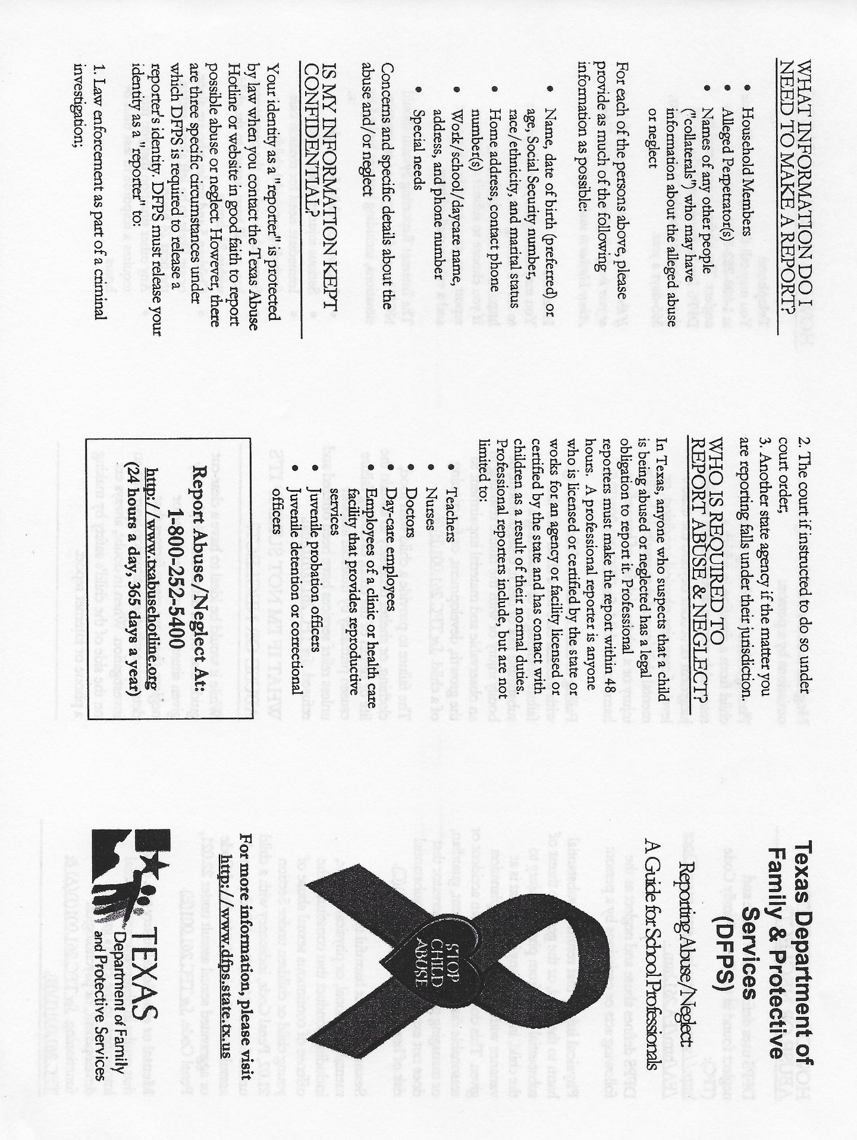

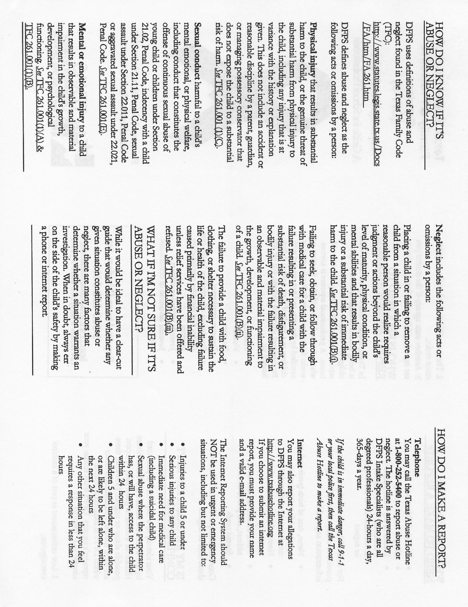
Establish a good relationship with the day-care facility

- Spend time at the day-care facility before you enroll your child. Ask questions about the program and observe the activities. Make sure the day-care facility has all the information needed about your child and family to provide good care.
- Work with the staff of the day-care facility you choose. Parent involvement is an important part of a successful experience with day care.
- Read all the material the day-care provider gives you. In addition to material required by licensing standards, each facility has its own policies and requirements. It’s important that you understand these requirements before you enroll your child. It’s equally important, once your child is in care, to read the notices, special requests, notes, and other materials the day-care provider sends home.
- Drop in occasionally during the day to observe how your child interacts with staff and other children, and get a good picture of the day-to-day activities at the center. Be careful not to disrupt activities.
- Keep your side of the bargain. Pick up your child on time.
- Discuss concerns with the day-care director. Be aware that the teacher’s main responsibility is working with the children. Don’t be offended if the teacher can’t spend much time talking with you when you drop off or pick up your child. If you need more time to talk about your child, set up a conference.
- It’s important to let the day-care facility know about things at home that may affect how your child is doing in day care.

When your child starts day care

- Remember that it’s normal for a child to have some fears and misgivings about starting day care. Children need time to get used to new situations. Prepare your children for the change as far in advance as possible. Discuss their concerns. If you’re enthusiastic, chances are they soon will be, too.
- Depending on their ages, some children will temporarily “act out” their feelings by clinging to you and refusing to let go, forgetting their toilet training, having bad dreams, sucking their thumbs, or other such behavior.
- Work with the day-care director and your child’s teacher on this.

Talk things over with your child

Make an opportunity each day to gently ask questions when your children are quiet and feeling secure and protected. Share their excitement about new friends, new skills, and new abilities; listen to their concerns; and give them a chance to boast about their achievements.

Parent responsibilities

The day-care facility must get certain information and records from parents to ensure the child’s health and safety, handle emergencies, and meet minimum standards. If you do not provide this material, the day-care facility will not be in compliance with the minimum standards.
- Complete an enrollment form that includes basic information about your child; telephone numbers where you can be reached during the day; authorization for emergency care for your child; and written permission for swimming, other water activities, and transportation services.
- Tell the caregiver about any special concerns or needs, including allergies, medical history, and current medications.
- Give the day-care facility a copy of your child’s immunization record showing immunizations against diphtheria, tetanus, pertussis, polio, measles, mumps, rubella, Hemophilus influenza type b, Hepatitis B and varicella. In some parts of Texas, a tuberculosis test report and Hepatitis A vaccine is also required. For school-age children, you can sign a statement that these records are on file at the school.
- Provide a doctor’s statement that your preschool child is physically able to participate in the day-care program.
- Inform the day-care facility in writing about who is permitted to take your child from the facility. Generally, the day-care facility may only release your child to you or to an adult you designate.
- The facility may allow a school-age child to leave the facility alone or allow an older brother or sister to pick up a child if you request this in writing. The facility is only allowed to do this when all safety considerations have been met.
- Make sure that child-care staff know the child has arrived. Make sure that staff are aware when you come to pick up your child. Don’t leave your child at the front door, and never leave your child at the facility before opening or after closing.
- Other requirements must be met if the day-care provider gives medication to your child, if your child is an infant, or if your child needs special care or a special diet.

What happens if your child is ill or injured?

- The day-care facility is not allowed to admit a child who seems to be sick unless a doctor or nurse gives approval in writing. This may cause problems for parents, but it is necessary to prevent a sick child from infecting other children.
- If your child has been absent because of a contagious illness, the day-care facility must follow guidelines concerning when the child can return to day care.
- If your child appears seriously sick or injured while at the center, the caregiver must call you immediately. It’s important that you pick up your child as soon as possible.
- If your child needs immediate medical attention, the center must call your child’s physician, take the child to the nearest emergency room or minor emergency clinic, or call for an ambulance. This is why the day-care facility must have your authorization for emergency medical care.

Liability insurance requirements

- Ask the day-care director whether or not the facility carries liability insurance. Texas law requires day-care facilities to carry liability coverage in the amount of $300,000 per occurrence to cover a child when the child is in care of the facility.
- Liability insurance coverage is not required if the insurance cannot be secured due to financial reasons; if the licensee is unable to locate an underwriter willing to issue a policy; or if the current policy limits have been extended. You are to be notified, in writing, that the coverage is not available.

Take a good look

As you become more familiar with your child’s day-care program, you will see many strong points. Almost all day-care facilities strive to provide a warm, loving, safe, and healthy environment for children. Look for these characteristics, but also be aware of warning signals that tell you something is wrong.
Feel secure when you see that:
- the facility welcomes you to visit any time, and you are invited to observe the class or participate in activities.
- staff are alert and involved with the children.
- staff seem warm and interested in the children. There is spontaneous laughter, hugging, and eye-to-eye contact.
- staff are gentle, but firm when necessary.
- the facility is clean and attractive.
- your child is relaxed and happy after the initial adjustment period.
- your child seems physically well cared for. Staff inform you of minor accidents and tell you when your child doesn’t feel well.
- children seem involved with constructive activities, and they get individual attention.

Be seriously concerned when you see that:

- parents are not encouraged to visit the facility.
- children are left without direct adult supervision.
- adults spend much time scolding, ordering, and yelling at children.
- adults are physically rough with children or allow rough play.
- the building is dirty, or you see unsafe conditions.
- your child is unhappy about being left at the facility, and this doesn’t improve with time.
- a child comes home bruised or injured, and the center can’t explain what happened. (The child may not remember minor bruises and scrapes received when playing, however.)
- children seem aimless, bored, angry, or frustrated, or there are too many children to supervise.

When things aren’t going well

You may find yourself displeased about something that has happened at the facility. Talk about these things with facility staff. There may be a misunderstanding that can easily be resolved.
If the situation isn’t resolved and you believe minimum standards are not being met, call the local day-care licensing office. They will handle your call discreetly.
A licensing representative will investigate your complaint. The licensing representative may need to interview you and your child and may also interview other children at the facility.
If the licensing representative finds that a standard has been violated, the facility will be notified and a time set for the facility to correct it.
Licensing staff may revoke a license if a facility doesn’t meet minimum standards. The
department does not take action to revoke a license unless children are in immediate danger or the licensee refuses to comply with standards.

If you suspect child abuse

Most day-care facilities, like most parents, take good care of children. Child abuse is rare, and it is very unlikely that anything like this will happen to your child.
If you do suspect that your child has been abused or sexually molested, report the situation immediately. Use the toll-free Child Abuse Hotline number 1-800-252-5400 or 1-512-834-3784 to report abuse or neglect that has occurred in Texas. The situation will be investigated immediately, and you will be given referrals or recommendations for help for your child and family.
Should agency staff interview or examine your child during an abuse investigation, a reasonable effort will be made to notify you within 24 hours after the interview or examination.
Parents who suspect or believe that their child has been abused in day care sometimes remove their child from care, but don’t report the problem. This leaves other children in danger. State law requires everyone, including day-care providers, to report suspected child abuse or neglect immediately.

Immunity

When people make a report of suspected child abuse in good faith, they are immune from any liability when the department investigates a complaint, the identity of the complainant is not revealed.

https://www.dfps.state.tx.us/Child_Care/Other_Child_Care_Information/parent-d.asp
Child Care Information Line at 1-800-862-5252.

This Parent Handbook is effective as of August 18,2026 and replaces all previously issued Parent Handbooks of FFELC.

Acknowledgement Page

Child’s Printed Name _______________________________________

I have received a copy of the FELC Parent Handbook for the school year 2026-2027 and agree to abide by the policies and procedures stated in the Handbook.

Parent’s Printed Name___________________________________________

Parent’s Signature_______________________________________________

Date_________________________________

