Crooked Horn Canadian Junior Rodeo Association
Building the Champions of Tomorrow

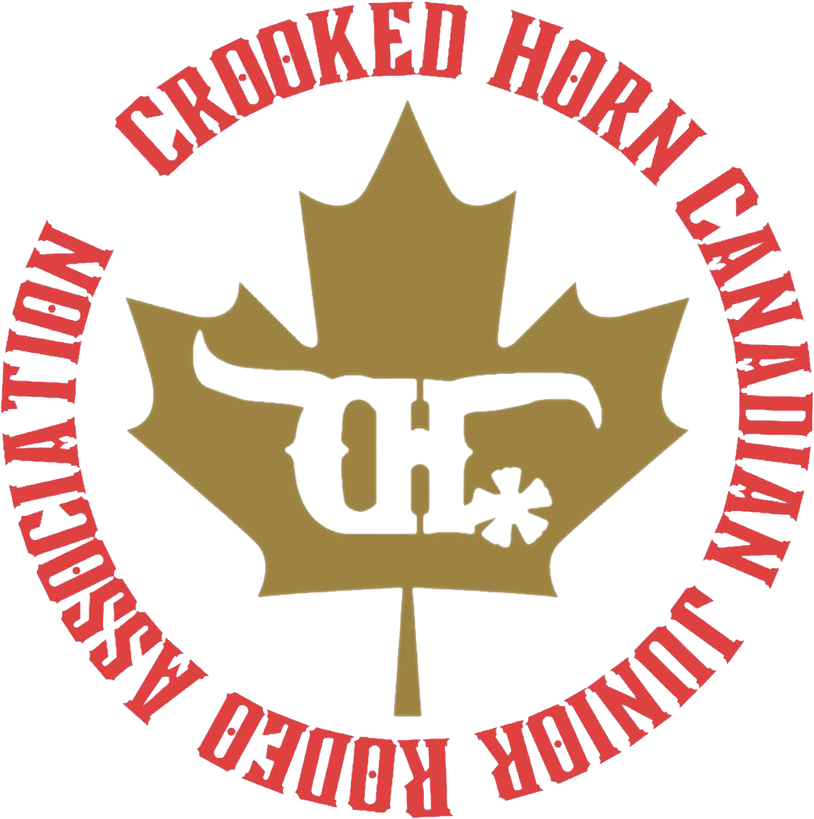

2026 Crooked Horn Canadian Junior Rodeo Association Sponsorship
  - From Local Arenas to the World Stage

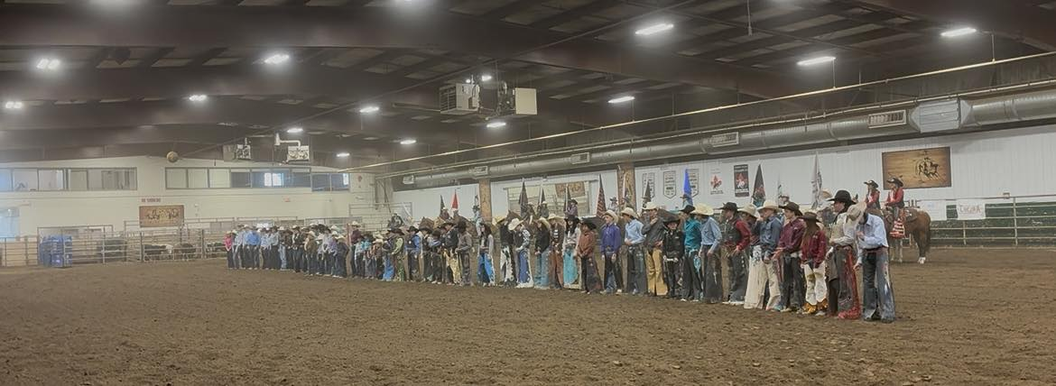

The Rodeo Experience
When you sponsor CHCJRA, you don’t just support rodeo, you live it. From the roar of the crowd to the thunder of hooves, it’s a full-senses experience that connects you to the heart of western tradition. You’ll feel the ground shake beneath your feet as 1,000-lb animals charge out of the gate a heart-pounding, unforgettable reminder of the power and precision of this sport.
Sponsorship delivers a real, face-to-face connection with the athletes and the animals, where focus, strength, and spirit are experienced up close not from a distance. It’s as close as you can get to the action without stepping into the arena, and a chance to witness firsthand the grit, passion, and sense of community that make rodeo so unique. Whether you’re attending an event or cheering from afar, your support gives you a personal stake in every ride, every run, and every young champion’s dream.

About CHCJRA
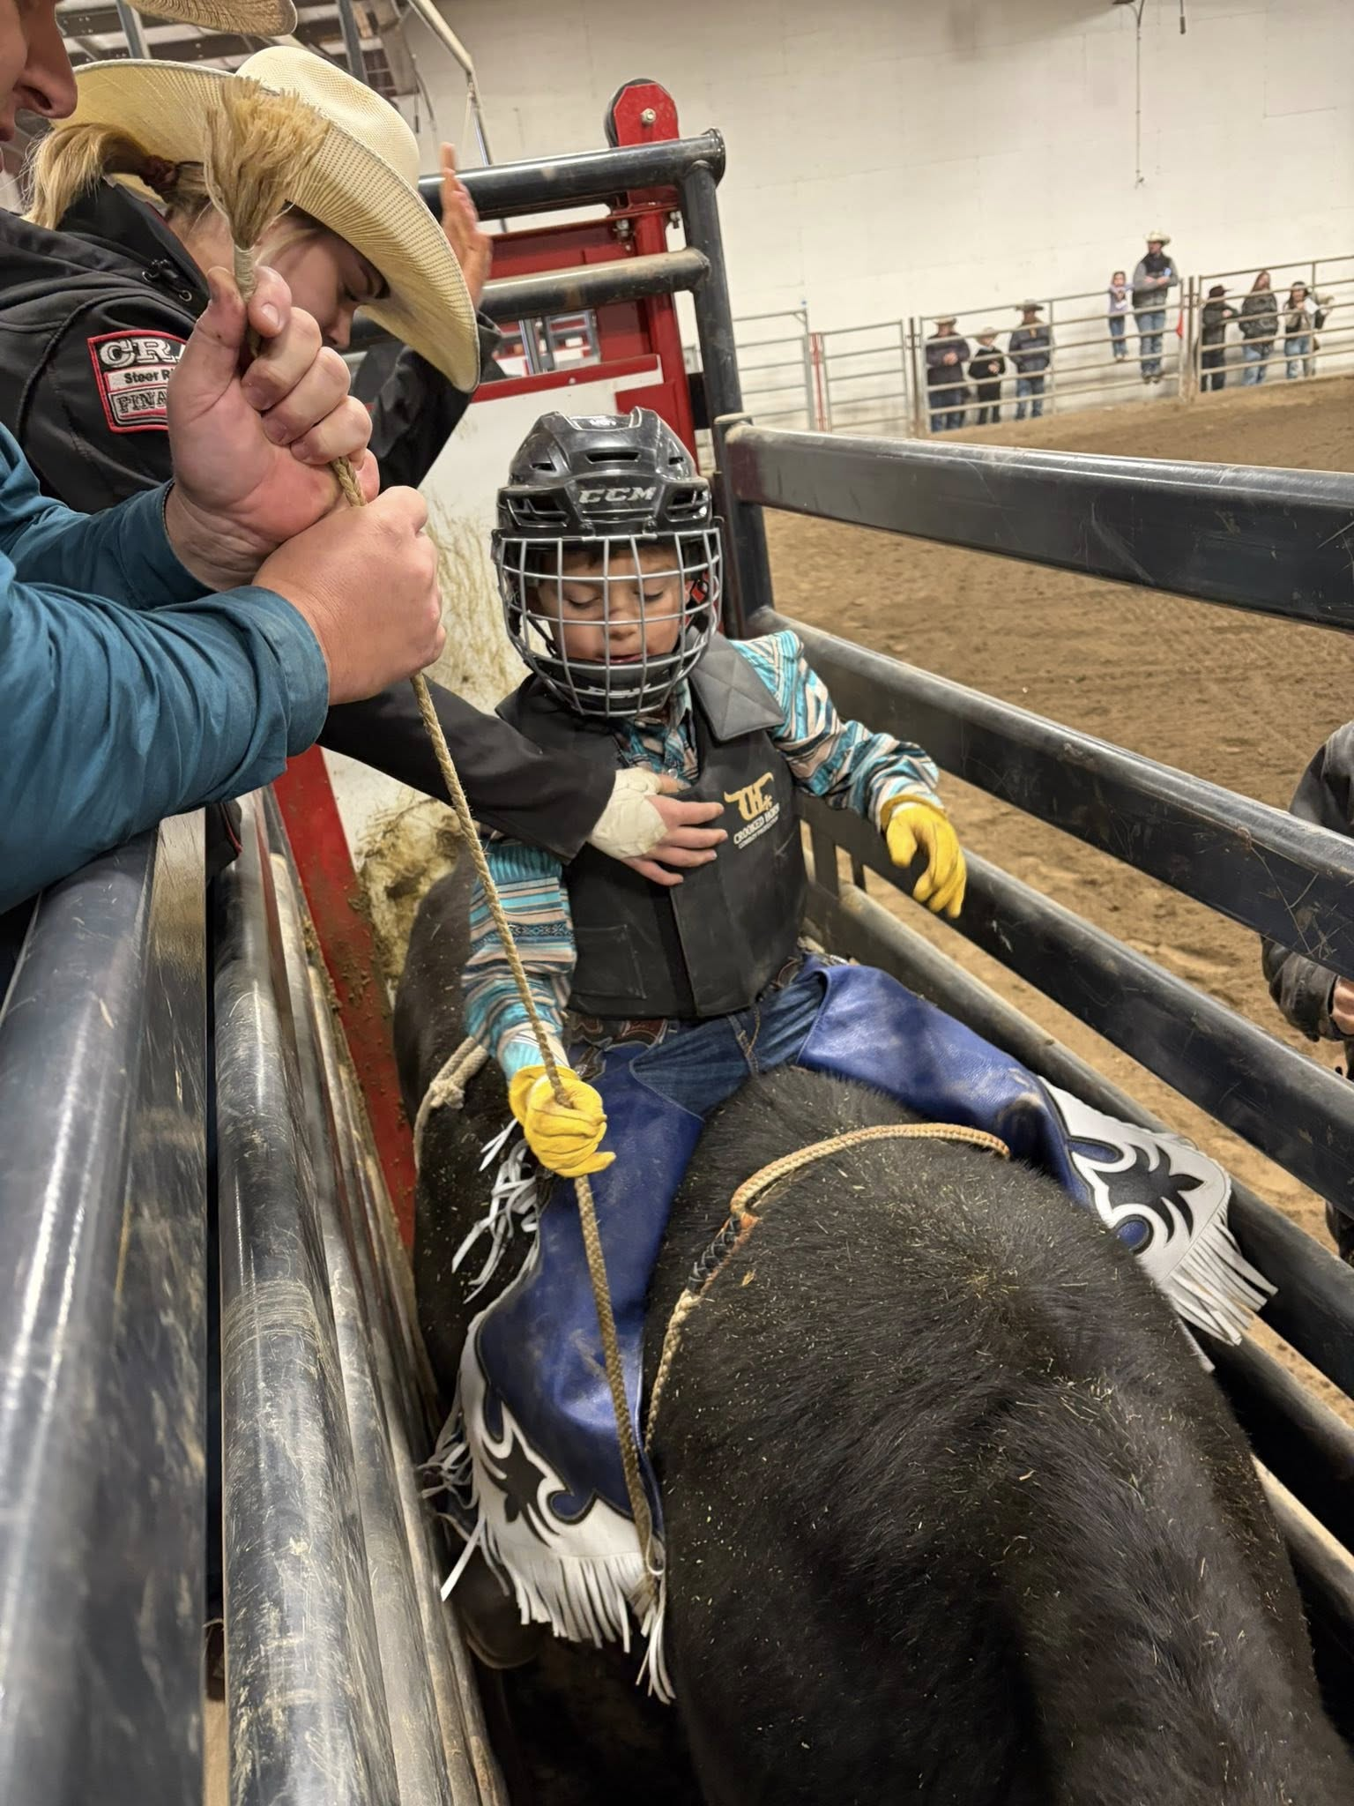
The Crooked Horn Canadian Junior Rodeo Association (CHCJRA) is a non-profit organization dedicated to empowering young rodeo athletes ages 6–18 across Alberta. Through a season of high-quality, family-oriented rodeo events, we provide a safe, structured, and supportive platform for contestants to build their confidence, sportsmanship, and skills, both inside and outside the arena.
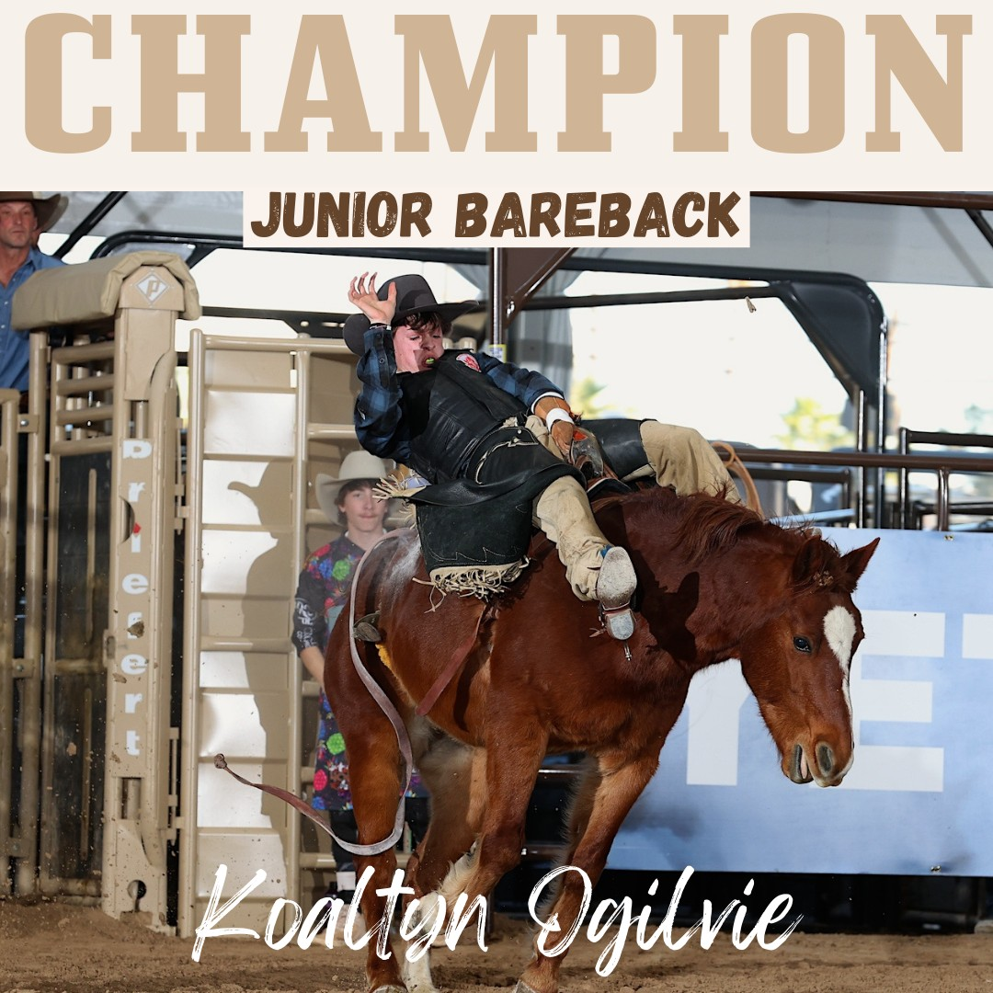
Over the past five years, CHCJRA has experienced remarkable growth, expanding from just 60 members in 2019 to more than 200 in 2025. Our association has proudly developed young athletes who have gone on to compete and excel at prestigious stages including the Canadian Finals Rodeo (CFR), the National Finals Rodeo (NFR), the Junior NFR in Arizona, and even the world-renowned Calgary Stampede. In 2025, CHCJRA experienced its most successful season yet, with over 1,250 entries across six events and more than $50,000 paid out in cash and prizes to contestants.

Why Now
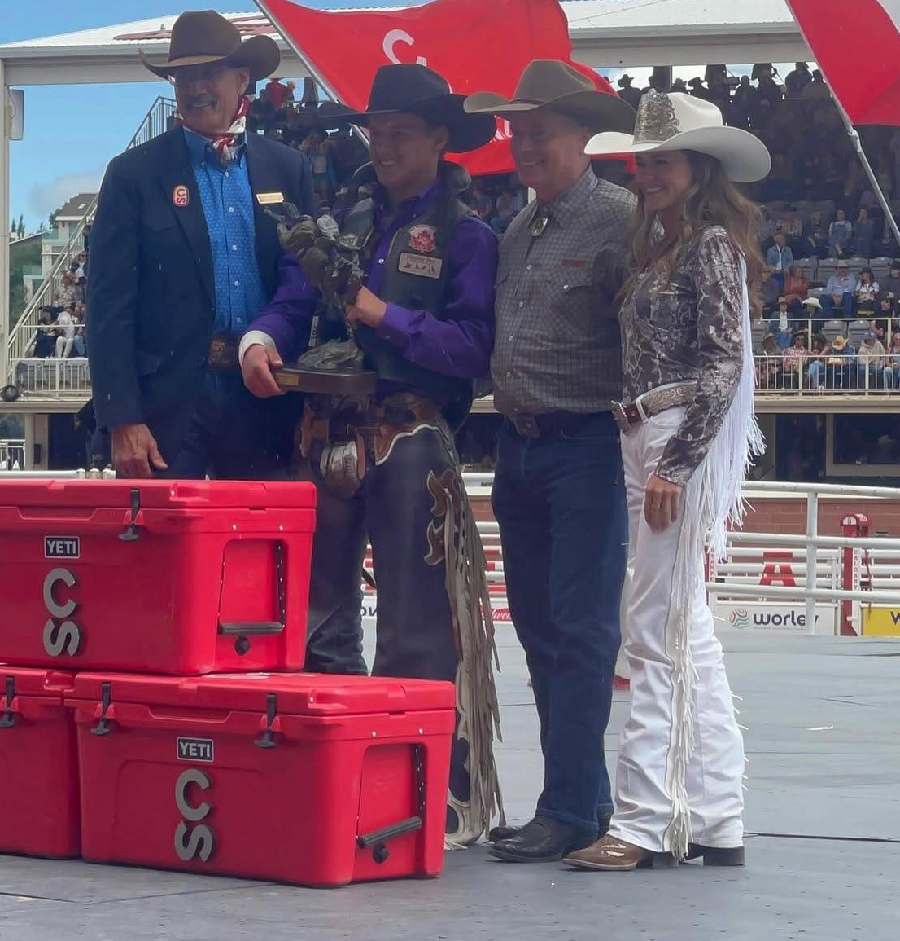
The CHCJRA continues to grow rapidly, with more contestants, events, and families joining every year. Your support this season will help expand opportunities for young riders, improve event safety and production, and ensure Alberta remains a leader in developing the next generation of rodeo champions. Sponsors who join now will be recognized as part of the foundation that’s driving this growth, helping local athletes reach national and international stages like the Canadian Finals Rodeo, Junior World Finals, and even professional events such as the Calgary Stampede.

Sponsorship Levels
We focus on giving our sponsors real value through visibility, engagement, and connection with the rodeo community. Packages are designed for measurable exposure, not just logo placement.

Season Sponsorship Opportunities

Platinum Season Sponsor – $10,000 (limit 3)
Premier, Exclusive, and Season-Long Visibility
- Exclusive recognition as a Presenting Partner of the CHCJRA Season
- Logo displayed wherever the CHCJRA logo appears — banners, awards, back numbers, finalist jackets, and promotional materials
- Featured across all CHCJRA social media campaigns and website
- Company flag carried at every event throughout the season
- Multiple announcers mention each weekend
- Six VIP seats at the Back Number Ceremony and Finals Awards Banquet
- Six No admission Tickets to all CHCJRA events
- Premium booth space at both the Finals Rodeo and the Awards Banquet
- Opportunity to display a booth or table at other events during the season upon request
- Platinum Sponsors may sponsor one event of their choice during the season and are invited to present that event’s Championship Buckle during the Finals ceremony
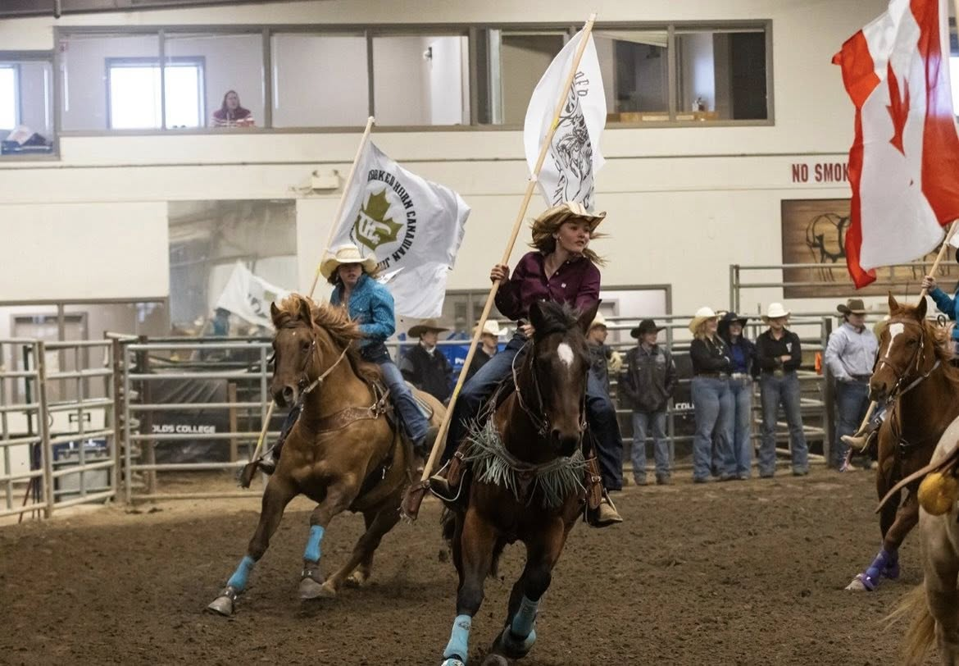
- Platinum Sponsors may present the Season Leader Award for their selected event during the Awards Banquet
- Platinum Sponsors may also present the back numbers for their selected event during the Back Number Ceremony
The ultimate partnership your name alongside every competitor, every event, all season long.
Gold Season Sponsor – $5,000 (limit 4)
High-Visibility Recognition Across the Circuit
Includes:
- Company flag carried at every event throughout the season
- Prominent logo placement on arena signage, event banners, and promotional materials at all CHCJRA rodeos
- Featured in monthly social media highlight posts and thank-you campaigns reaching families, contestants, and rodeo fans across Alberta
- Logo featured in the Finals program and on the CHCJRA website sponsor list
- Recognition during the Awards Banquet and Finals presentations
- Four VIP tickets to the Awards Banquet
- Four No admission tickets to all CHCJRA events
- Booth or display space at the Awards Banquet to meet contestants, families, and community members
- Announcer mentions at each event and during the Finals
- Gold Sponsors may sponsor one event of their choice during the Finals and are invited to present that event’s Championship Buckle during the Finals ceremony
Ideal for companies who want to make a big impact and be visible at every competition

Silver Season Sponsor – $3000 (limit 2)
Strong, Consistent Presence All Year
Includes:
- Company flag carried at every event throughout the season
- Logo displayed on arena signage and event banners at all CHCJRA rodeos
- Recognition on the CHCJRA website sponsor list and in the Finals program
- Featured mentions in social media thank-you posts throughout the season
- Announcer recognition at each event and during the Finals
- Two VIP tickets to the Awards Banquet
- Two No admission tickets to all CHCJRA events
- Silver Sponsors are invited to present the Cowgirl or Cowboy of the Year Award during the Awards Banquet

Perfect for regional businesses that want to stay visible and connected with the rodeo community.

Bronze Season Sponsor – $1,500
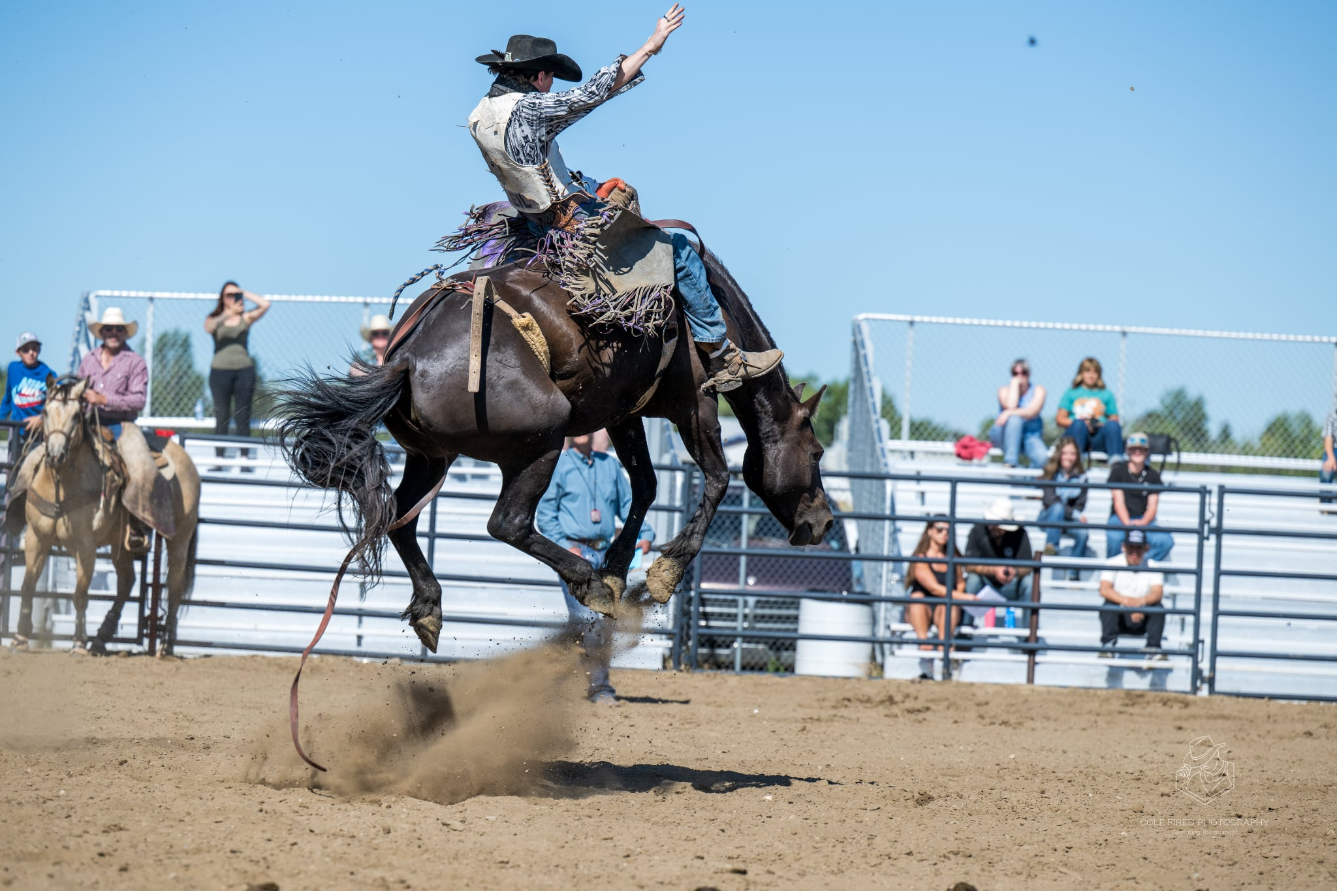
Community Recognition, Season-Long Support
Includes:
• Company flag carried at every event throughout the season
• Logo displayed on arena signage and event materials at CHCJRA rodeos
• Social media mentions and announcer recognition throughout the season and Finals
• Name and logo listed on the CHCJRA website and in the Finals program
• Two tickets to the Awards Banquet
• Two no-admission tickets to the Finals Rodeo

A great way to show pride in your local youth rodeo athletes.

Buckle Sponsor – $350
A Timeless Rodeo Tradition
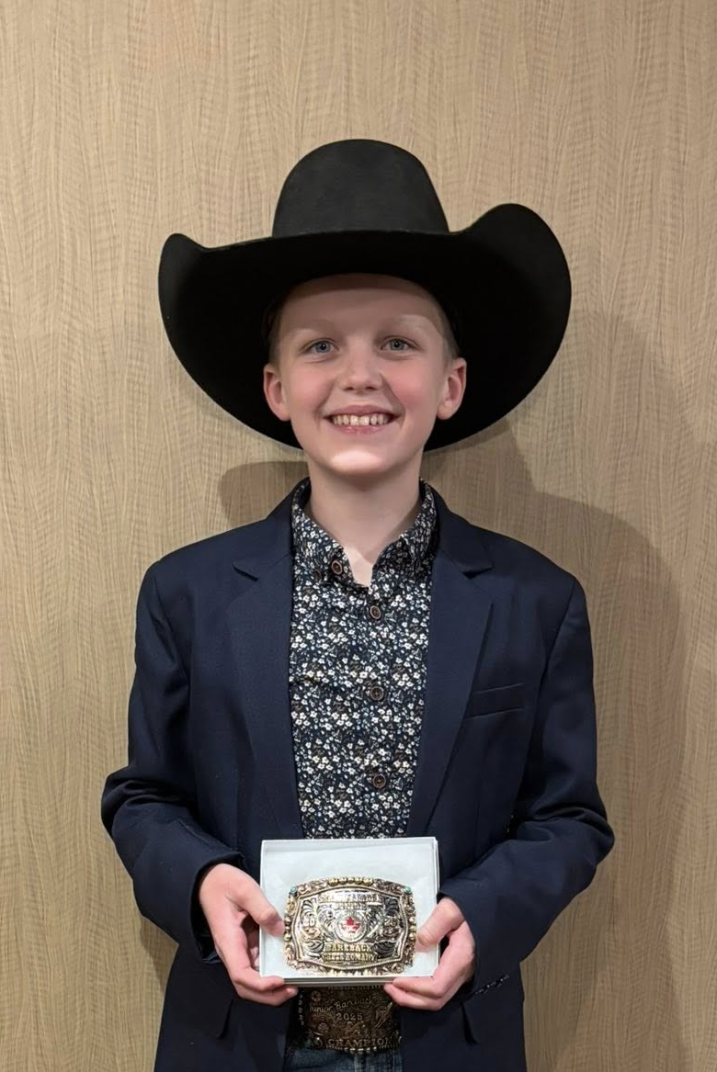
Includes:
• Recognition throughout the season on social media and event materials
• Acknowledgment during the awards banquet when your sponsored buckle is presented
• Commemorative photo of the champion with your sponsored buckle
An affordable, heartfelt way to support the athletes who represent the spirit of rodeo.

Individual Event Sponsorship

Level 1 – $1,250 (limit 2)
Full Weekend Event Sponsor
Includes:
- Exclusive recognition as one of only two Full Weekend Sponsors
- Company flag carried in opening ceremonies each day
- Prominent arena signage in prime viewing areas
- Top-tier logo placement on all event materials, posters, and programs
- Featured social media spotlights before and after the event
- Opportunity to display a booth or promotional table on-site
- Frequent announcer mentions throughout the weekend
- Two no-admission tickets to the event
- Two tickets to the Finals Awards Banquet
You’ll receive the highest level of exposure and recognition available for an individual event

Level 2 – $1000 (limit 6)

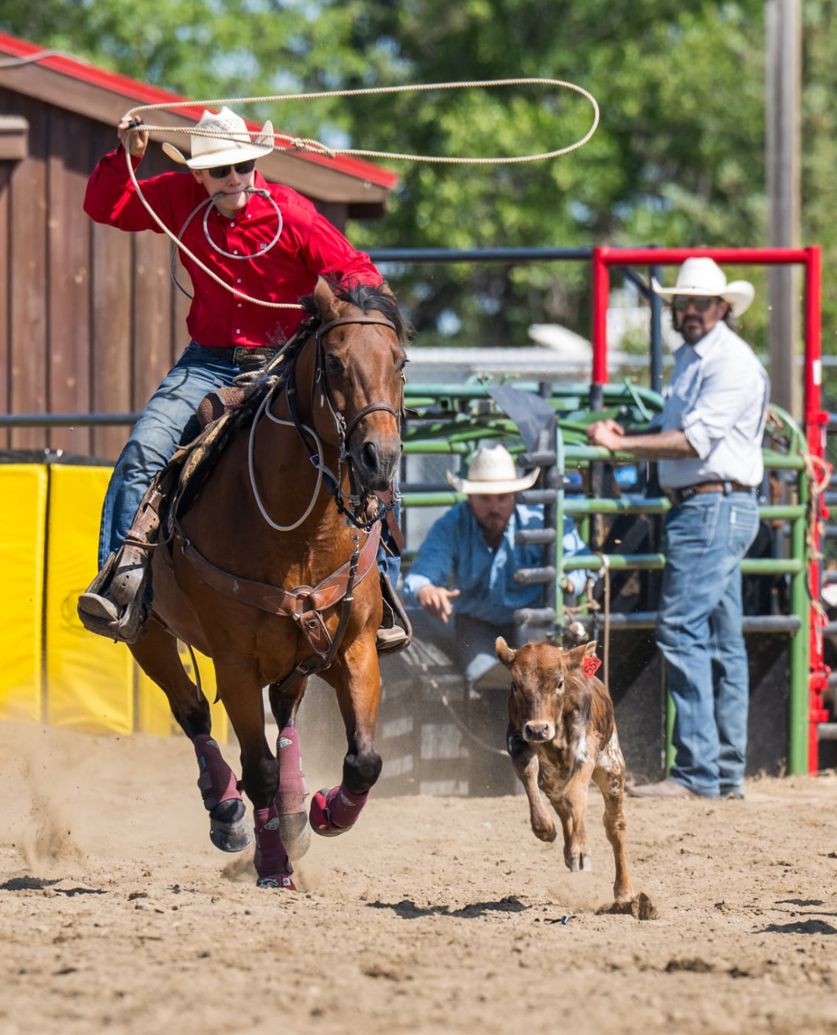
Event Naming Rights Sponsor
Includes:
• Official naming rights for one event (e.g., Barrel Racing presented by [Your Company])
• Large arena signage
• Logo on event materials and programs
• Dedicated social media feature highlighting your event
• On-air announcer mentions during your sponsored event
Perfect for businesses who want visibility and name association with a marquee event.

Level 3 – $500
Supporting Sponsor
Includes:
• Large logo displayed in shared sponsor banner section
• Announcer mentions throughout the weekend
• Logo featured in event thank-you posts on social media
Ideal for regional companies looking to stay top-of-mind in the community.

Level 4 – $250
Community Supporter
Includes:
• Medium arena logo display
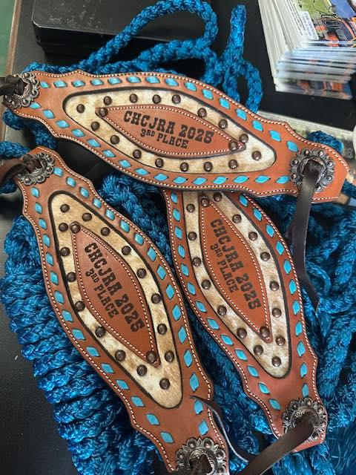
• Name listed on website and in event-day thank-you announcements
• Group recognition post on social media
An affordable way to make a big impact and show your support for young athletes and the sport.

Custom Sponsorship Packages
Custom sponsorship packages are available for businesses or individuals looking for a tailored partnership with CHCJRA. Whether you want to combine multiple event levels, sponsor a specific award, or create a unique presence at the Finals or Awards Banquet, we’ll work with you to design a package that fits your goals and budget.
Your support helps us continue to grow youth rodeo in Alberta while showcasing your brand in front of engaged families, contestants, and communities across the province

Exposure Opportunities
Our marketing strategy ensures sponsors are showcased appropriately at every touchpoint from local arenas to digital promotions.
• Arena Signage: Banners and flags displayed prominently at rodeos and finals.
• Announcer Mentions: Your business recognized throughout each event.
• Radio Mentions: (where Applicable) Sponsors featured in local radio advertisements.
• Social Media: Platinum, Gold, and Silver sponsors featured in monthly highlight posts.
• Event Presence: Complimentary tickets, awards presentation opportunities, and VIP seating.
• Sponsor Exposure Snapshot:
- 10+ rodeo Events across Alberta each year
- 2,000+ live spectators
- 200+ contestant families sharing sponsor content
- 10,000+ annual social media impressions
- Full-season brand presence for Platinum through Bronze sponsors
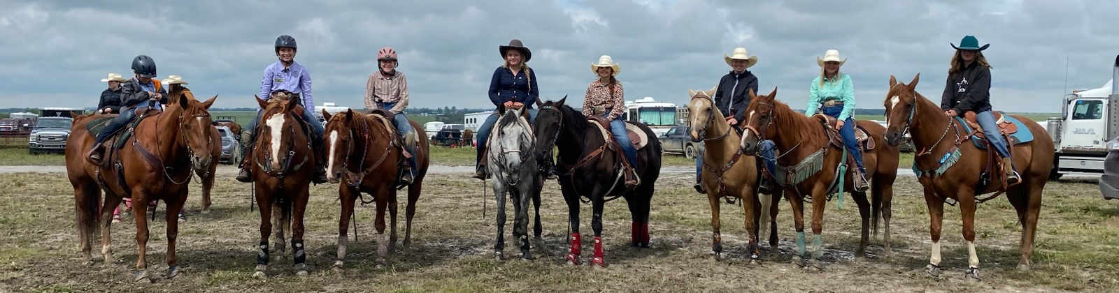

Making a Difference
Every sponsorship directly impacts real kids with big dreams. Riders who started with CHCJRA have gone on to compete and succeed at major professional rodeos including the Calgary Stampede, Canadian Finals Rodeo, and Junior World Finals. Your support helps build not just young champions, but future professionals representing Alberta and Canada on some of the most prestigious rodeo stages in the world.

Join Us
Sponsorship opportunities for the 2026 season are now open. Packages are limited and assigned on a first-come, first-served basis.
Partner with CHCJRA today and help Alberta’s young rodeo athletes chase their dreams, build confidence, and carry on the traditions of western excellence.

Contact Us
Crooked Horn Canadian Junior Rodeo Association
sponsorship@chcjra.ca
www.chcjra.ca

