Platinum Tours
Presents....

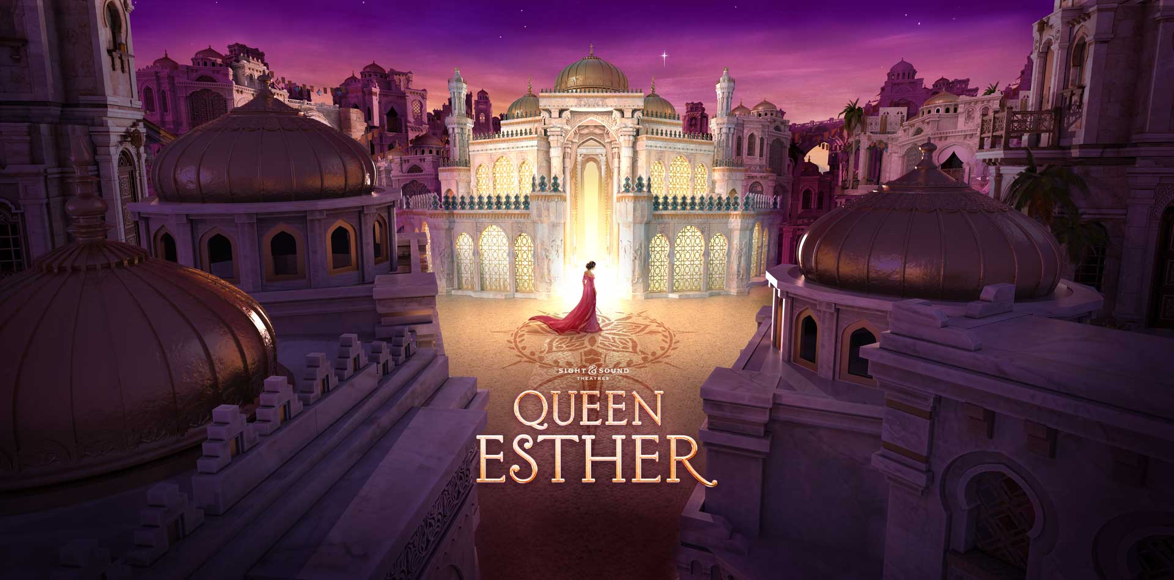
In Lancaster, PA

Saturday, September 11, 2021

Itinerary…

6:00 AM Depart Hanover Community Center on a deluxe air-conditioned, restroom equipped motorcoach.
11:00 AM Arrive at Sight & Sound for Live Production of “Queen Esther”
1:30 PM Leave Sight & Sound for Miller’s Smorgasbord
2:00 PM Arrive for dinner at Miller’s Smorgasbord
3:30 PM Depart Miller’s for your return trip home
8:00 PM Arrive back in Montpelier

Your Package Includes:
Restroom equipped motorcoach with video Driver’s Gratuity
Admission to “Queen Esther” 1 Lunch Buffet at Millers Smorgasbord
Continental Breakfast and snack pack

Prices
$198.00 per Person

Deposits are not refundable
Payment Plan Due Date Amount
Deposit 06/15/21 50.00
2nd Payment 07/15/21 75.00
Final Payment 08/15/21 Balance

For more information or to make reservations
Roddy G. Mitchell
804-883-7746

Arrangements made by
Platinum Travel & Tour Co. LLC
“A Christian Organization”

P.O. Box 414 Montpelier, VA 23192 804-883-7746 Fax: 804-883-7211 website: www.platinumtours.travel

