MT OLIVET BAPTIST CHURCH

BROTHERHOOD MINISTRY
17TH ANNUAL CAR SHOW

SHOWDATE: June 3, 2023 Time: 9:00 a.m. - 2:30 p.m.
Rain Date: June 10, 2023 Place: Mt. Olivet Baptist Church
17520 Jefferson Hwy
Entry Fee: Just $15 Montpelier VA 23192

1st 50 Arrivals & Register Receive A Dash Plaque
REGISTRATION ENDS PROMPTLY AT NOON!!!

Great Food!! Great Fun & Prizes!! Gospel Music!!
Top 20 Classics! Great 8 Modern!! People’s Choice Awards!! Motorcycle Class!
Truck Class! Specialty Class! PLUS…
Best GM, Best Ford, Best Mopar, Best Import, Best Custom,
Best Street Rod, Car Club Participation, Best Paint, Best Engine &
BEST OF SHOW!!!

For Directions Visit: www.mtolivetbaptchurch.org

CONTACT: Melvin James - (804)306-5756 Greg Wyatt - (804)752-2312
Antonio Johnson - (804)971-7090 Darryl Thomas - (804)647-3926
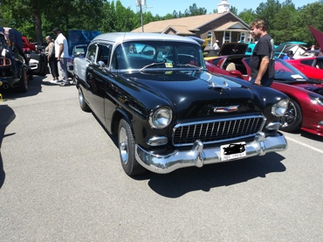
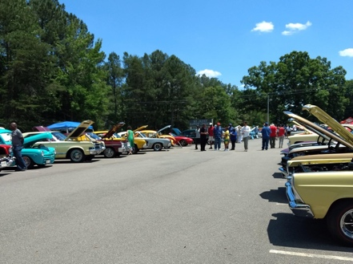
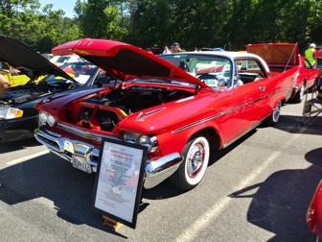
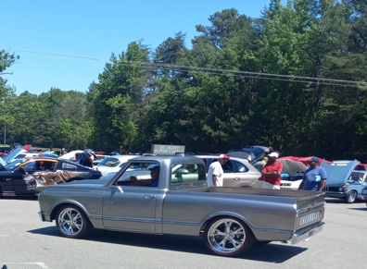
Car Show Benefits Church Scholarship Fund!

