Olivia Bradley Releases Debut Album, 'Misty Morning Shore'
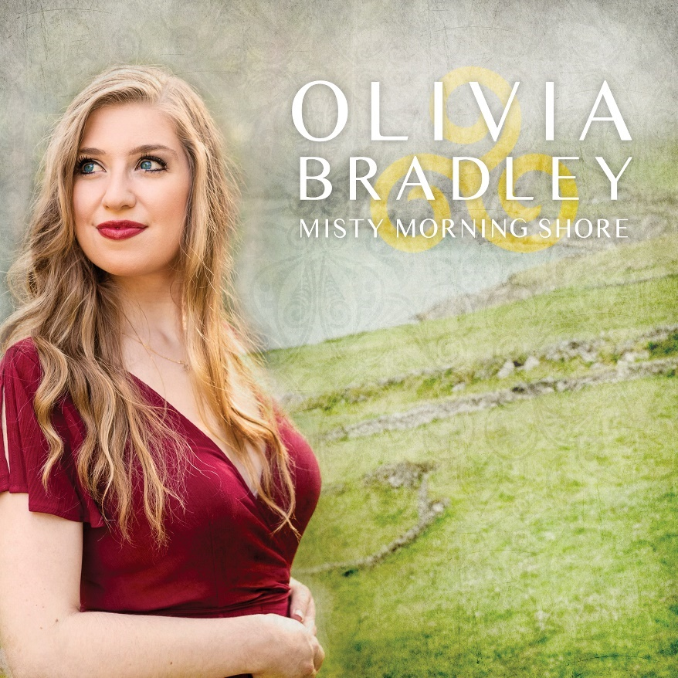
FOR IMMEDIATE RELEASE

Singer/Performer/Producer Olivia Bradley Releases Her Debut Album, 'Misty Morning Shore'

November 3, 2023 (Atlanta, GA) - In between solo gigs, collaborative performances, and touring the US as a member of the Celtic Angels (https://www.celticangels.com/), emerging artist Olivia Bradley has produced a new solo debut album, 'Misty Morning Shore,’ which was released on Spotify, Apple Music, and all major streaming platforms on November 3rd, 2023. Coinciding with the online release, a CD version of the album was launched and first made available at the 2023 IrishFest Atlanta event (https://www.irishfestatlanta.org/). A digital download version in addition to the CD is also available on Bandcamp (https://oliviabradleymusic.bandcamp.com/).

Olivia is joined on the album by a number of touring bandmates and friends, including traditional music luminaries Dave Curley and Colin Farrell, veteran musician/producer Sonny Lallerstedt, title track songwriter Gary O'Driscoll, and vocalist/cellist, Brian Adams. Crafting together a beautiful and high-quality work, Olivia includes a mix of Irish songs (one in Irish Gaelic) that explore timeless themes such as love, heartbreak, loss, freedom, sacrifice, leaving home to start a new life, and longing for what's left behind.

Sung with a powerfully clear, emotional, and lyrical style that magnifies, yet never overpowers the songs she selects, the album contains eight total tracks, including:
- 'Molly Malone' - a traditional song arranged by Daniel Thompson in an upbeat style, supported by touring bandmates and matching the energy of Olivia's on tour Celtic Angels performances
- 'County Down' - featuring the vocals and guitar playing of traditional music all-star, Dave Curley
- 'Misty Morning Shore' - a song about Irish emigration and the album's title track, including songwriter Gary O'Driscoll on guitar
- 'A Gaelic Blessing' - a choral composition showcasing Olivia's vocal range, and supported by a number of musicians including Colin Farrell of Lúnasa and The Ashley Davis Band on fiddle and whistle
- 'Mountains of Pomeroy' - a traditional ballad, supported by Sonny Lallerstedt on guitar and mandolin, and Colin Farrell on fiddle and whistle
- 'Galileo (Someone Like You)' - a sublime song written by Irishman Declan O'Rourke, and featuring beautiful harmonies with vocalist/cellist Brian Adams, and a virtuosic performance by Lacy Rostyak on fiddle
- 'Slan Le Maigh' - a traditional slow air lament, arranged by Peter Sheridan, with Olivia's soaring vocals highlighting the poetic beauty of the Irish Gaelic lyrics
- 'The Fields of Athenry' - a more modern and popular Irish folk ballad, supported by touring bandmates Daniel Thompson, Gil Clark, and Danielle Turano, as well as Brian Adams on cello

In terms of musical influences, Olivia credits a number of talented singers and musicians whose direct and indirect influences are reflected in the album, including Ashley Davis, Dave Curley, Lisa Kelly, Cathy Jordan, Seamus Begley, John Doyle, Colin Farrell, Cormac de Barra, and Joannie Madden, just to name a few.

Album Credits
Recorded & mixed by Sonny Lallerstedt at A La Carte Studio, Smyrna, GA
Mastered by Justin Weis at trakworx.com
Produced by Olivia Bradley and Sonny Lallerstedt
Visual design by B. Jeffrey Gribble at designindustry.com
Photos of Olivia by Brooklyn-Photography.com
Cliffs of Moher photo courtesy of Gary McLoughlin at ShamrockandPeach.com

Song Credits
1 Molly Malone | Traditional, arranged by Daniel Thompson
Daniel Thompson, piano & keys, Gil Clark, guitar, Danielle Turano, fiddle, Matt Rapiejko, drums, Sonny Lallerstedt, bass
2 County Down (feat. Dave Curley) | Tommy Sands
Dave Curley, vocals/guitar
3 Misty Morning Shore | Gary O’Driscoll
Gary O’Driscoll, guitar, Larry Martin, bass, Danielle Turano, fiddle
4 A Gaelic Blessing | John Rutter
Paula Grissom-Broughton, piano, Teresa Sheppard, harp, Brian Adams, cello, Colin Farrell, fiddle & whistle
5 Mountains of Pomeroy | Traditional
Sonny Lallerstedt, guitar & mandolin, Colin Farrell, fiddle & whistle
6 Galileo (Someone Like You) (feat. Brian Adams) | Declan O’Rourke
Brian Adams, vocals/cello, Peter Sheridan, piano, Lacy Rostyak, fiddle, Gil Clark, guitar
7 Slan Le Maigh | Traditional, arranged by Peter Sheridan
Peter Sheridan, piano, Brian Adams, cello
8 The Fields of Athenry | Pete St. John
Daniel Thompson, piano, Gil Clark, guitar, Danielle Turano, fiddle, Brian Adams, cello

About Olivia Bradley
Olivia is a vocalist, performer, bodhran (Irish drum) player, and open champion level Irish dancer based out of Atlanta, Georgia. Steeped in a background of Irish music and dance, and blessed with perfect pitch, Olivia weaves her classical training and dramatic sensibility from musical theater together with her Irish and Scottish roots to bring traditional songs, stories, and ballads to life for modern audiences. For more info, please visit her website at https://OliviaBradleyMusic.com

Social Media Accounts
-Facebook: https://www.facebook.com/OliviaBradleyMusic
-Instagram: https://www.instagram.com/OliviaBradleyMusic
-YouTube: https://www.youtube.com/@OliviaBradleyMusic
-TikTok: https://www.tiktok.com/@OliviaBradleyMusic

Media Contact
Email: OliviaBradleyMusic@gmail.com
Mobile: 678-404-0040
Please visit Olivia’s Press page for high-res photos and other info: https://oliviabradleymusic.com/press

