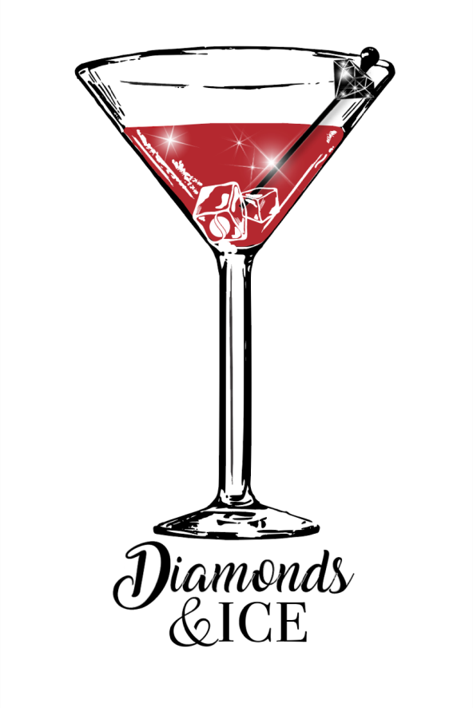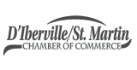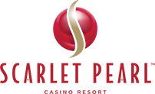

**You are invited to join us for a night of Diamonds and Ice. At this premier event, guests will enjoy a signature cocktail that contains an ice cube filled with either a cubic zirconia or one of two diamonds. Jewelers will be on hand to evaluate each stone to determine its worth. Guests will also enjoy live music, a cash bar and selection of heavy h’orderves. A portion of the proceeds from this event will go to support a local Charity.**

**Sponsorship Information**

Sponsorships are being accepted in a limited number. Sponsors will receive ten tickets to the event and their organization’s logo in an ice sculpture. Sponsorships are $500.00. Tables are being offered for $300.00 with seating for 10 people. Please fill out the information below and return payment in check form to: D’Iberville/St. Martin Chamber, 10491 Lemoyne Blvd, D’Iberville, MS 39540.

**Business/Org.________________________________________________________________________**

**Contact Name: _______________________________________________________________________**

**Address___________________________________ City________________ State_______Zip________**

**Preferred Phone (______) __________________________ Fax: _______________________________**

**Email: __________________________________________**

**For questions, please contact the D’Iberville/St. Martin Chamber Sissy Andrews/Chair Person 228-860-6205**

November 30, 2018

Scarlet Pearl Casino Resort

Presents