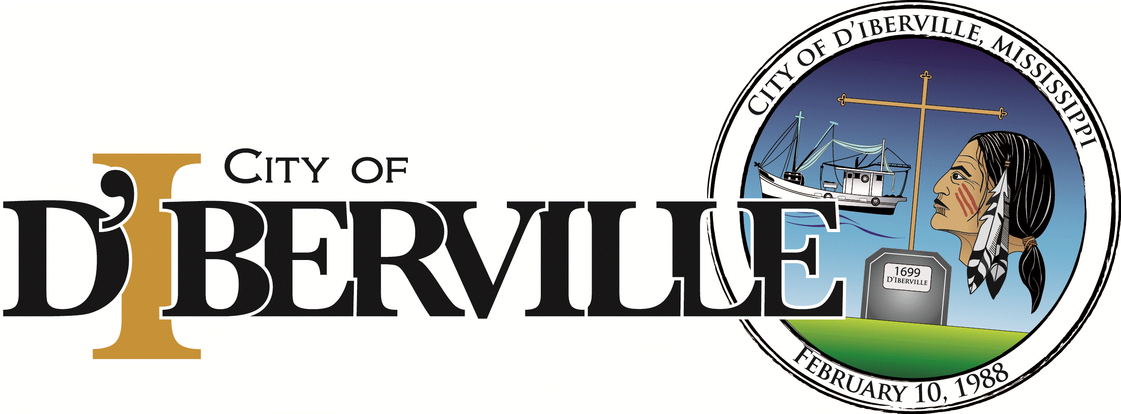 2018 Trunk or Treat 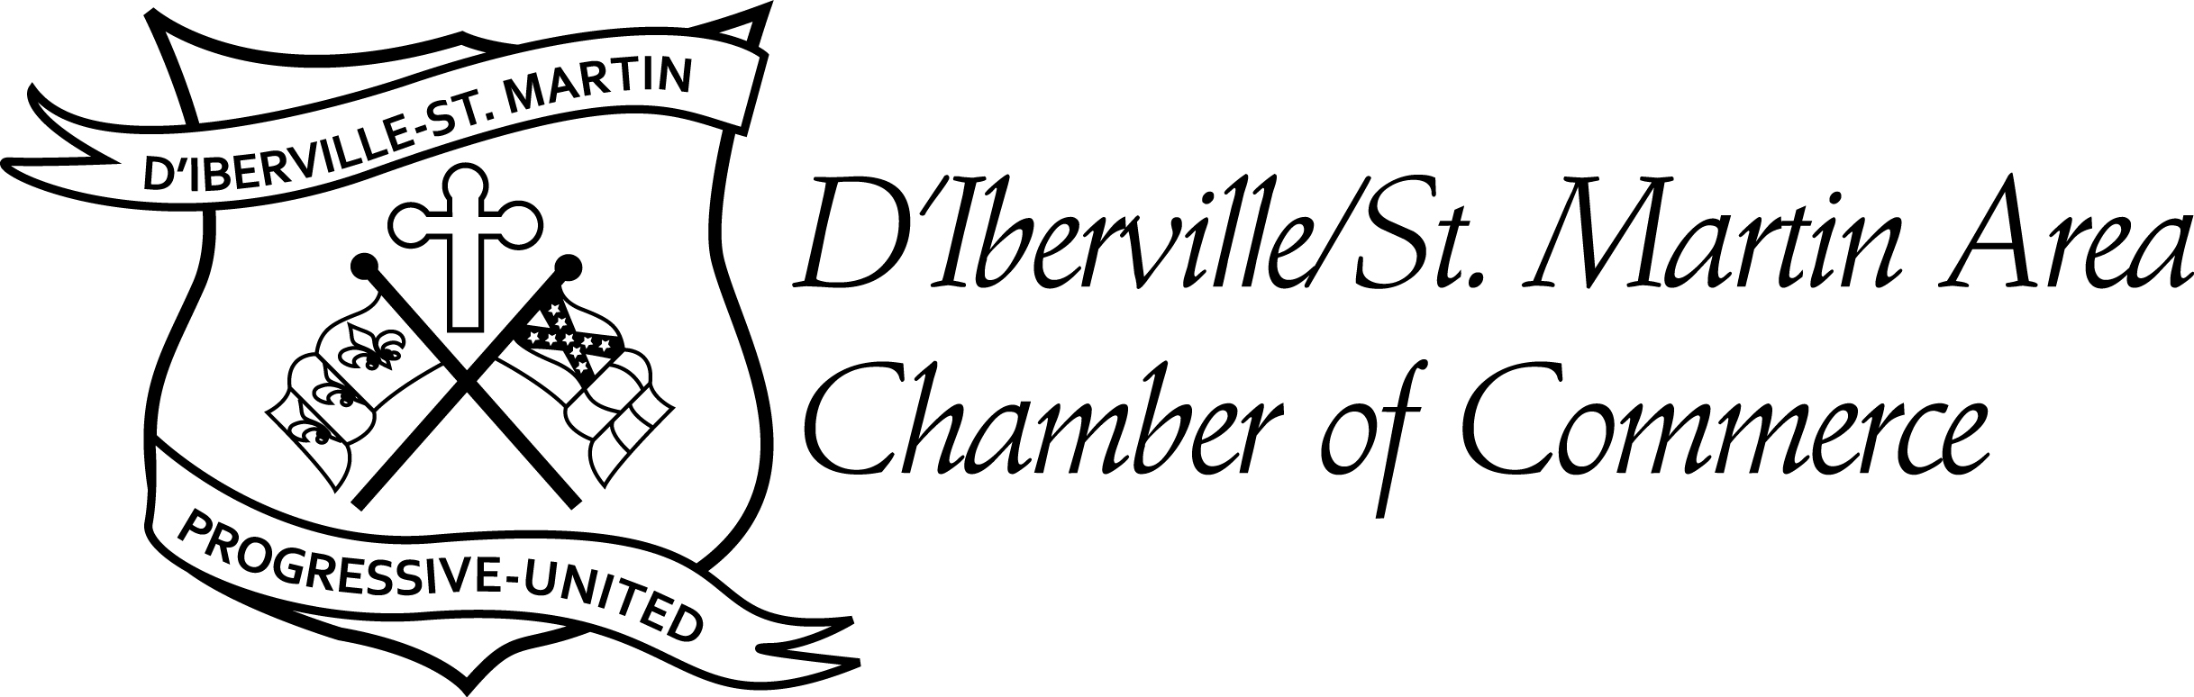
Wednesday, October 31, 2018
The City of D’Iberville and the D’Iberville/St. Martin Chamber of Commerce will sponsor the annual Trunk or Treat Halloween Event on Wednesday, October 31st, 2018 at the Bobby Eleuterius Sports Complex (located off of Brodie Road). The event will begin at 5:30PM until 7:30PM. We would like YOUR BUSINESS or ORGANIZATION to participate in this fun-filled evening. We request that all trunks be decorated and parked in place no later than 4:45PM on the night of the event.
The Police and Fire Departments will also be hosting the “HOUSE OF PAYNE” spooky Haunted House. If you are interested in sponsoring a Haunted ROOM in this year’s Haunted House, please contact 228-396-4252.
HOW DO YOU PARTICIPATE?
Please fill out the form below and email or mail to: dsm@dsmchamber.com

D’Iberville/St. Martin Chamber of Commerce
10491 Suite A, Lemoyne Blvd
D’Iberville, MS 39540

Participation Form – Trunk or Treat
Business Name & Address:

Contact Person & Phone Number

Email Address

If you are unable to attend the Halloween event and would like to contribute, we are in need of the following: Bags of Candy – individually wrapped
Monetary Donations to purchase Candy are also greatly appreciated.
Drop off at D’Iberville Chamber of Commerce (Pam)
