

Distributed in North America by Naturacopia llc
Contact details are available on www.iminohoney.us

Information Sheet for Professional Veterinarians and Carers

Important Information
These statements have not been evaluated by the FDA. This product is not intended to diagnose, treat, cure or prevent any disease. Professional veterinary guidance should be consulted for proper usage. Content current as of date of design. July 2026

Standardized Bioactive Chemistry (The "Why" Factor)
Verified Casuarine Content: Unlike other honeys, Iminohoney is analytically verified by specialized glycochemistry laboratories (Dr. Nash Glycohealth) using proprietary methodologies to ensure Casuarine content, a rare, plant-derived iminosugar.
Casuarine is also known as Iminose A. The IUPAC chemical name for the natural compound Casuarine (a polyhydroxylated pyrrolizidine alkaloid) is (1R, 2R, 3R, 6S, 7S, 7aR)-3-(hydroxymethyl)hexahydro-1H-pyrrolizine-1,2,6,7-tetrol. Its chemical formula is C₈H₁₅NO₅. Casuarine is well-known in pharmacology as a potent glycosidase inhibitor often extracted from plants like Casuarina equisetifolia and Eugenia jambolana.
In Iminohoney, Casuarine is measured in rare African honey's where bees forage for nectar from the flowers of Casuarine-rich plant species.

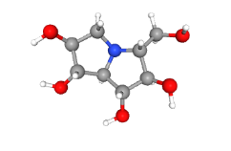
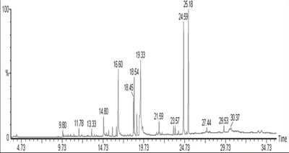

Beyond Geography
Microclimates, soil, season, aspect, rainfall and foraging variables mean that standard African honey chemical fingerprints vary widely. Iminohoney is unique in that it carries the Casuarine Quality Mark, verifying batch to batch Casuarine-content consistency.

Mechanism of Action
Glucose Inhibition & Immune Modulation: Casuarine acts as an iminosugar that interacts with cellular carbohydrate-processing enzymes (glucosidases). This interaction alters glycoprotein processing which modulates immune cell signaling and metabolic pathways.
Immune Activation Support: we and our partners have preclinical data on file that indicates an immunomodulation effect mediated by Casuarine via C-Type Lectin receptors on immune calls.

Uses in Pet Care
Iminohoney has several different potential applications as a supplement to support pet health:
Senior Support - Ideal as a natural, low-risk, supplemental metabolic support for senior pets experiencing age- or sickness-related health issues.
Immune system support - Helps support the natural immune response during periods of stress, treatment recovery or supplemental support for the management of chronic infections or diseases.
Palatable Compliance- Offers an exceptionally palatable, easily administered supplement for pet carers struggling with treatment fatigue in sick or recovering pets.

Dosing
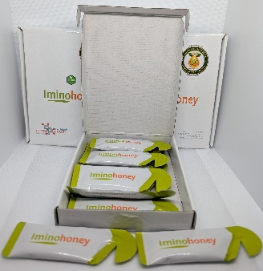
Anecdotal evidence suggests that optimal dosing is one 10ml sachet of Iminohoney given every 3 days with more frequent dosing having not demonstrated and additional benefits. One 10 sachet pack of Iminohoney therefore lasts for one month of supplementation.
Iminohoney may crystallize on storage or shipment in cooler environments and can be gently warmed to reconstitute it in liquid honey form.
Iminohoney can be used in a few different ways: added to food or given directly.
Some pets do not like honey and so may refuse it even when mixed with food.

Caution - Honey
As with any other honey or sugar-containing supplement, use Iminohoney with caution in pets with diabetes, sugar-related metabolic diseases or in any situation were, in a veterinarian's professional opinion, sugar-content might be considered an issue.

Safety and Purity
Iminohoney is a pure, raw, natural, food-grade African honey with nothing added or removed. Each batch of Iminohoney is selected by chemical analysis with batches approved or refused according to iminosugar content, and particularly, the presence of Casuarine in significant concentration. Strict Quality Control ensures the fingerprint and presence of desired iminosugars, while the honey is also tested for undesired impurities.

Comparison to Manuka Honey
Iminohoney has a very different profile to Manuka Honey. Manuka Honey is another natural honey where chemical content, activity and profile is measured and claimed with associated health benefits. While Manuka Honey relies on methylglyoxal (MGO) for topical antimicrobial pathways, as described above, Iminohoney functions via a completely different class of chemistry. Analysis of Manuka honey does not show the presence of Casuarine or other significant Iminosugar components.
It is understood that the two types of honey are vastly different, and batches are selected with completely different chemical content criteria. Therefore, these two products should not be interchanged with the expectation of similar supplemental benefits.

Scan here for more information and access to testimonials and example cases

