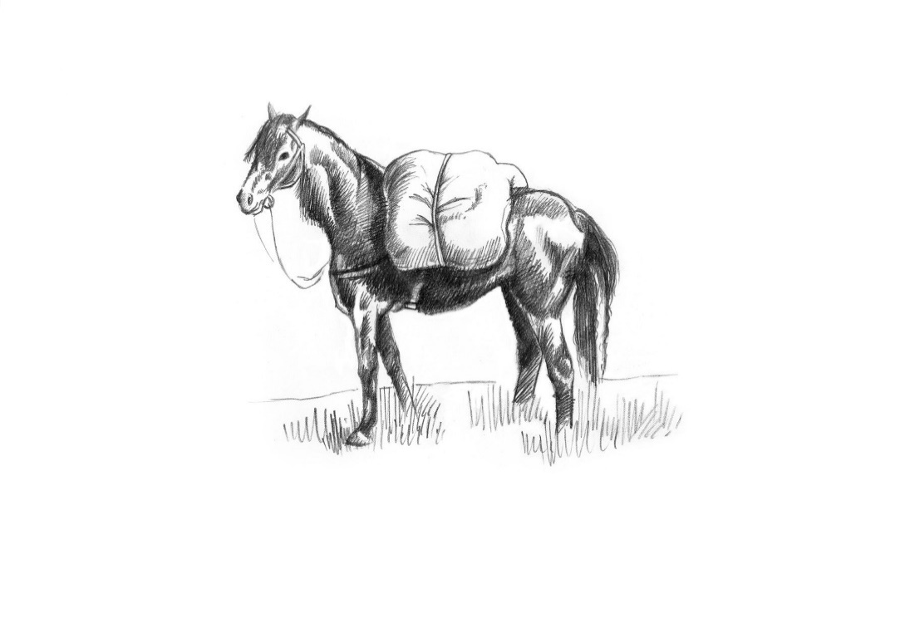
Snacks
Manchester egg 8
Seaweed dust Whitebait, preserved lemon mayo 9
Nocellara olives 6
House bread, Herb butter 5
Brisket Croquette, Honey mustard Ketchup 11

Starters
Caesar salad of charcoal roast sardines, Lincolnshire Poacher 12
Isle of White tomato salad, pumpkin seed dressing, Rosary goats’ cheese, cracker 14
Glazed Kimchi pork ribs, kohlrabi slaw 16
Marinated Artichoke, haricot beans and red pepper Panzanella 12
Smoked garlic and rocket Soup, Crispy Serrano Ham crumb 10
Crispy Scottish Squid, watercress salsa verde, hot honey pickles 16

Mains
Norwegian trout, braised Puy lentils, Gooseberry and cucumber vinaigrette 19
Fish and chips, mushy peas and tartare sauce 22
Wild Boar Ragu, pappardelle, Pangrattato 20
Nettle and garlic Malfatti, Isle of White tomato Ragù, smoked Poacher 22

From the charcoal oven
Pork loin chop 250g 24
Beef rump 250g 28
Lamb Barnsley chop 280g 30
Cote du boeuf for two 750g 46PP

Sauces- Price included
Chimichurri, green peppercorn

Sides
Orla potatoes, herb butter 6
Chips 5
Grilled Courgette, Mint, Dill and Sunflower seed dressing 6
Harrissa roasted carrots, Dukka 6

Our cookbook- The Pack Horse, A Journey Through the Seasons 25

Desserts
Salted caramel custard tart, Coffee chantilly 10
Cherry Clafoutis, Chocolate ice cream 12
Apricot, Toasted Almond and Basil Pavlova 11
Strawberry, honey cake and yoghurt sorbet, Pistachio 12
Truffled Baron Bigod, treacle & walnut malt loaf, balsamic onions 14

Please inform a member of the team if you have any allergies or dietary requirements. Our menu is carefully curated and costed; we do not offer substitutions for tastes.

