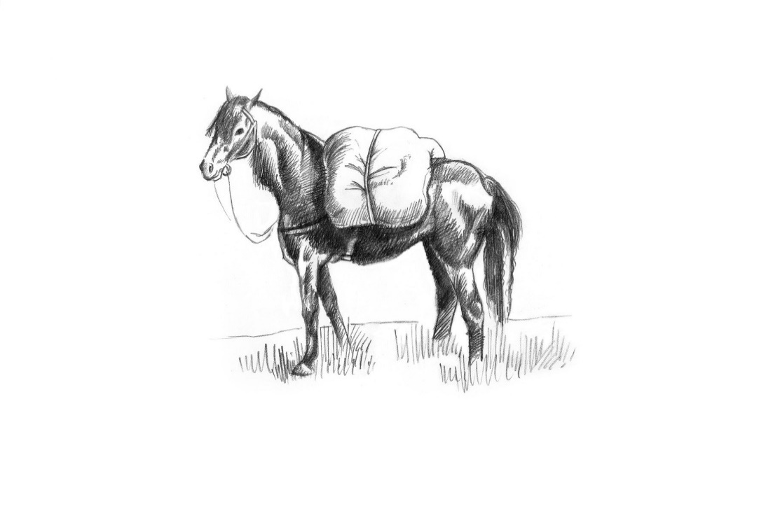
Sunday

Snacks
Manchester egg 8
Seaweed Dust whitebait, preserved lemon mayo 9
Nocellara olives 6
Brisket croquettes, sweet mustard ketchup 11

Meat & Fish One Course 28 Two courses 38 Three courses 45
Vegetarian One Course 22 Two courses 30 Three courses 37

Starters

Isle of White tomato salad, pumpkin seed dressing, Rosary goats’ cheese, cracker
Caesar salad of charcoal roast sardines, Lincolnshire Poacher
Rocket and smoked garlic soup, Serrano ham crumb
Marinated Artichoke, haricot beans and red pepper Panzanella
Glazed Kimchi pork ribs, Kohlrabi slaw
Crispy Scottish Squid, watercress salsa verde, hot honey pickles

Mains
Derbyshire beef rump, Sunday roast trimmings
Mint & honey slow braised lamb shoulder, Sunday roast trimmings
Baron Bigod, caramelised onion and potato pie, roast garlic mash, buttered cabbage
Cod, Shrimp, Mussels, Coconut Brown Crab and Red Pepper Sauce
Golden Cross Goats cheese, Grilled Courgettes , Caramelised onion and cheddar tart, roast trimmings

Charcoal oven

Cote du boeuf for two 760g +26pp

Sides
Orla Potato herb butter 6
Harissa roast carrots, nut Dukka 6

Our cookbook- The Pack Horse, A Journey Through the Seasons 25

Desserts
Salted caramel custard tart, almond chantilly
Cherry Clafoutis, Chocolate ice cream
Apricot, Toasted Almond and Basil Pavlova
Strawberry, honey cake and yoghurt sorbet, Pistachio
Truffled Baron Bigod, treacle & walnut malt loaf, balsamic onions

Please inform a member of the team if you have any allergies or dietary requirements. Our menu is carefully curated and costed; we do not offer substitutions for tastes.

