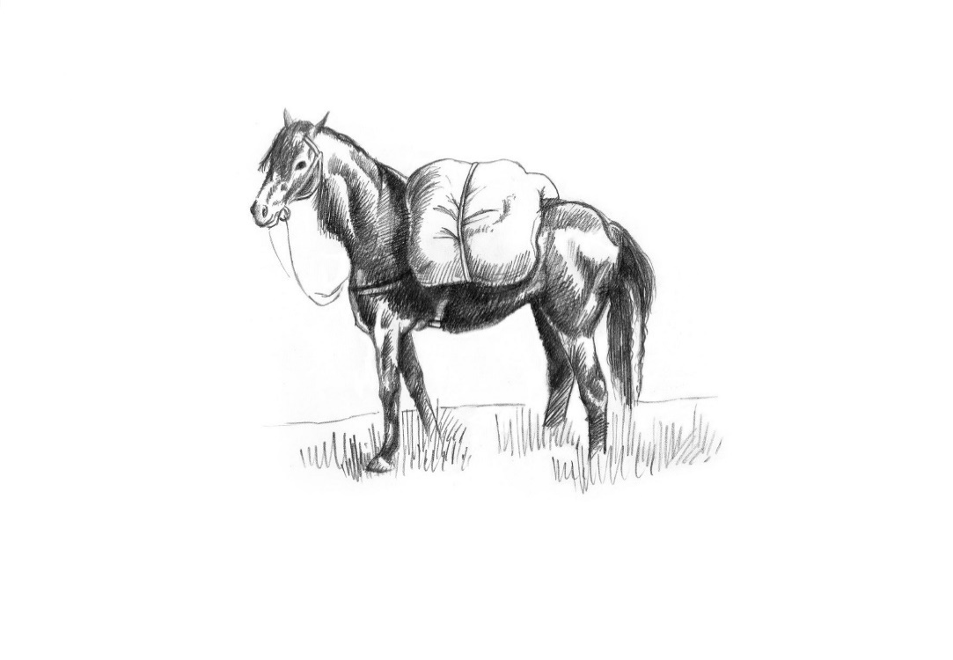
Snacks
Manchester Egg 8
Seaweed Dust Whitebait, Preserved Lemon Mayo 9
Nocellara Olives 6
Brisket Croquette, Honey mustard Ketchup 11

Two courses 47 Three courses 55

Amuse bouche & house bread

Starters
Isle of White Tomato Salad, Pumpkin Seed Dressing, Rosary Goats’ Cheese, Cracker
Caesar Salad of Charcoal Roast Sardines, Lincolnshire Poacher
Crispy Scottish Squid, watercress salsa verde, hot honey pickles
Marinated Bedlam Farms Artichoke, haricot beans and red pepper Panzanella
Glazed Kimchi Pork Ribs, Kohlrabi Slaw +4

Mains
Poached Herb Fed Chicken, Confit Croquette, sweetcorn, Girolles
High Peak Lamb Rump, Faggot Chou Farci, Anchovy Creamed Potato, Turnip +5
Norwegian Rainbow Trout, braised Puy lentils, Gooseberry and cucumber vinaigrette
Coley, Shrimp, Mussels, Coconut Brown Crab and Red Pepper Sauce
Nettle and Garlic Malfatti, Isle of White Tomato Ragù, Smoked Poacher

For Two
Charcoal-Roast 760g Cote de Boeuf, Chips, Grilled Courgette, Peppercorn Sauce +26pp

Sides
Orla potatoes, Herb Butter 6
Harissa Roast Carrots, Dukka 6
Chargrilled Courgettes, Sunflower Seed, mint and dill Dressing 6
Chips 5

Our cookbook- The Pack Horse, A Journey Through the Seasons 25

Desserts
Salted Caramel Custard Tart, Coffee Chantilly
Cherry Clafoutis, Chocolate Ice Cream
Apricot, Toasted Almond and Basil Pavlova
Strawberry, Honey Cake and Yoghurt Sorbet, Pistachio
Truffled Baron Bigod, Treacle & Walnut Malt Loaf, Balsamic Onions +4

Petit four

Please inform a member of the team if you have any allergies or dietary requirements. Our menu is carefully curated and costed; we do not offer substitutions for tastes.

