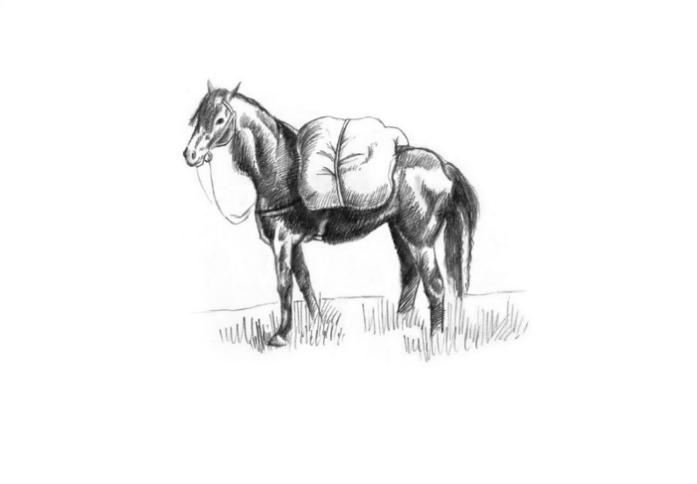

Cold
Nocellara olives 6

Hot
Manchester egg 8
Seaweed dust whitebait, preserved lemon mayo 9
Brisket croquettes, honey mustard mayo 10

This week’s special 22
Fish and chips, mushy peas and tartare sauce

From the charcoal oven
Pork loin chop 250g 23
Beef rump 250g 28
Lamb Barnsley chop 280g 30
Cote du boeuf for two 750g 45PP
Sauces- Price included
Chimichurri, green peppercorn

Sides
Orla potatoes, herb butter 6
Chips 5
Harissa roast carrots, nut dukka 6

Our Cookbook – The Pack Horse, A Journey Through The Seasons 25

