CURRICULUM POLICY

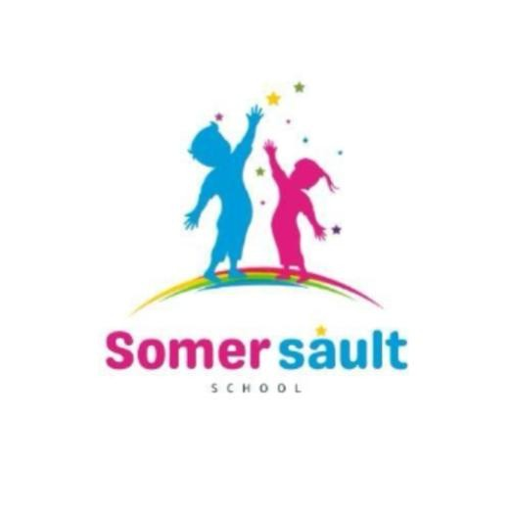

Reviewed: March 2026
Due for review: September 2028

Policy Statement
Somersault School is located on the same site as Hopscotch Residential home, in a separate building, which has been designed to meet the needs of our educational intent. At the school we aim to provide our children with a rich, hands-on learning experience. Learning will be personalized to meet individual needs with a focus on practical learning. Understanding the disruption that would have affected the lives of many of our children and young people, we aim to meet learning needs by providing a hand-in-glove transition between traditional education and a more alternative experience.

Intent
Somersault School provides 25 hours of education per week, using the Equals Curriculum tailored for children with additional learning needs (ALN). The content (units) will be selected based on the pupil’s prior experience, interests and needs. The teaching hours may vary according to the needs of each pupil/student. Our main learning intentions are for our children to become lifelong learners and to make a positive contribution to society despite any disruption to their early lives. We encourage group and individual work as appropriate, emphasize outdoor activities, utilise various therapies, and prioritise mental and physical well-being through our broad, balanced curriculum

Math at Somersault School
Math will be taught at the students' current level. With personalized learning journeys. Pupils will be taught the four mathematical operations and will apply them to real-life, single then multi-step problems. Pupils will be expected to employ reasoning skills to their math. They will be given daily opportunities to practice key number skills which include learning their addition and subtraction number bonds to 10, 20 and 100 and their multiplication tables with associative division facts. Pupils will also be presented with number puzzles and open-ended problems to develop their thinking and deepen their mathematical understanding. Teachers will aim to exploit practical, real-life and outdoor opportunities to teach mathematics. White Rose Maths through Teachers Pet, Doodle Maths and Classroom Secrets will be used to supplement the Equals Curriculum and ensure full curricular coverage. Older (Key Stage 4) students will be given the opportunity to work towards a functional skills qualification in Maths, where possible.

Reading and Writing (English) at Somersault School
At Somersault School we believe that reading is the key skill that our pupils need to succeed in life. We want to foster a love of reading. To this end, every classroom has a range of fiction and non-fiction texts that are central in every room. Staff will read to pupils at least once a day. Pupils will also have access to a range of age appropriate for both fiction and non-fiction books. Pupils will be encouraged to read through a variety of media, including iPads and kindles. Pupils’ fluency will be developed alongside their comprehension skills. Older (Key Stage 4) students will be given the opportunity to work towards a functional skills qualification in English.

We will be using Read, Write Inc for our English lessons as well as Reading Eggs for our reading scheme. We have chosen an online scheme of books that is interactive and will engage our small cohort of children.

Science at Somersault School
At Somersault School, science teaching and learning will be centered on the needs and experiences of the children. These include access to a kitchen and a wonderful outside area.
Pupils will be encouraged to ask questions, perform tests, make observations, and gather and analyze data. As far as possible, pupils will use household and familiar materials to test out scientific phenomena.

Other subjects at Somersault School
All other subjects will follow the Equals scheme of work and mixed learning schemes of work. These will be backed further by other accreditations including AQA certificates and achievements.

Implementation
The curriculum will be implemented through a combination of personalized learning journeys and outdoor learning experiences. The Equals Curriculum will form a basis of the Somersault curriculum. Once the pupils arrive, staff will agree which aspects, themes and teaching arrangements will be most appropriate. Pupils will be taught all eleven subjects across a term, with a daily input of mathematics, reading and writing. Pupils will be grouped according to their age, interests and may be taught individually. High staffing ratios will allow for flexibility in teaching arrangements.

Impact
Learning will be assessed regularly and informally through structured questioning and activities. All learning conversations and examples for learning will be recorded electronically on our own management system. All learners will have regular opportunities to contribute to their learning journeys. Learners will be set termly, agreed targets for reading, writing, and mathematics and for personal and social development. Children will work towards their end of phase age-related expectations. Learning will be scaffolded to enable pupils to make at least expected progress and prepare children for their next stage in learning.

