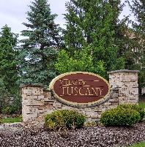

**Villas of Tuscany**

**Homeowners Association**

**Complaint Form**

**Nature of Complaint (animal, noise, etc.): ______________________________________________**

**_________________________________________________________________________________**

**Location: _________________________________________________________________________**

**Number of Occurrences: _______**

**Date(s) of Violation(s): _______**

**Times(s) of Violation(s): _______**

**Name of Offender (if known): ________________________**

**Was Any Attempt Made to Resolve This Problem (circle one) Yes No**

**If “YES”, What Were the Results?:______________________________________________________**

**Name (please print): ____________________________**

**Your Address: _____________________________**

**Signature (please sign) ________________________________________________________________**

**Received by VOTHOA:**

**Date_________________________________________ Manager or Other______________________**

**Disposition__________________________________________________________________________**

**Note: If complainer will not fulfill their role and identify themselves, VOTHOA Board cannot fulfill its role and cannot take enforcement action.**

**Mail completed form to:**

Iris Management Group, LLC

Mike O’Brien

7449 Cypress Court

Macedonia Oh 44056

**Email questions to:** mobrienwphoa@gmail.com