Sham, a Champion at Heart
© 2005 Mary Walsh. All rights reserved.

Unlike his nemesis, Secretariat, Sham wasn’t considered a champion in the world of thoroughbred horseracing upon his retirement in the fall of ‘73. However, he had all the vital qualities a champion must possess – breeding, balance, stamina, and a steadfast will to succeed. Born on April 9, 1970, just ten days after Secretariat, he was ultimately cursed with the misfortune of being born in a truly unlucky year for racehorses. Every owner and trainer of a proven thoroughbred racehorse came to challenge Secretariat. Of the entire one hundred and fifty-nine that did, a mere seven of them beat him to the finish line, and one other, by default. Though Sham challenged Secretariat in four consecutive starts, he accomplished the feat of beating Secretariat only once. Ironically, challenging Secretariat for The Triple Crown ultimately cost Sham his claim to fame.
Sham had a sleek, leggy, frame with a glossy, velvet-like sheen to his dark bay coat. When he stepped into the sunlight countless dapples glimmered like tiger-eye semiprecious stones, and he attracted attention wherever he went. He was a striking equine with a quiet grace about him, and an impeccable pedigree to back him up. Sham began his racing career under the tutelage of his birthplace, Claiborne Farm, in Paris, Kentucky. However, his first three attempts to break his maiden were unsuccessful. Then, with the unfortunate passing of Claiborne’s owner, A.B. “Bull” Hancock, Jr., Sham’s racing career took an abrupt turn. Bull’s Last Will and Testament forced Claiborne to return to the commercial market to sell off many of the yearlings at the farm, and, many two-year-olds in training at Belmont Park. Thirty-five meticulously pedigreed thoroughbreds were slated for the sale, and Sham was one of them. On a crisp morning at Belmont Park in the fall of ‘72, Fasig-Tipton Co., Inc. auctioned off bloodstock from such champion sires as Bold Ruler, Buckpasser, Damascus, Dr. Fager and more. Sham brought the second-highest price at the sale, $200,000. He was purchased by well-known New York real estate developer and his wife, Sigmund and Viola Sommer, and immediately was the charge of award-winning trainer, Frank Martin.

© Photo courtesy CTBA. All rights reserved.
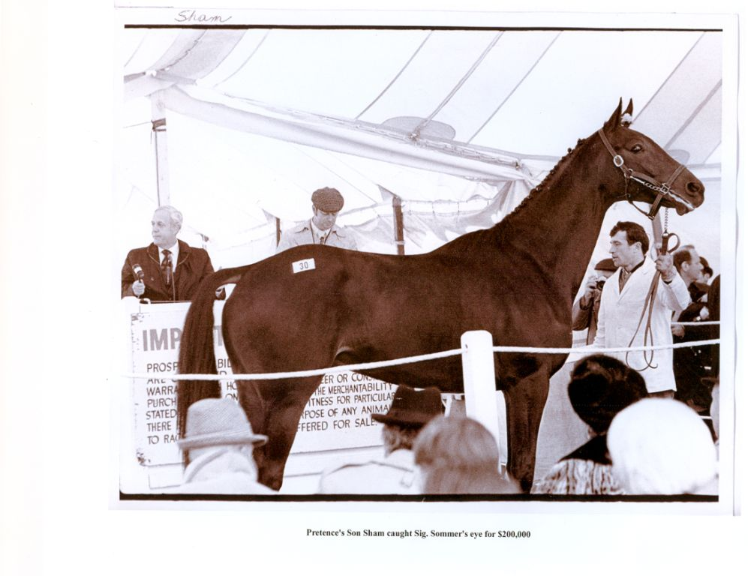

Meanwhile that same fall, Secretariat finished his record-breaking juvenile season for Meadow Stable. With only one loss and one disqualification in nine starts, he won the 1972 Eclipse Horse of the Year award, and became the third horse in history to accomplish that feat as a two-year-old.
On a miserably cold and wet December day at Aqueduct racetrack in New York, Sham won his first race and broke his maiden. That first start under the green and gold silks of the Sommer stables, told the Sommers and Martin they had a diamond-in-the-rough. Sham was shipped to Santa Anita Park racetrack in California for intensive training. As the palm trees swayed in the humid ocean breeze waving to the blue sky above, his racing career took off. It took Sham some time to realize the purpose of horseracing, but with Frank Martin in control, Sham understood, and there was no stopping him. His new jockey, Laffit Pincay, Jr, only enhanced Sham’s longing to be first at the wire. Pincay was already one of the winningest jockeys with a no-nonsense style of accelerating down the homestretch to the finish line. Pincay subliminally relayed his zealous lust to win to all of his mounts, and it paid off. He won the 1970 and 1971 Eclipse awards for Leading Money-winning Jockey. Teamed up with Pincay at the start of his sophomore year, Sham’s will to win intensified and carried him down the homestretch with such amazing final bursts of speed, that he defeated favorites at the wire with ease. He destroyed his rivals with winning margins of 15, 6, and 2.5 lengths.
Sham’s ultimate claim to fame was in winning the Santa Anita Derby. The California favorite, Linda’s Chief, couldn’t get past him from start to finish, and coming down the homestretch, Sham widened his lead to win by two-and-a-half lengths, and 3/5^{ths} of a second off the track record. Instantly, Sham earned the title of best horse in the west, with five wins in six starts for the Sommers. Rumors spread across the nation that Sham’s net worth had spiraled to over ten times his purchase price. He annihilated the west coast competitors, while his soon-to-be-rival, Secretariat, exterminated favorites in the east. It was inevitable that these two would compete for The Triple Crown. Their first meet was their final Triple Crown prep-race run at Aqueduct, The Wood Memorial. However, Secretariat had one great advantage to that match. He was already at Aqueduct, while Sham was shipped from Los Angeles to Long Island.

© George Andrus Photo courtesy Bill Mochon Photography. All rights reserved Sham winning ’73 Santa Catalina Stakes.

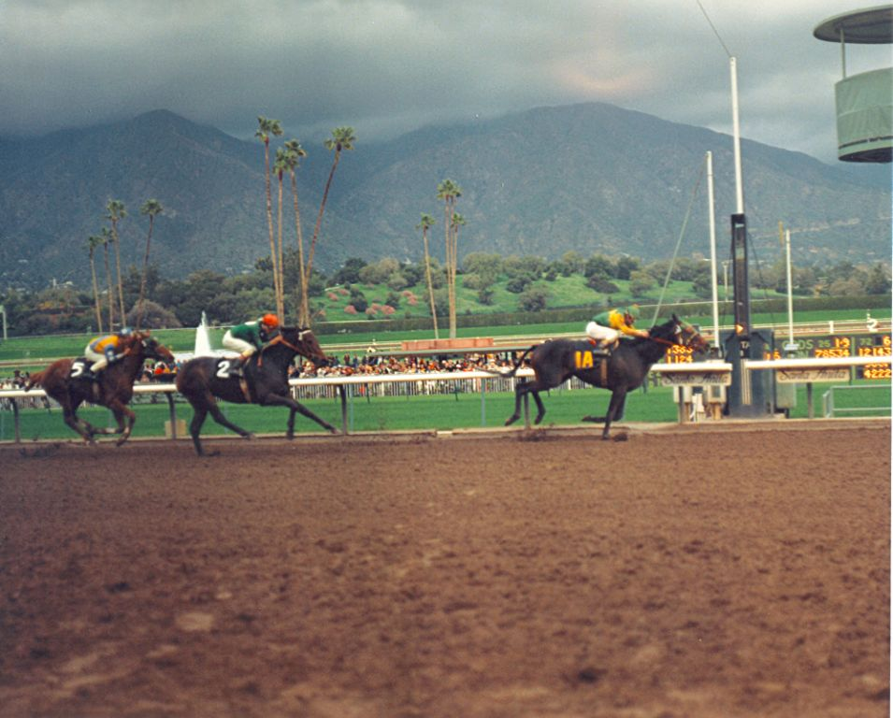

The Wood was particularly important, as both Sham’s and Secretariat’s performances there would set up betting odds for the much-anticipated Kentucky Derby. When race day arrived, there was one small change of plans. Pincay couldn’t make the race, so Martin was forced to find another jockey without delay. Jorge Velasquez, the New York-based jockey who rode Sham to victory in his first maiden race for the Sommers, signed on and was ready for the challenge.
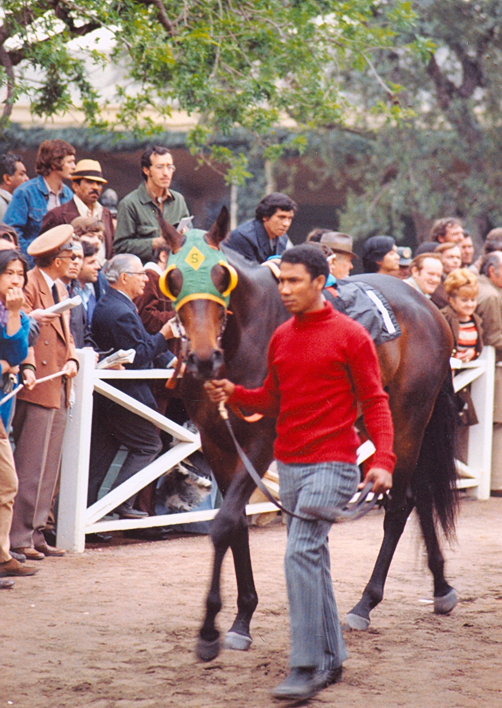

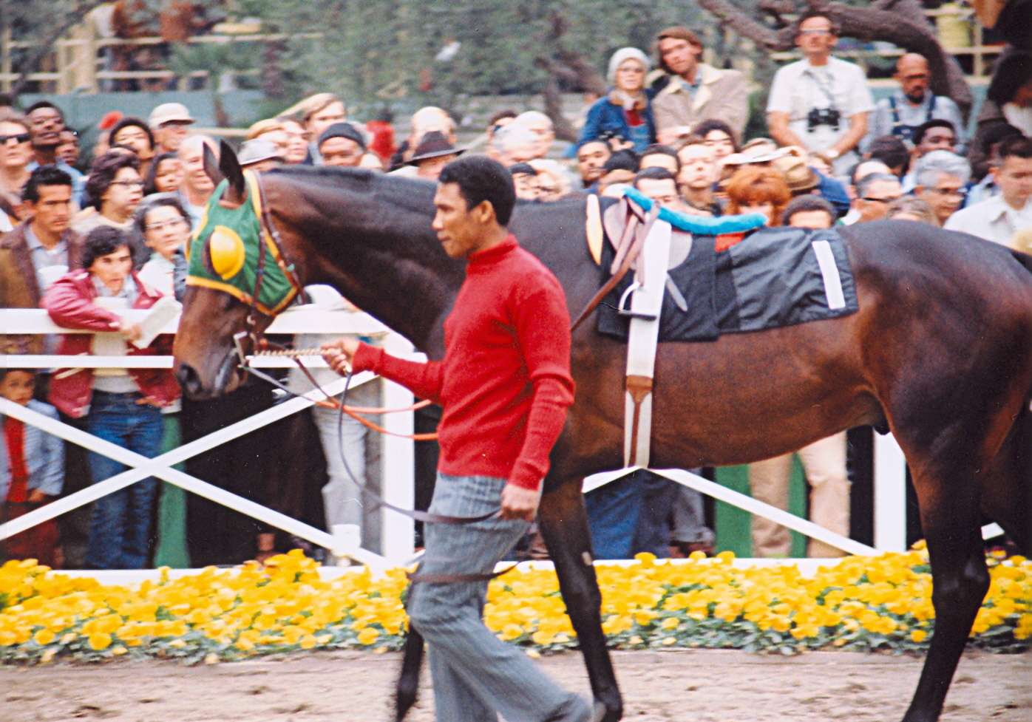

© Bill Mochon Photography. All rights reserved. Sham and groom, Secundino Gato

When the steel gates burst open, Sham sprang into action leaving Secretariat in his wake. Angle Light took the lead with Sham following a close second. Sham was ready to overtake Angle Light, but wouldn’t make his move until Secretariat’s final burst of speed. That proved to be a monumental mistake. Rounding the turn for home, Secretariat was far behind, and Sham had waited much too long for a challenge. With the finish line just yards ahead, Velasquez belatedly roused Sham, and drove for the wire. In a flash Sham and Angle Light were at the finish line. Angle Light won by a head with Sham narrowly missing his mark. Secretariat crossed the wire four lengths behind, barely holding on to third place. Sham’s team was so excited that Sham beat Secretariat to the finish line; they completely overlooked the fact that Angle Light won. They chalked it up to a fluke – just bad racing luck. Suddenly their dreams seemed to come true, as now Sham’s chance to win the upcoming Derby was undoubtedly a reality.
The racing world was immediately pitched into a state of doubt and uncertainty as the first Saturday in May approached, bringing with it The Kentucky Derby. It was the first jewel of the ultimate test of racing skills, The Triple Crown. Combined with the knowledge that 25 years had passed since Citation won it all in ’48, the racing world was abuzz with speculation as to whether Secretariat or Sham would become the ninth thoroughbred in history to accomplish the feat. They settled into Barn 42 at Churchill Downs, only eight stalls apart. Reporters ran back and forth, desperately trying to get their news breaking stories on the two colts. By beating Secretariat in the Wood, Sham gained more attention than ever before. Not only from the media and racing fans, but other trainers and owners reconsidered their decision to hold their horses from the Derby. After all, if Angle Light and Sham both beat Secretariat, their horses should have an excellent chance of doing the same. A total of thirteen horses entered the line-up on May 5th with Secretariat the favorite, Sham, second, and Shecky Greene, third.
The Kentucky Derby was Sham’s most brilliant demonstration of strength and will. In spite of the pandemonium caused by the record crowd of 134,476 fans jammed between the Twin Spires of the stands and overflowing out across the lush green lawns of the infield, Sham remained calm and collected. He quickly entered the fourth gate beside Warbucks, already settled in third. A wall of heavy-hitters: Our Native, Royal and Regal, Forego, Secretariat, Shecky Greene and My Gallant, held quietly in posts seven through twelve, consecutively.
Twice a Prince was washy; his mere surroundings had worked him into a nervous sweat. His jockey, Santiago, frantically tried to sooth him while other horses entered their gates. Without warning the colt reared and flailing legs jammed through the bars of the gate. Panic instinctively took hold of Twice a Prince. He thrashed around desperately trying to pull his legs free. Sharp aluminum shoes jabbed through the rigid steel bars dangerously close to Our Native and Brumfield pinned in the adjacent gate. With a powerful backward thrust of muscle, tendon, and bone, Twice a Prince jerked his legs free.
The buzzer screamed, and a reverberating crash sent tremors through the ensnaring steel surrounding the horses as the gates swung open. Navajo, on Twice a Prince’s immediate left, sensed that colt’s fear and jolted to his left, knocking Sham off balance as he sprang out of gate four. Sham’s mouth hit the swinging gate, and took the full impact of the forward thrust from his powerful hindquarters. Instantly, blood flew from his mouth.
Freedom jettisoned the horses’ tense bodies into the air. Scrambling hooves struck the ground in unison, grabbed up dirt and sprayed it out behind with each leap. Sham ran on blind panic as a searing pain burned in his mouth. He was fifth when they passed the stands for the first time. Shecky Greene led, with Royal and Regal, Gold Bag, and Angle Light clustered in his wake. Behind Sham, Our Native, Restless Jet, My Gallant and Forego clawed at the ground with their hooves. Navajo, Secretariat, Warbucks and Twice a Prince were last, and struggled to gain momentum. Instinctively Sham felt secure to be in the middle of the herd. The intense pain, and sickly-sweet taste of blood on his tongue, distracted him. Pincay sensed something was wrong but couldn’t see the extent of Sham’s distress and urged Sham up with the leaders.
Shecky Greene sprinted into the backstretch with consecutively faster fractions to the three-quarter-mile pole, where Sham suddenly appeared to duel for first place. Sham’s ominous presence at Shecky Greene’s side forced that colt to drive faster. While they battled heads apart, Secretariat made his move back in sixth place.
Red froth dripped from the edge of Sham’s mouth as his hooves dug into the dirt. He easily passed Shecky Greene and led the field in record-breaking time. Sham set the pace as the teletimer blinked :23 2/5 for the quarter fraction at the mile mark. Suddenly, Secretariat stormed past Angle Light in fifth, then Royal and Regal, and ran a close third behind Shecky Greene. He swung wide on the final turn coming into the home stretch. Pincay knew Sham had more to give and urged him on. Sham’s legs sliced through the air in rhythmic succession as he obliged. He lowered his head and extended his front legs, while his hind legs coiled and thrusted like a powerful machine. Something else mimicked him not far behind, now in second place and continuing to build momentum in his wake. Secretariat’s copper coat glistened in the sunlight, while his powerful muscles rippled and stretched taught as he whittled down Sham’s lead. Blood continued to seep through the rip in Sham’s gums, but his sleek form continued to soar with agility and determination.
Ron Turcotte raised his whip and suddenly Secretariat appeared at Sham’s side. The two ran in unison, stride for stride – four lengths ahead of the other horses. Their hooves became a blur while their bodies soared through the air as if on wings. They were now eight lengths in front of the field. Shouts and cheers echoed through the grounds urging Sham and Secretariat on. Sham strived to hang on, but Secretariat pulled away from him as they seared down the final yards of the track in sizzling time. The copper colt’s nose reached out for the finish line and the teletimer flashed 1:59.4 – a new track record! Two and a half strides later, Sham also crossed the finish line in record-breaking time. It was an unheard-of final quarter-mile fraction of :23 1/5. Sham gave everything he had to give, while his injury bled the whole race. Secretariat had to break a record – just to beat Sham to the wire. Official time is only taken for the winner, but with generalities being 1/5th of a second per length, Sham’s two and a half lengths behind Secretariat unofficially set him at 1:59.9.
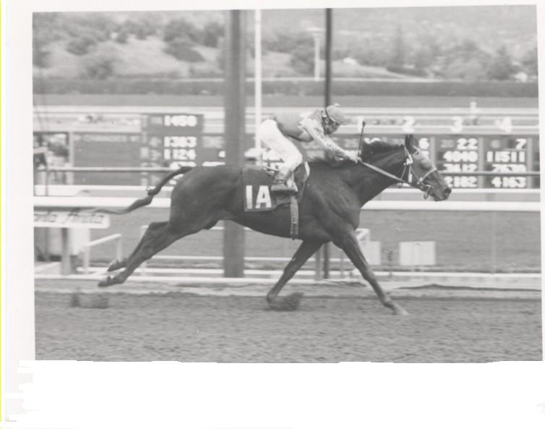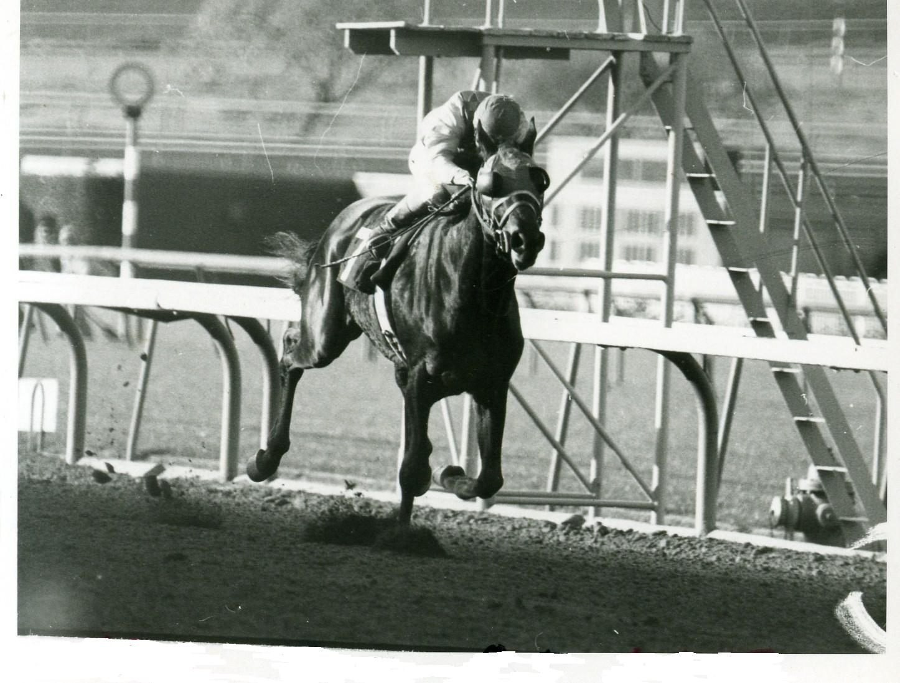
© Photos courtesy of Santa Anita Park. All rights reserved Sham with Laffit Pincay Jr. up.

Hundreds of horses have run in the Derby since May of ’73 – crowd pleasers like Smarty Jones (2:04.06), Funny Cide (2:01.19), Sunday Silence (2:05), Spectacular Bid (2:02), Charismatic (2:03.29), Affirmed (2:01), Seattle Slew (2:02), and more. However, the only other horse to run under 2:00, was Monarchos at 1:59.97.
Through Sham’s brilliant courage and challenge to Secretariat, he unofficially remains the second fastest horse to run in the Kentucky Derby. Though he lost, he proved to the world that he was truly a champion at heart, by his heroic will to succeed.

© Marcia Skiles Photo. All rights reserved 