Mini Cowpers Pre School Uniform
Order Form

Item | Size (Age) | Price £  each | Quantity | Total £
Preschool Starter Kit (Polo top with embroidered logo, jumper & Book bag  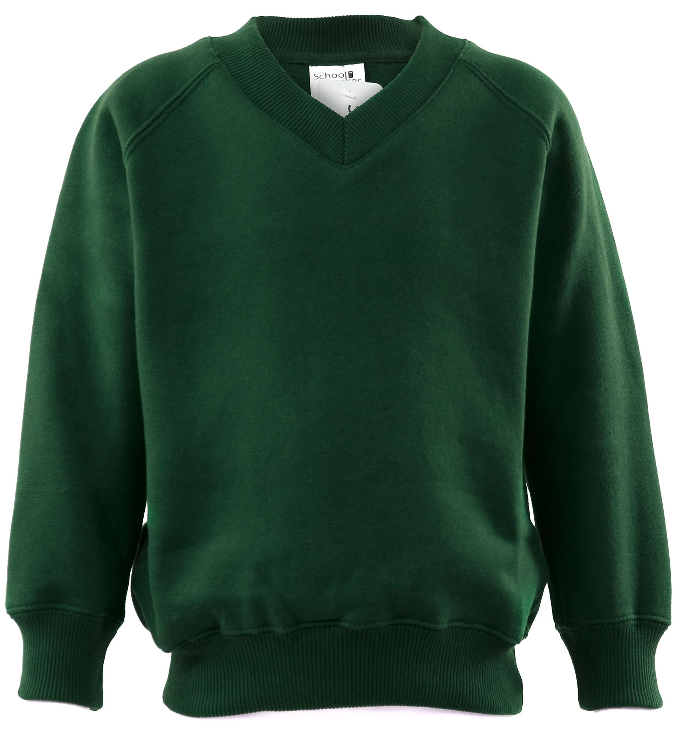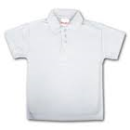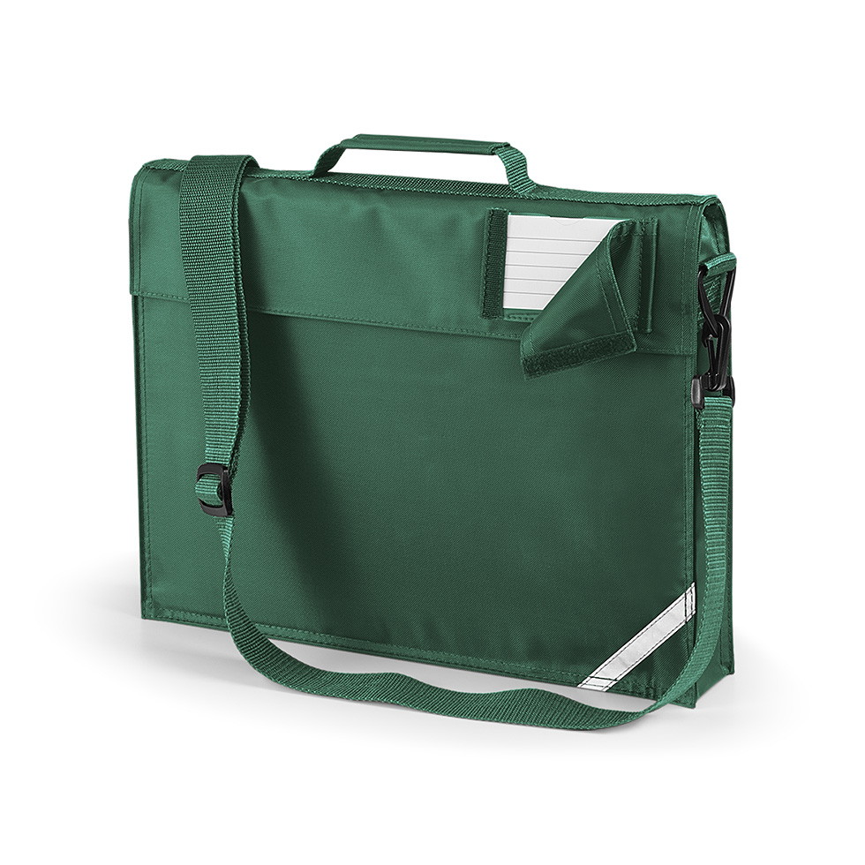 | (Please specify) | £25.00
White Polo top (with embroidered logo) | 2 | £9.50
 | 3/4 | £9.50
Green Sweater (with embroidered logo) | 2 | £11.50
 | 3/4 | £11.50
 |  |  | TOTAL £

Child’s Name:……………………………………………………………………………
Please enclose payment with your order (cash/cheque) or you can pay by Bank Transfer. Sort code – 30-99-86 Acc no 01143441
Many thanks
Nicola Martin
Leader

