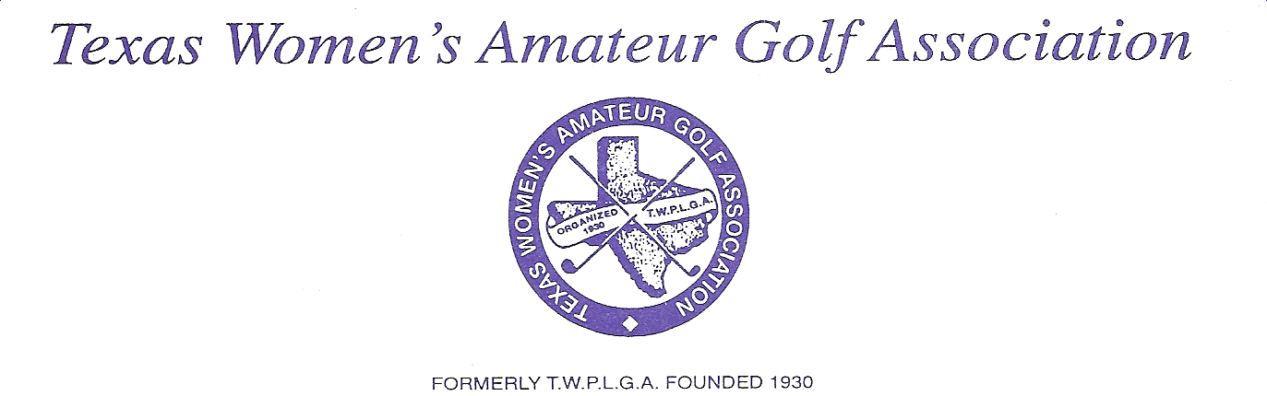

December 1, 2020
Linda Jenkins
P. O. Box 351
Strawn, Texas 76475
940-727-1103

Dear TWAGA Representative,

The Texas Women’s Amateur Golf Association club dues for the year 2021 will be thirty five dollars ($35.00). Please make your check payable to TWAGA and send it to me along with your Club Registration Card, PLEASE FILL OUT THE FORM COMPLETELY. All club dues are due and payable before February 28, 2021. The 2021 Membership Cards will be mailed after your membership dues are received.

THE 2020 TWAGA TOURNAMENT SITE WILL BE THE Hideout Golf Club and Resort in Brownwood, Texas. Dates for the tournament will be May 08, 2021 thru May 14, 2021.

All women, Military, Public Links, Golf Club or Country Club members, age twenty-one years or older, who maintain a maximum handicap of 36, and for three months prior to the tournament have been a member in good standing of a women’s golf association and a resident of the state of Texas for six months and whose association has paid the annual dues to the TWAGA, are eligible to play in the State Championship Tournament.

Type 1 or Type 2 members:

Type 1 members belong to a specific golf course or golf club with a valid USGA course rating. You, as your Club’s Representative, will receive an invitation. This invitation may be copied so that any member wishing to be included in the entries for the tournament may complete it and mail to the instructed location. As the representative from your club, it is your responsibility to get this information to the rest of your membership. If you have received this letter and are not longer the club representative, please forward it to the new club representative. Please list those members associated with your club.

Type 2 members who are not affiliated with a particular golf course or gold club but still wish to participate in the State Championship Tournament may send in their dues individually. Please state you are Type 2 on your registration Card.

Sincerely,

Linda Jenkins
Secretary/Treasurer, TWAGA

