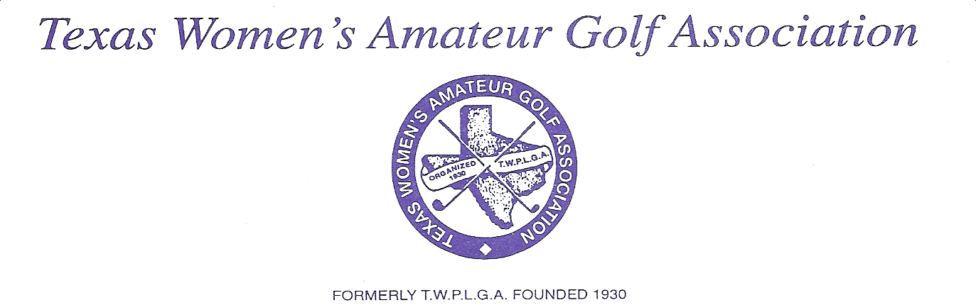

January 4, 2022
Dear TWAGA Representative,

The Texas Women’s Amateur Golf Association club or individual dues for the year 2022 will be thirty five dollars ($35.00). Please make your check payable to TWAGA and send along with your Club or Individual Registration Card. PLEASE FILL OUT THE APPROPRIATE FORM COMPLETELY. All dues are payble before February 28, 2022. The 2022 Membership Cards will be mailed after your membership dues are received.

All women, Military, Public Links, Golf Club or Country Club members, age twenty-one years or older, who maintain a maximum handicap of 36, who are currently a resident of the state of Texas and whose association or individual member dues have been paid for the current tournament year, are eligible to play in the State Championship Tournament.

Ladies Association members belong to a specific golf course or golf club with a valid USGA course rating. You, as your Club’s Representative, will receive an invitation. This invitation may be copied so that any member wishing to be included in the entries for the tournament may complete it and mail to the instructed location. As the representative from your club, it is your responsibility to get this information to the rest of your membership. If you have received this letter and are not longer the club representative, please forward it to the new club representative. Please list those members associated with your club.

Individual members who are not affiliated with a particular golf course or golf club but still wish to participate in the State Championship Tournament may send in their dues individually.

MAIL TO:
Sincerely, Joy Ellithorp
Joy Ellithorp 608 White Oak Lane Secretary/Treasurer, TWAGA Harker Heights, Tx 76548
254-702-4632

