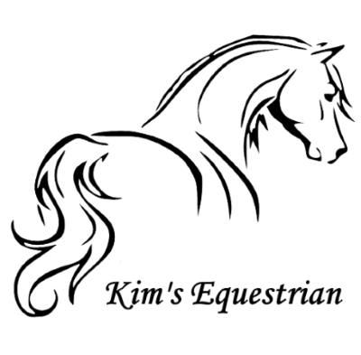

To...............................................................

**PLEASE NOTE:**

* **Please do not bring balloons or use umbrellas.**
* **Wellies or riding boots MUST be worn.**
* **No trainers are allowed for safety reasons.**
* **Trousers, joggers or long leggings must be worn.**
* **Sorry, no Party Dresses.**
* **Please bring a waterproof jacket and gloves, just in case.**

From.........................................................

You are invited to my horse riding Birthday party at:

**Kim’s Equestrian Riding School**

**Westwick Row**

**Hemel Hempstead Herts**

**HP2 4UB**

Date.................................................

Time................................................

This Declaration must be signed by a Parent/Guardian and brought with you to the Party.

**I understand that riding is a risk sport and that my child rides at my own risk.**

Name of Parent/Guardian ................................................................

Signed ................................................................. Date...................................

Phone Number..................................................

Child’s name.......................................................

Does your child have any medical conditions or disabilities? YES/NO (Please delete as applicable).

Details:

....................................................................................................................................................................................................