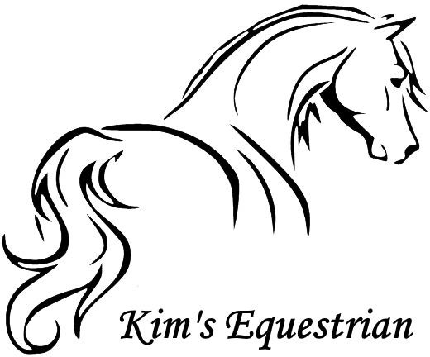RIDER REGISTRATION FORM

**CONFIDENTIAL - Please complete all Sections and Boxes**

First Name: Surname:

Address:

Tel (Mobile):

Tel (Home):

Email:

Date of Birth: Age:  Weight:  Height: Occupation:

Kim Slater Westwick Row Farm Westwick Row Hemel Hempstead Hertfordshire

HP2 4UB

Tel: 07966462143

Have you or the rider you are signing for, ever suffered a serious injury or discomfort while riding or been advised not to ride?

Yes  No

If Yes, Please describe:

Please detail any disability or medical conditions that may affect your ability to ride. This may include but not limited to any back problems and any condition, which can affect balance or cause blackouts/ loss of consciousness/ fitting etc.

**EMERGENCY CONTACT**

Contact Name & Relationship: Tel:

**RIDING ABILITY/DECLARATION - Tick all boxes that apply**

I consider myself (or the person riding for who I am signing on behalf as a minor) to be a:

Complete Beginner  Beginner  Novice  Intermediate  Advanced

None under 12 12-40 40+

How many times have you/rider ridden in last 12 months:

What do you believe yours or the person riding’ capabilities to be on a horse or pony to be?

Riding at a walk  Trotting with stirrups  Trotting without stirrups  Cantering Hacking Riding over jumps up to 0/5m (18”) Over jumps 0.75 (30”) Riding over cross country jumps

* I can confirm that to the best of my knowledge all the above details are correct.
* I have read the Horse Riders’ Code of Conduct overleaf. I understand that riding at any standard has inherent risk that I may fall off and could be injured. I accept that risk and agree that the riding school will not be liable for injury or damage to property unless it is caused by their negligence.
* Where I am signing on behalf of a minor I have explained the Riders Code of Conduct to my child and we both accept the risk and agree that the riding school will not be liable for injury or damage to property unless it is caused by their negligence.
* I have read and understand the lesson booking and cancellation policy and agree to abide by it all times.
* DATA PROTECTION: I understand that information I provide will be held in accordance with data protection laws but may also be made available to Insurers and other parties in the event of any injuries or accident.

|  |  |  |
| --- | --- | --- |
| **Signature** | **Print Name** | **Date** |
| If signed on behalf of a minor: |  |  |
| **Rider’s Name** | **Relationship to minor** |  |

**TO BE COMPLETED BY INSTRUCTOR/SUPERVISOR ON BEHALF OF THE EQUESTRIAN ESTABLISHMENT**

This client has been assessed and our judgement of their capabilities is as follows:

Complete Beginner (Lead rein/Lunge)

Novice (Walk, Trot, Canter independently)

**ASSESSMENT LESSON CONTENT:** Walk

**OFFICE USE - Assessment Lesson**

Beginner (Beginning Walk & Trot independently)

Intermediate (Jumping, Stage 1)

Advanced (Stage 2, Equivalent and above)

Trot

Canter

W/O Stirrups

Jump

Lateral

Horse Used

Date Signature

Lesson Type

Time

Print Name

Position

**KIM’S EQUESTRIAN**

**TERMS OF SERVICE AND HORSE RIDER’S CODE OF CONDUCT**

* I understand that riding at any standard has inherent risks and that all horses may react unpredictably on occasions when I/my child may fall off and could be injured. I accept that risk and understand that Kim Slater can therefore not be held liable/responsible for any potential personal injury that may be sustained whilst on and around the horses.
* I understand that instructions are given for my/my child’s safety and agree to follow instructions given to me by staff and instructors of the riding school
* I understand that wearing an appropriate riding hat and body protector may reduce the severity of an injury should an accident happen and agree that I/my child will always wear a riding hat whilst riding
* I understand it is my choice whether or not I/my child wear(s) a body protector
* I understand that the riding school will make decisions based on information I give them and agree to always be honest and volunteer accurate information about my/my child’s abilities and riding experience, any previous riding accidents and any medical condition(s) which may affect my/my child’s ability to ride
* I understand that children are at particular risk around horses and agree that I will keep any children, for whom I am responsible, under close supervision when they are not being instructed by the riding school
* I understand that the riding school may refuse my/my child’s request to ride for safety or operational reasons
* I understand that there is a requirement for 48 hours’ notice of cancellation of lessons or hacks or the full fee is payable
* I understand that the horse I have booked may not be available to ride and that Kim’s Equestrian reserves the right to change my/my child’s horse without notice
* I understand that Kim’s Equestrian reserves the right to change Instructors without notice
* I understand that while every attempt will be made to notify Customers if lessons are cancelled, this may not always be possible

**ADDITIONAL TERMS & CONDITIONS FOR HACKS**

* I understand that if I/my child have not learned to ride at Kim’s Equestrian, I/my child will undertake a short riding ability assessment, if required, to demonstrate my/my child’s competency to ride safely on a hack
* I accept that the decision of the Assessor as to whether or not it is safe for me/my child to hack out is final
* In the event that it is decided a hack cannot be offered, I/my child will be offered a lesson, to be taken during the rest of the time available during the time slot booked for the hack
* I accept that the lesson cannot be re-booked for another time
* I accept that no payment is refundable in the event that I/my child decline(s) to have the lesson
* I understand that wearing an appropriate riding hat and body protector may reduce the severity of an injury should an accident happen and agree that I will always wear a riding hat that meets current British standards whilst riding, leading, and grooming horses at the riding school. I understand it is my choice whether or not I wear a body protector
* I understand that competing carries enhanced risk over and above general riding and agree that if I choose to participate in any competition or event, it is up to me to ensure that I have the experience, and ability to ride the course including any jumps which form part of it. If I am in any doubt, I will use my judgement and experience and not enter.

**PLEASE INFORM US OF ANY FUTURE CHANGES OF CONTACT DETAILS OR MEDICAL CONDITIONS SO WE MAY KEEP OUR RECORDS UP TO DATE**

Signed: ………………………………………..

Dated:…………………