BOOMING CORN CROP AMIDST DROUGHT!!!
Drought conditions across the nation are stressing crops, farmers and consumers. Crops are non-existent or stunted. Yields are depressed. Farmers are facing bankruptcy. Consumer prices are unaffordable. Ethanol shortages are pressuring gas prices.  Croplands were dry and caked. Roots were dry. 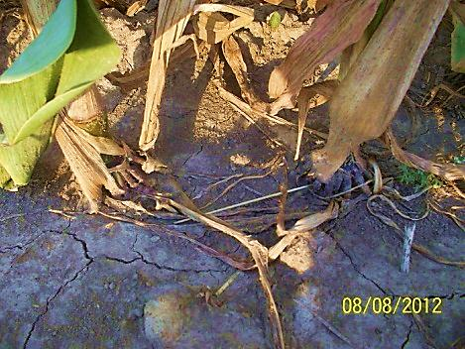  Stalks were weak and stunted.  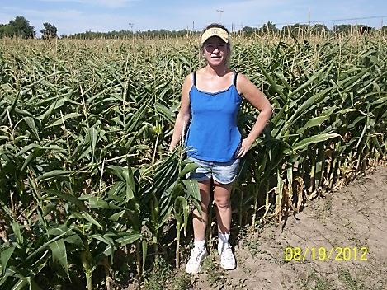  Ears were small  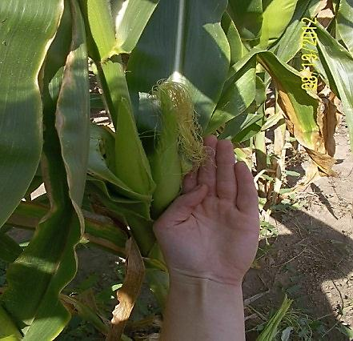  And undeveloped  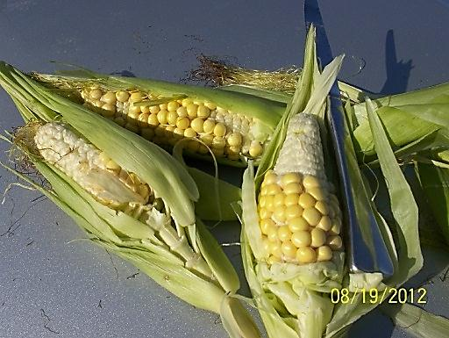 | But Tanya Reid, NY, enjoyed abundance. She BioWashed three (3) times. Her first treatment was at 6” tall, followed one week later, then again three weeks later. Her total investment: less than $18 per acre.  Rewards? Exceptionally pleasing.  Tanya’s stalks: Tall & robust.  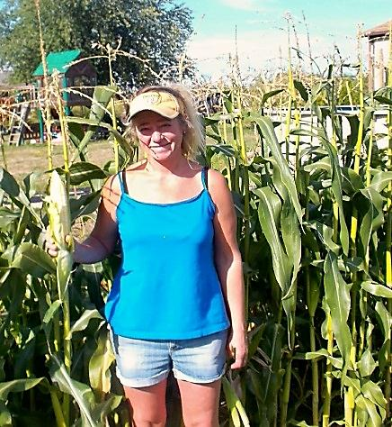  Loaded with large, healthy ears.  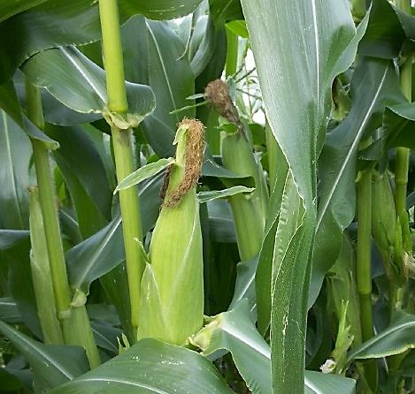 They were fully developed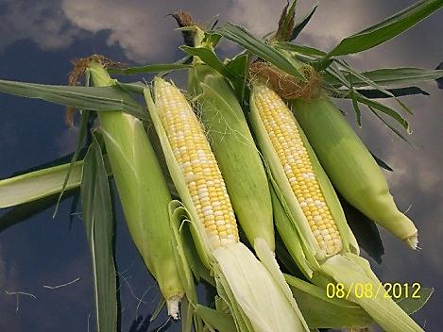  Typical ear: Sweet and delicious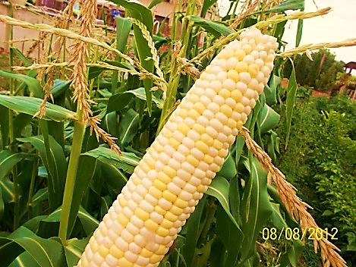 | How can a natural-plant-based solution not only save crops under such severe drought conditions, but produce abundance?  BioWash stimulates cation exchange, enabling plants to absorb moisture, oxygen and nutrients via the soil.  Tom Shields, PhD, McNeese University, School of Agriculture, theorizes that BioWash also enables plants to absorb any available moisture, nutrients and nitrogen via its leaves.  Robert Treloar, Northern Iowa University, (retired) believes another factor is the increased root size and improved cation exchange efficiency. Providing stronger roots by BioWashing during planting and soon after sprouting gives the plant extra strength and hardiness to withstand stresses. 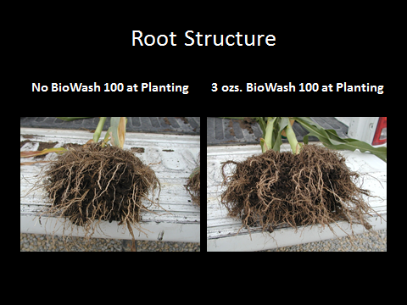  Suggested applications  At 6”-12” – 3 Oz/acre w/20+ Gals  2 weeks later – 5 Oz/acre w/20+ Gals.  3 weeks later- 6 Oz/acre w/25-30 Gals.  Cease BioWashing before tasseling  BioWash  is blended from farm grown plants by  1st EnviroSafety, Inc  10200 Betsy Parkway  St James City, Florida 33956  239-283-1222  For more details, see  www.FertilizerBoosters.com

