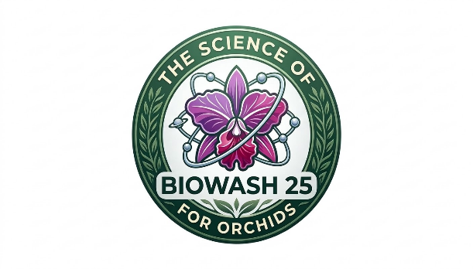
Introducing Biowash 25 for Orchids
Biowash 25 is a colloidal surfactant and bio-stimulant that acts as a cation exchange enhancer. In orchid cultivation, its primary advantages include:
- High Carbon Content: Carbon is the backbone of plant life. Biowash provides a readily available carbon source that fuels the microbial life in the orchid bark or moss, enhancing the "living" environment of the root zone.
- Nutrient Bioavailability: It breaks down complex minerals into smaller, ion-sized particles. This ensures that even in the inert media typically used for orchids (charcoal, perlite, bark), the plant can absorb nutrients more effectively.
- Brix Level Elevation: By stimulating photosynthesis, it increases the sugar (Brix) levels in the orchid’s pseudobulbs and leaves. High Brix levels make the plant naturally more resistant to common orchid pests like scale, mealybugs, and spider mites.
- Stomatal Efficiency: When used as a foliar spray, the colloidal action ensures the solution penetrates the waxy cuticle of the orchid leaf, delivering moisture and nutrients directly to the cellular level.

Application Protocol: The "Alternating Power" Method
For optimal results, follow this 10 to 14-day cycle. This prevents mineral buildup while ensuring the plant receives both systemic and localized stimulation.

Dilution Ratio
- Standard Dilution: 1 tablespoon per 1 gallon of water.
- Metric Conversion: 15 ml per 3.8 liters of water.
- Biowash 25 is formulated for broad compatibility and can be efficiently tank-mixed with most balanced commercial fertilizers. Its colloidal nature acts as a catalyst, enhancing nutrient bioavailability and maximizing the efficacy of the co-applied fertilizer
**always perform a standard jar test with new mixtures to confirm specific compatibility before large-scale use.

Feeding Schedule & Expected Outcomes
Week | Method | Specific Instruction | Expected Result
Week 1-2 | Foliar Feed | Mist both the tops and undersides of leaves early in the morning. | Increased leaf glossiness (turgidity) and darker green pigmentation.
Week 3-4 | Root Drench | Apply 4 oz (120 ml) of the dilution directly to the root zone/media. | Expansion of the root system; noticeable "green tips" on active roots.
Week 5-6 | Foliar Feed | Focus on the base of the plant where new "leads" or pseudobulbs emerge. | Faster maturation of new growth and stronger flower spikes (inflorescence).
Week 7-8 | Root Drench | Ensure the media is slightly damp before application for better penetration. | Enhanced nutrient storage in pseudobulbs, leading to longer-lasting blooms.

The Importance of Moderation: Disadvantages of Over-Feeding
While Biowash 25 is a natural, bio-based catalyst, "more" is not always "better" with orchids. Over-stimulating the plant or using a concentration that is too high can lead to several physiological issues:
- Root Desiccation: Orchids have sensitive roots. Excessively high concentrations of any stimulant can cause "fertilizer burn," where the salts or concentrated colloids pull moisture out of the roots, turning them black and brittle.
- Soft, Weak Growth: Over-feeding can trigger rapid, "leggy" growth. This tissue is often soft and lacks the structural integrity to support heavy flower spikes, making the plant more susceptible to fungal pathogens and crown rot
Call Us Today! 1-239-392-4869 or 1-239-283-1222|info@1stenvirosafety.com

