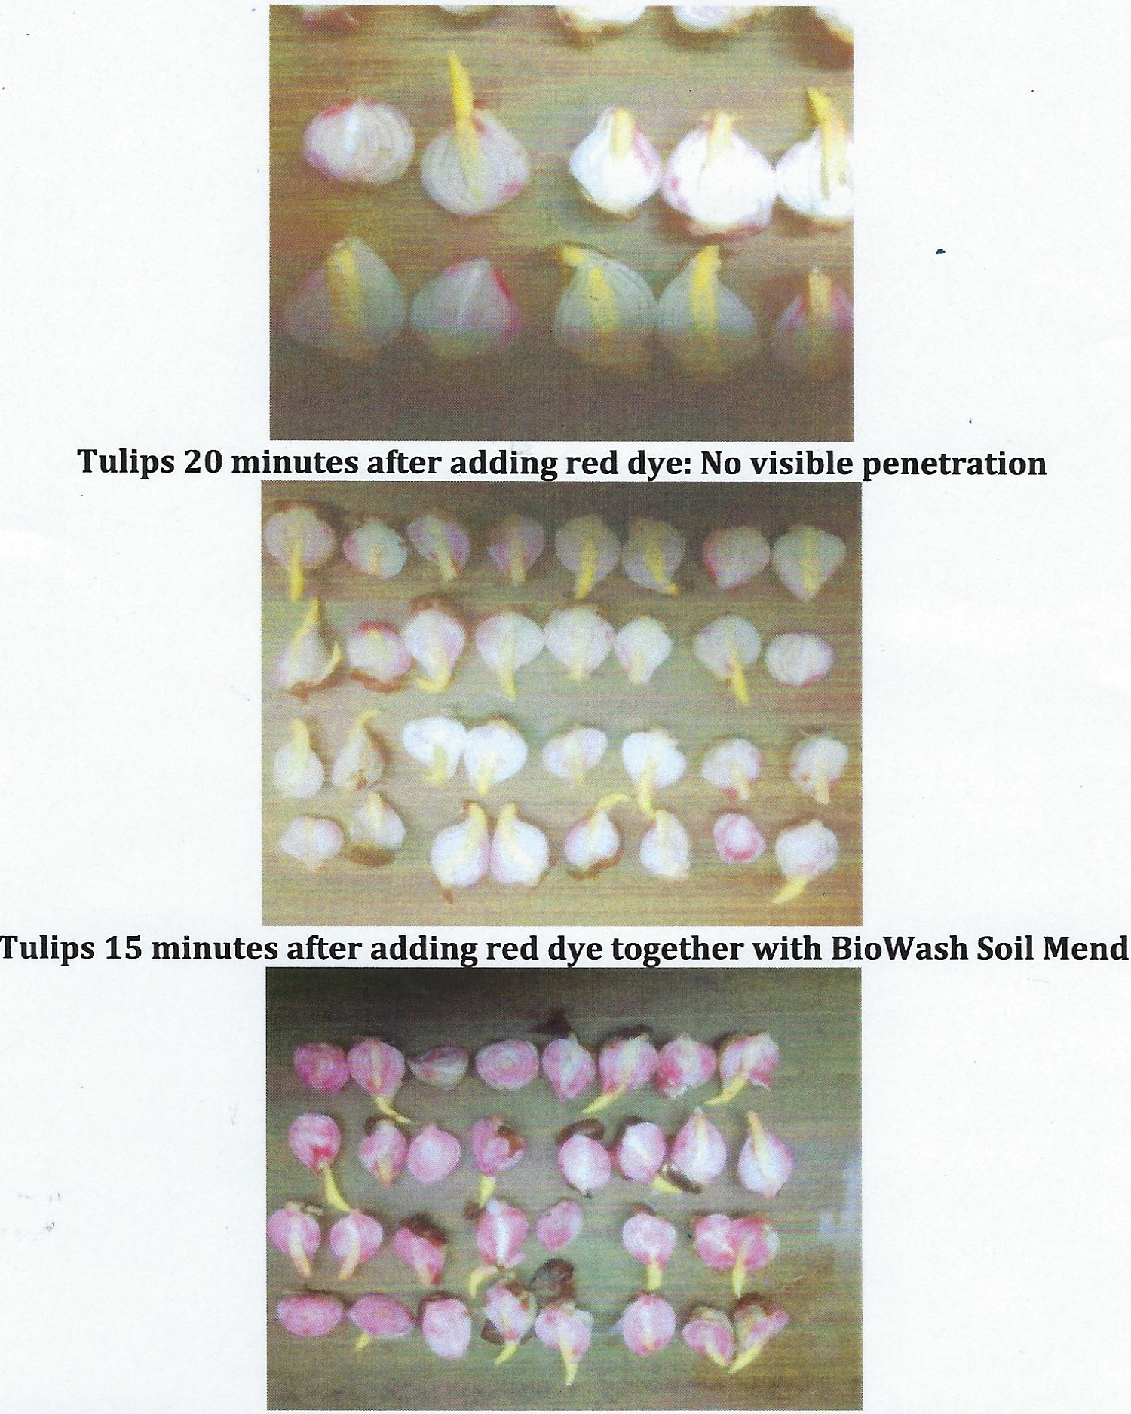BIOWASH SOIL AMENDMENT
Stimulates rapid nutrient absorption & plant.growth!!
Roelf Havinga, Organic Supplier, The Netherlands was curious regarding the nearly immediate visible growth when tulip growers added BioWash to fertilizers. Roelf tested it with red dye. He placed tulip bulbs in a tank of water, added red dye and photographed the before and after results.

Before adding red dye

This illustrates how BioWash so dramatically increases the efficacy of nutrients.
Reportedly, BioWash also increases moisture, atmospheric nitrogen & oxygen absorption .
BioWash works on all plants.
BioWash is not a cost!
BioWash is an essential farm investment!
Genotoxicity Free & Suitable for Organic Farming

1st EnviroSafety, Inc.
10200 Betsy Pkwy, St James City, Fl 33956

239-283-1222
www.FertilizersBoosters.com

