INCREASED CITRUS PROFITS!
CONFIRMED PERFORMANCE  Gary Scott, Mt Dora, Florida, purchased an orange grove containing 1,800 trees.  The previous owner had sold $16,150.00 of oranges. (2010)  Gary removed and replanted 600 dead trees then BioWashed the 1,200 remaining trees.  His yield and income increased to $22,000.00. (2011)  During the 3rd season, (2012) Gary BioWashed twice. His yield and income soared to $32,500.00!  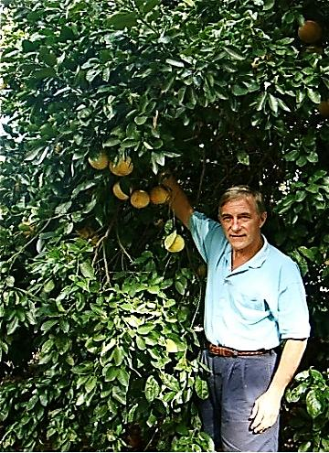  BioWash Soil Amendment  Is produced by  1st EnviroSafety, Inc  St James City, FL  239-283-1222  More details at  www.FertilizerBoosters.com | SIZE  A major factor in Gary’s increased profits was the increased size of his fruit.  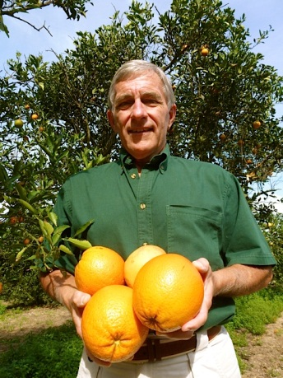  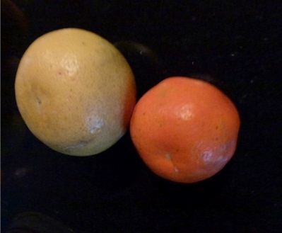  Tangerine compared to grapefruit.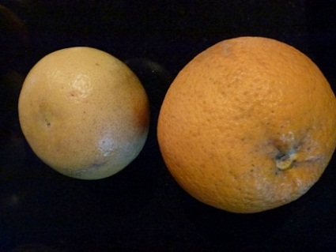Grapefruit & naval orange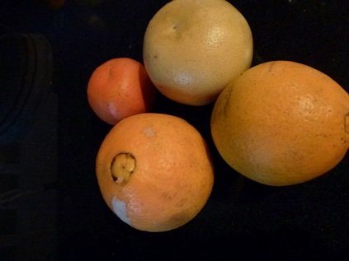Due to increased sizes; fewer oranges are needed to fill a case. | REDUCED COSTS  BioWash reduces the cost of fertilization. Just add 1 Oz per gallon to fertilizer, herbicide or insecticide.  DORMANT TREE REVIVAL  After 7 barren years, a pamelo tree was BioWashed. It became so loaded with fruit the limbs had to be supported. It works on mangos.  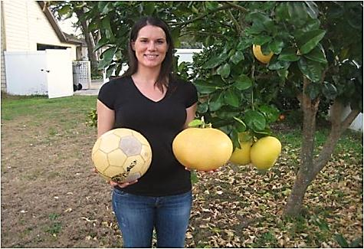  FROST/FREEZE RESISTANCE  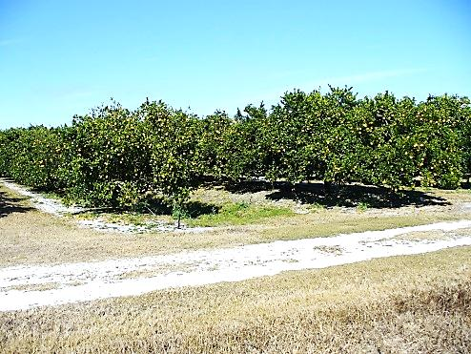  BioWashed grove (above) in Felda, FL survived 26 F. freeze. The adjacent non-BioWashed grove (below) suffered damage.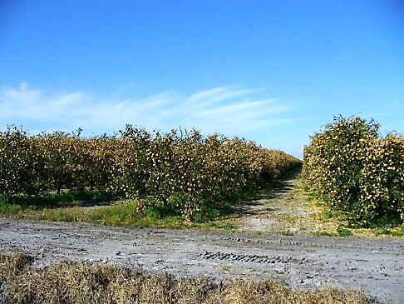  BioWash is priced like soap…  A little goes a long way. One gallon ($125) treats 500 +/- trees for as little as $.25 per tree. Order on line or call 239-283-1222.

